Newsletter

What a term!!!
As ever, I would like to thank you for your unwavering support and understanding during what has been, in many ways, an incredibly difficult term. However, we have been much more fortunate than last year and we have been able to celebrate Christmas in a way that we would like and that has brought much joy to the children. Despite the challenges that Covid-19 has presented, we have shared many great times and made great memories this term thanks to the resilience, tenacity and hard work of our amazing students and staff.
We are excited to share some of the highlights from 2021 autumn in our newsletter.
We continue to keep our Facebook page updated with information about school life and events and have a support page for you to share advice too. We have taken great pleasure from the many positive comments on our Facebook page and it is lovely to engage with all parents / carers. If you need to contact school during school holidays, you can email me (cbarker@bluebellschool.co.uk) and I will endeavour to get back to you as soon as possible.
We look forward to welcoming students back to Bluebell School on Tuesday 4th January 2021 and hope for a COVID-19 free year!!!
At Bluebell School we have 4 key learning intentions for all pupils.
Intention 1 | Maximise behaviour and skills for learning | Pupils will want to learn and have the skills to learn.
Intention 2 | Reach full academic potential | Pupils will develop appropriate knowledge, skills and understanding enabling them achieve to the best of their ability academically, creatively and physically.
Intention 3 | Rebuild and nurture | Pupils will be rehabilitated, enabling them to develop self-worth, a positive identity, confidence and contentment.
Intention 4 | Prepare to make a positive contribution to the advancement of British society | Pupils will leave the school to engage in further meaningful study or employment. They will be community-spirited, respectful, law-abiding young citizens in full support of democracy and individual liberty.

As always, my door is always open and should any parents / carers wish to talk to me, please contact me on 01782 987012 or cbarker@bluebellschool.co.uk
Wishing you all a very Happy Christmas. We look forward to seeing you all in 2021.
Kind Regards
Craig Barker (Headteacher)

Safeguarding Update

With the festive holiday nearly upon us, we know that many of our pupils will be spending an increased amount of time on-line. Some may be receiving internet enables devices or upgraded devices as Christmas gifts. As we know, the internet can enrich all our lives in so many ways but it also brings various forms of risks, and those who would wish to abuse or cause harm to our children become even more active during school holiday periods. Many of these individuals hide behind fake, yet very convincing, profiles.

The UK Internet Safety Centre continues to provide some very helpful practical advice and information for parents and professionals alike. The link below relates specifically to the giving of gifts which connect to the internet, but it will also signpost you to a wide range of invaluable sources of help in ensuring you keep you loved ones safe, not just at Christmas but throughout the year.

4 tips for giving tech gifts this Christmas - UK Safer Internet Centre

Minton
Minton class have had a great end to the autumn term! We have had some exciting opportunities, including going on our surprise day to Castaway and an exciting visit from Elsa and Anna and some reindeers! Building up to Christmas, the children have been involved in lots of festive activities, including Christmas crafts and Christmas trips.

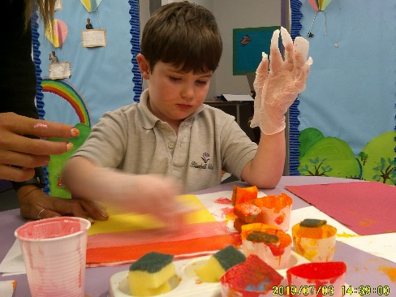
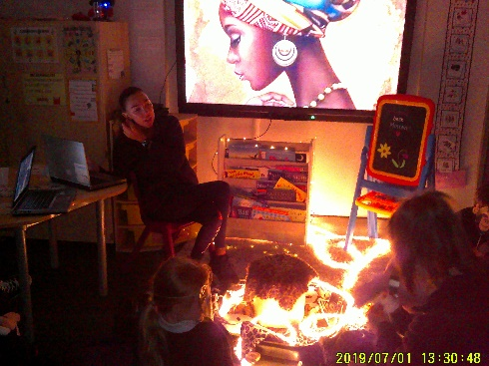
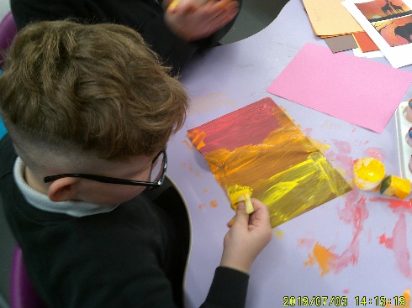

During English, class Minton have been reading the story of “the Leopards Drum”. We have enjoyed joining in with a role-play of the story, and acting out the different characters by expressing their emotions using the drum that we have made. Children even created artwork related to the story using sponges and traditional colours.

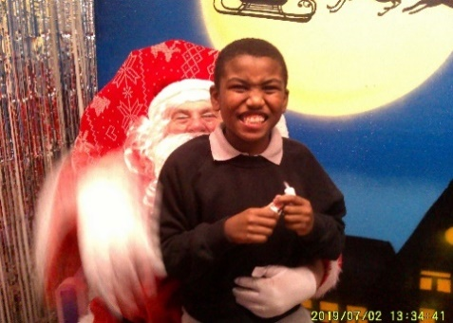
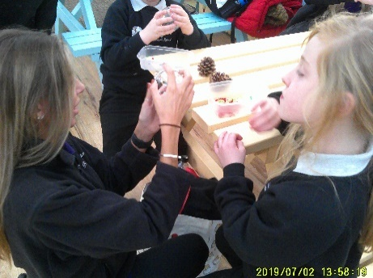
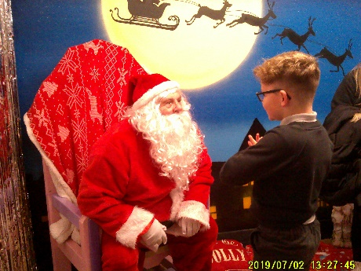

Class Minton had a great trip out to Castaways as a Christmas treat. Children enjoyed playing on the climbing frame and going inside the giant inflatable igloo. We stopped for a juice break to refuel before creating baubles, making reindeer food and playing in the sand pit. As we got ready to leave the children were surprised with a visit to Santa, which got a thumbs up all round!

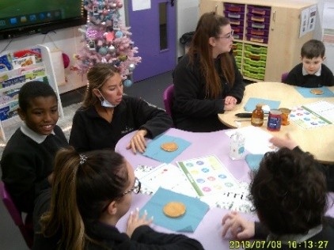
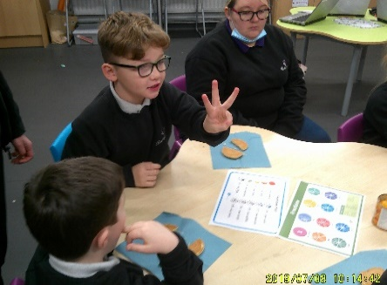
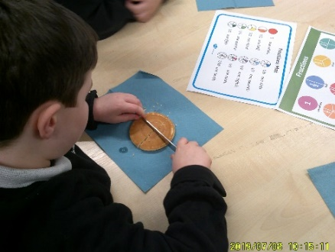

During maths, the children have been learning to identify halves and quarters. We spent time working individually before engaging in a team pancake making activity. Each child cut their pancakes in to a half and then a quarter and used whiteboard pens to write their answer. Once we figured out the answer, we enjoyed decorating our pancake with syrup and fruits and ate them all up.

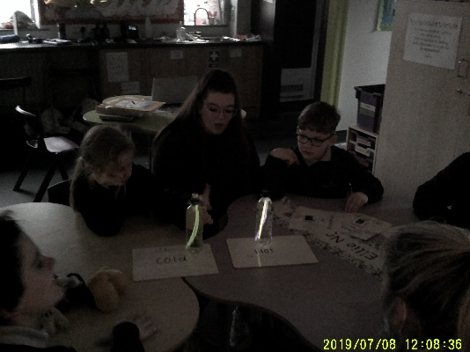
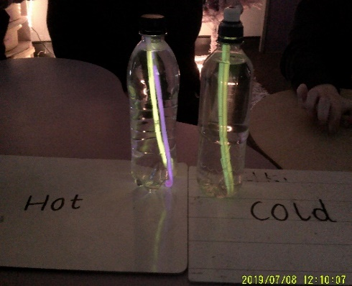
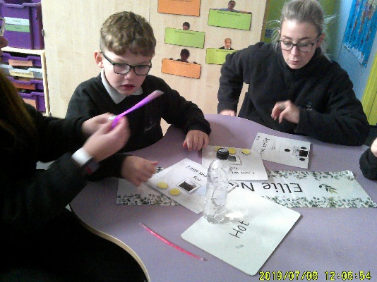

Beswick
For Science we have been taking part in lots of exciting experiments, today we had a look at the way in which we identify if a test is fair. The children watched as staff played out some very unfair tests, it did not take class Minton long to identify that it was not fair. Children then took it in turn to fix these silly unfair experiments and then watched to see the amazing results.

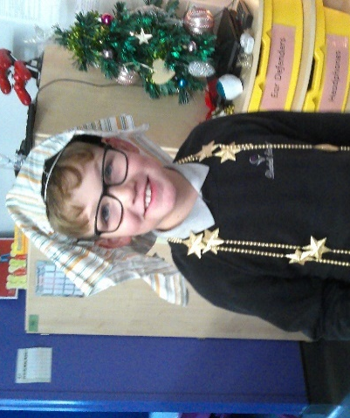
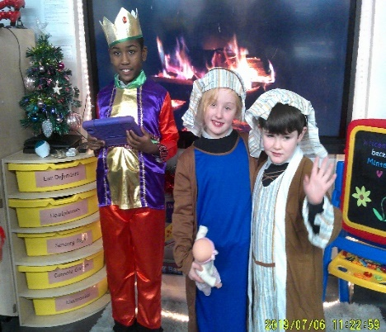
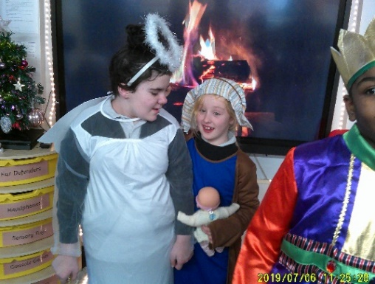

This afternoon we enjoyed watching a video all about the Nativity before we had fun dressing up and acting out the different parts of the film. After having our fun, we sat around a virtual fireplace and listened to the original nativity story. We had a lovely discussion all about how this story relates to how we celebrate Christmas today. Before we went home, we took it in turns to talk about the things we do on Christmas day.

A big well done to class Minton for all their hard work and efforts this term. The staff team and I hope you have a fantastic Christmas and we look forward to welcoming you back in January.
Abbey & Josie

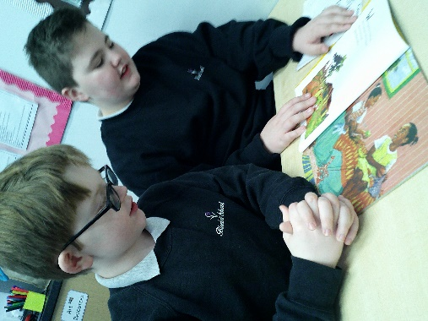
Dudson

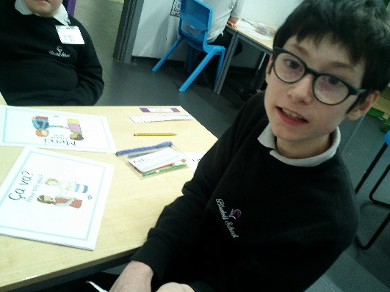
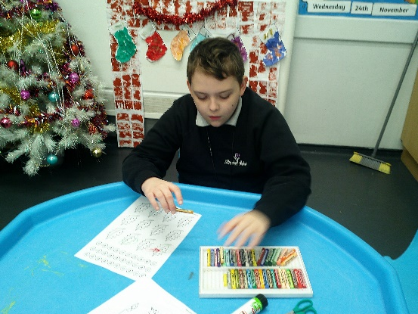
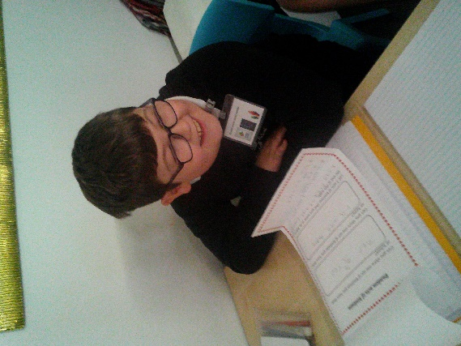
We have had a fantastic end to the autumn term in Class Dudson! In English the KS2 pupils have continued to focus on stories from Africa and other cultures. They created their own independent short story about finding a wild animal that included adjectives. The KS3 children continued to develop their communication/writing skills by completing a project to write a formal letter of complaint about a holiday to New York.

In Maths we have focused on recognising the different types of triangles, symmetry and building our recall of number patterns to 100. We even finished the term learning how to use the method of column addition!
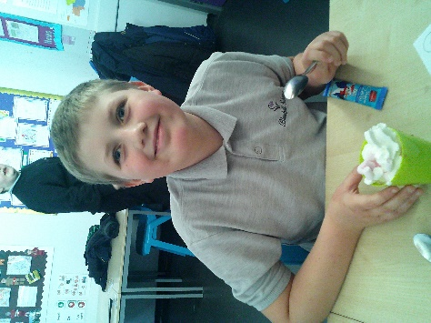
In Science, the KS2 children developed their knowledge of day, night, shadows and how light travels. The KS3’s continued experimenting with dissolving, evaporation and filtration.

In Topic, the KS3’s moved onto looking at tourism and created their own tourist attraction leaflets. They debated if tourism is good or bad and shared experiences of visiting new places. The KS2 children created pieces of art and models of Benin African artefacts and art.
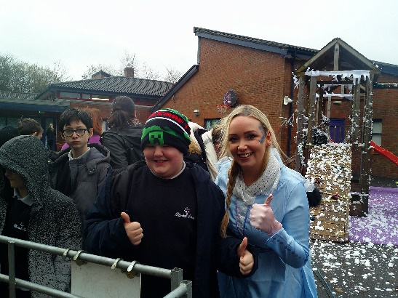
We have had a fantastic time tubing during our outdoor PE sessions and we have grew in confidence with this each week.

We are so proud of all of the pupil’s achievements over the autumn term and we hope you have a fantastic Christmas and a happy New Year
Kirstie, Pip, Rachel & Hanna

Wade
Class wade have been really busy this half term and have taken part in lots of activities and had plenty of fun whilst we learn!

In Science, we have continued to further develop our knowledge of light. We have been looking closely at daylight and how this occurs. We have also focused on how light travels and how we see light through our eye. We have had lots of fun exploring and taking part in many practical activities in order to further understand our learning.
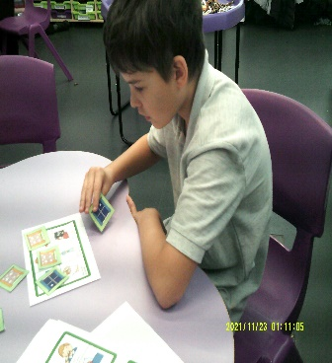
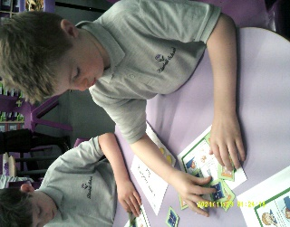
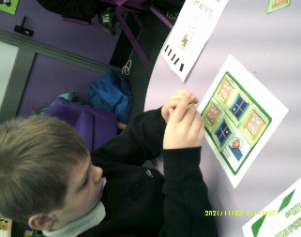
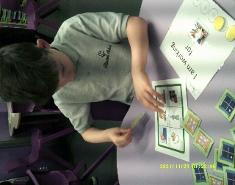
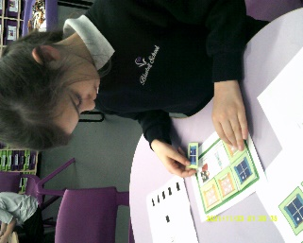
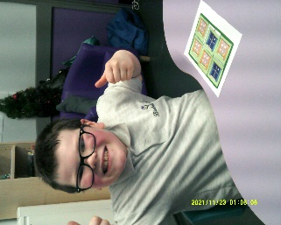
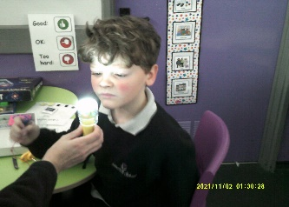
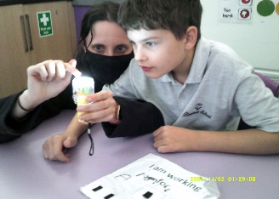
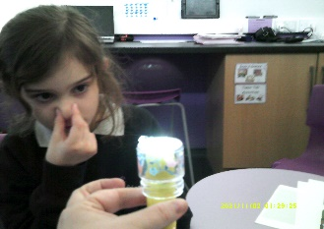
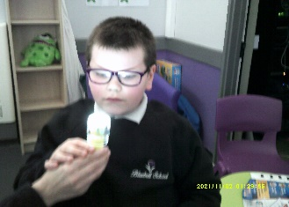

During English, we have continued to look at stories that have a cultural focus. We have explored the sensory elements to stories as well as developing our reading and writing skills. We have also looked closely at the difference between fiction and non-fiction books, identifying the characteristics of a range of poetry.
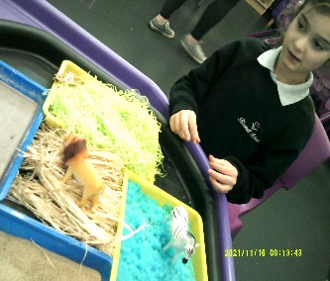
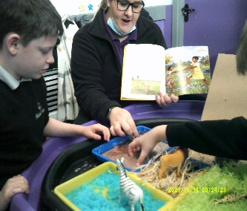
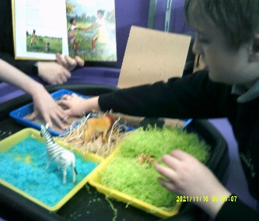
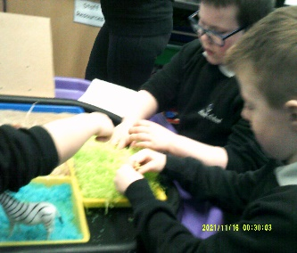
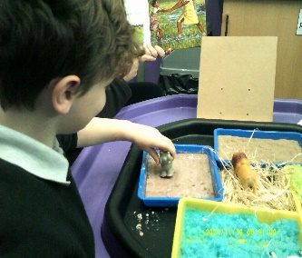
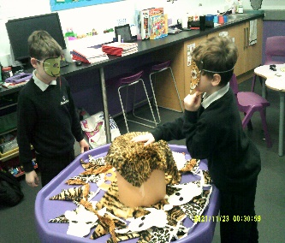
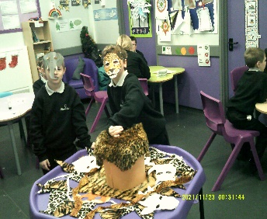
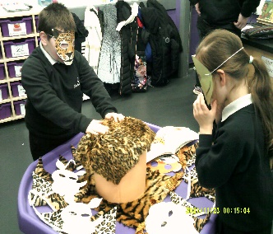
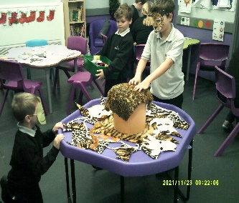
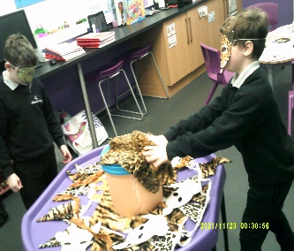

In Topic, we have really enjoyed our area of focus ‘Benin Africa’. We have been looking at the history of Benin trade and took part in a food tasting exercise. We also began to understand what we mean by the work ‘history’ and created a timeline of our own events in order to understand past, present and future before moving on to the history of the Benin Kingdom. We created 3D resources each week in order to build a tabletop timeline of Benin Africa throughout time.
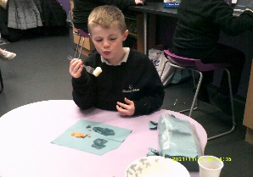
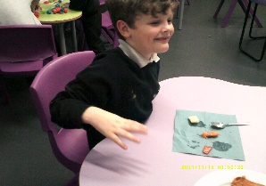
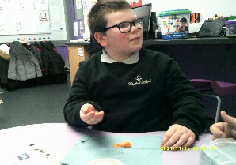
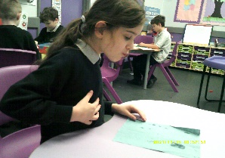
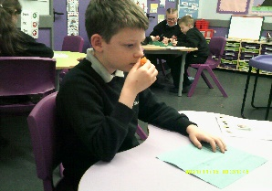
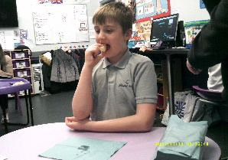
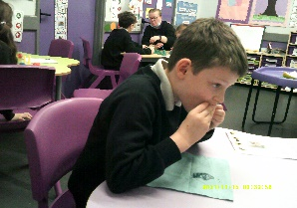
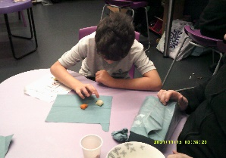
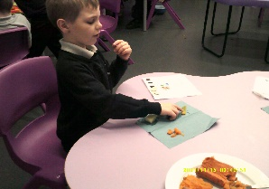
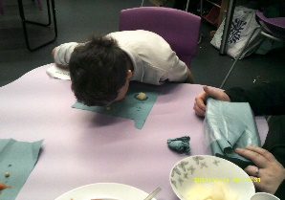
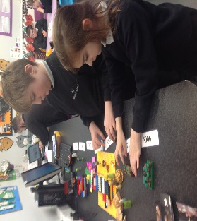
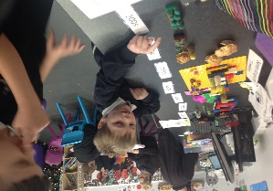
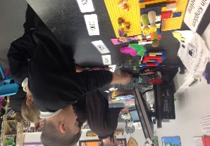
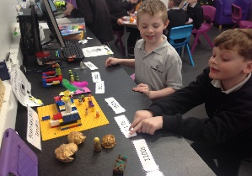
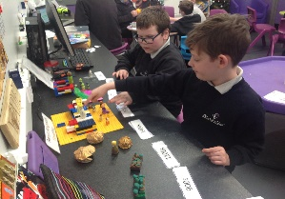

During Maths, we have built on many key skills using the Numicon to support. We have further developed our knowledge of ‘one/ two more and one/two less’ and were able to apply these skills when handling money. We have also further explored numicon in order to develop our number knowledge whilst beginning to learn our times tables. We have then moved on to division, using the skills learnt from our times tables that really helped us with this!
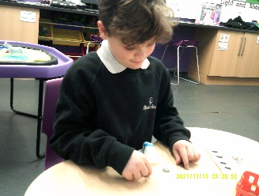
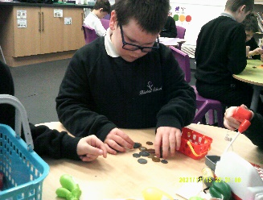
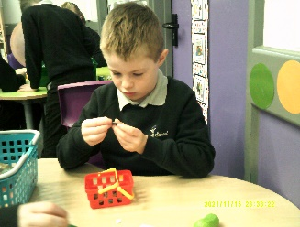
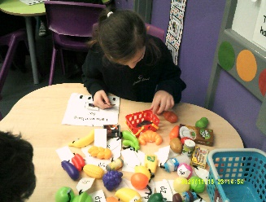
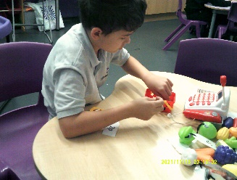
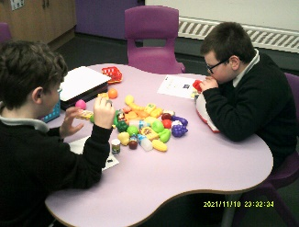
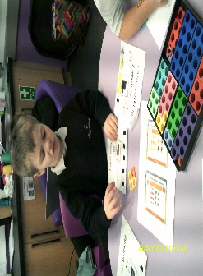
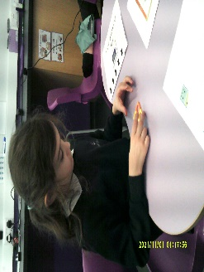
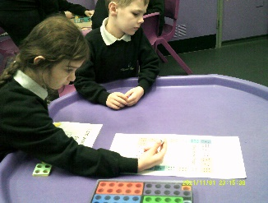
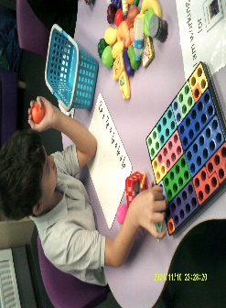

We would like to wish you all a lovely Christmas break and look forward to seeing the children back in school in the New Year!

Moorcroft
This term in English, our KS2 children have been looking at different genres while KS3 have been exploring deception. We even went to the library as a class to discuss different books and explore how many different genres can be accessed.
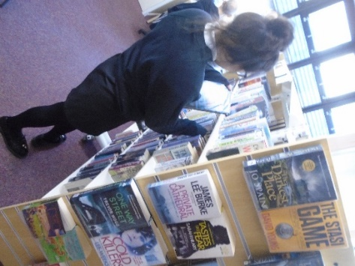
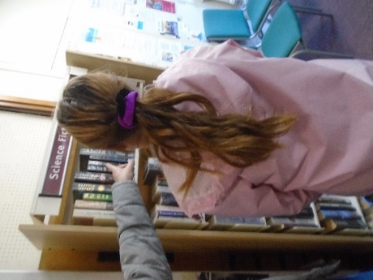
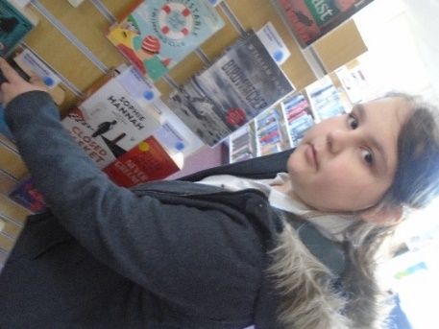
In Maths this term we have looked at Money and adding and subtracting various amounts, while work on numicon has remained as a key focus. Some children have used numicon to solve multiplication problems while some have used them to understand place value.
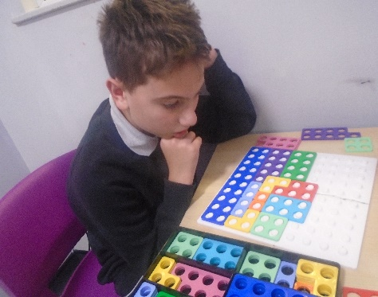
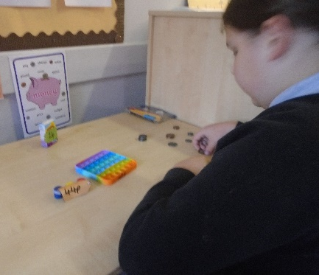
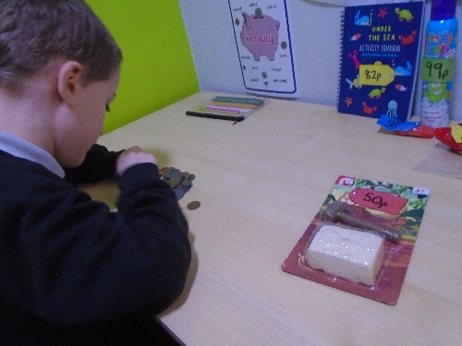

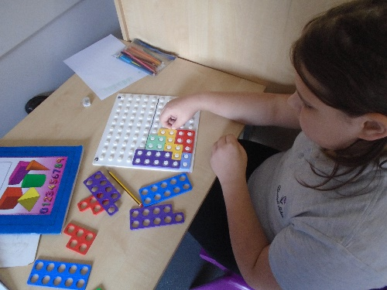
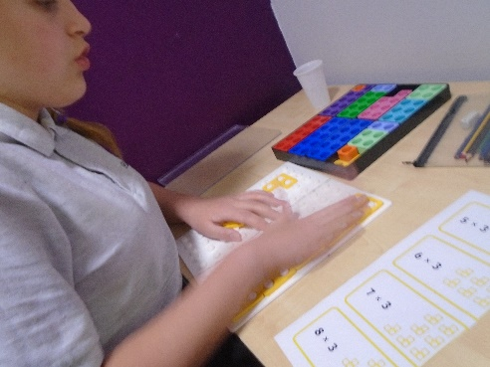

Topic, KS2 have been looking at the history of the Victorians and designed their own room based on what was typical of the era. While KS3 have been looking at the major changes to Britain starting in the 1940s up until the 2000’s.
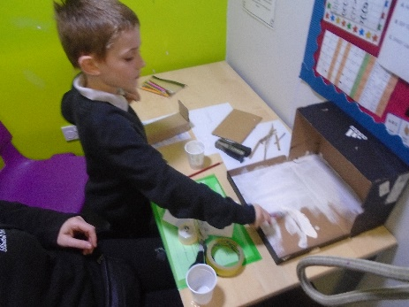
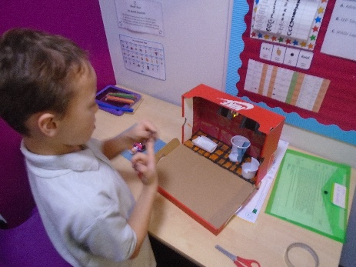

During the Christmas period we had some special visitors at Bluebell. The children fed the reindeers and some children tried to pet them too! Anna and Elsa even made an appearance on the day under the snow covered playground.
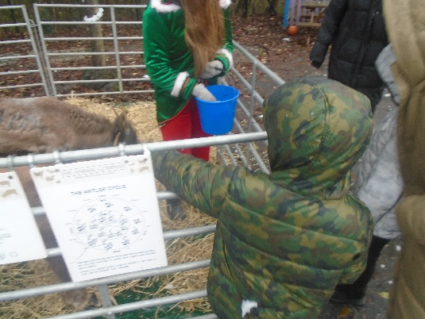
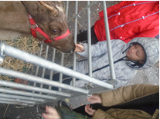

Spode
Class Spode have had a lovely half term at school and have engaged in a range of different activities which they have enjoyed. The children have completed some amazing work around our theme The Victorians.
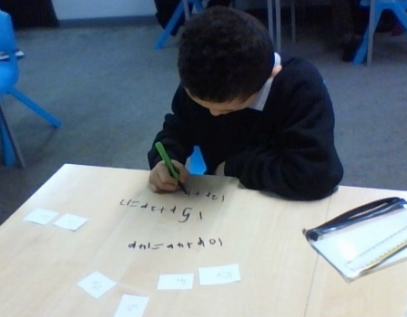
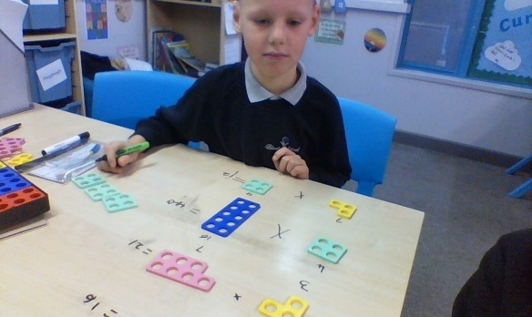
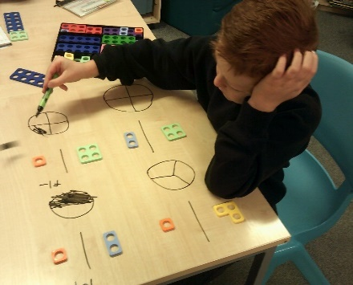
In maths the children have completed a range of different activities practically to consolidate their understanding. The children began the half term looking at number problems followed by fractions and to end the term they have been exploring money.

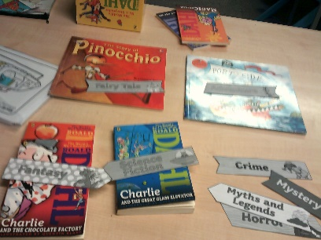
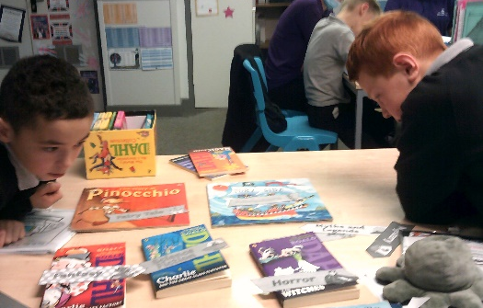
Within English the children have explored the topic short stories. They began the term exploring the different story genres then reading and identifying the correct genre of the chosen story. The children have ended the term exploring the structure of a story and then considered the different aspects of a horror story, before selecting their own setting and character and writing their own beginning to a horror story.

During the end of the half term, children have engaged in a range of exciting Christmas activities. The children were able to visit a local theatre to watch a panto show which they found extremely funny! The children have completed lots of Christmas crafts including cards for the local residents and decorations for our class Christmas tree. We has some special visitors at school where the children got to see the reindeers here at school.
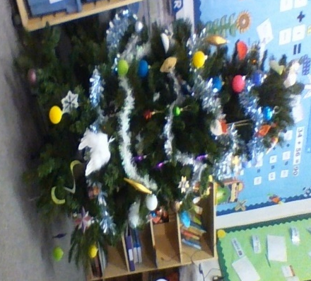
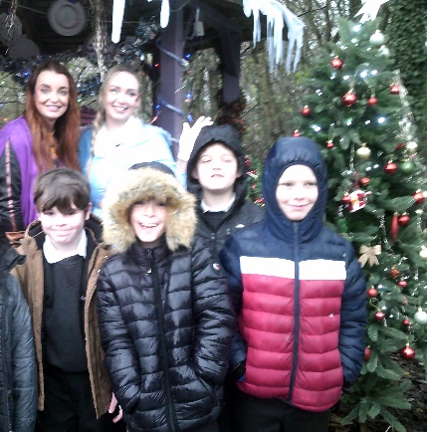
I have had another lovely term with the children in class Spode and I wish you all a very Merry Christmas and a Happy New Year!
Stay Safe and I look forward to welcoming you for the spring term.

Charlotte and the class Spode team

Middleton
What an exciting term we have had in Class Middleton. Children have loved taking parts in lots of lovely Christmas activities!
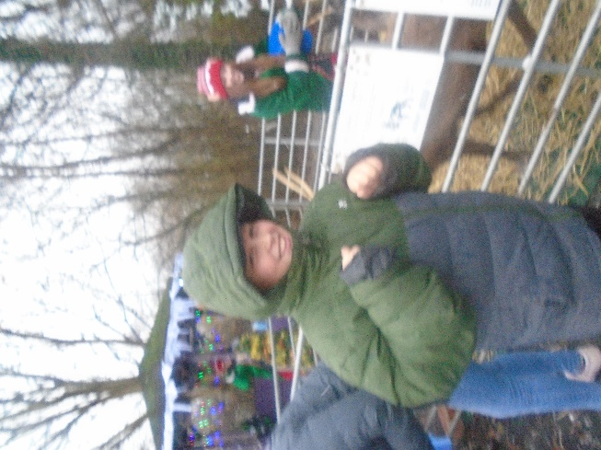
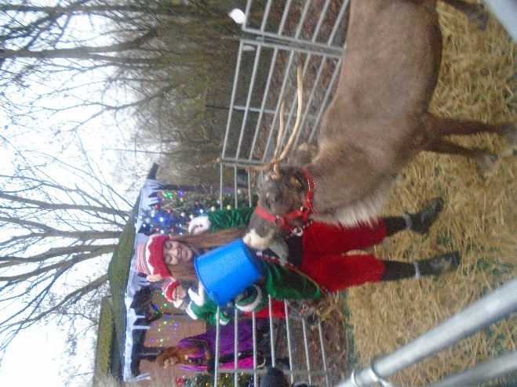
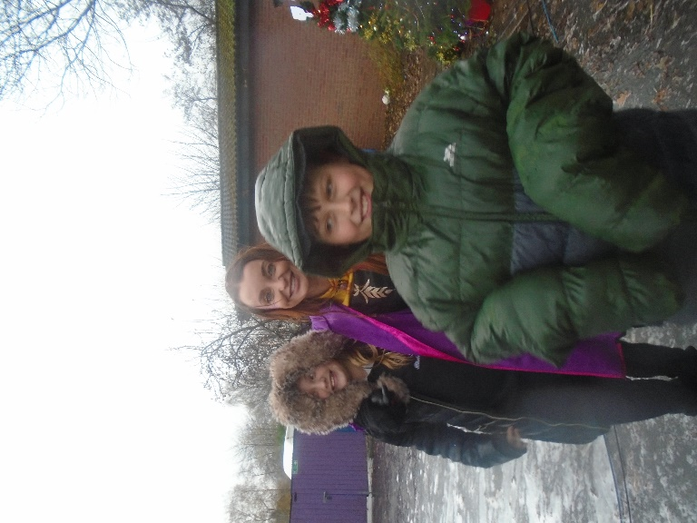

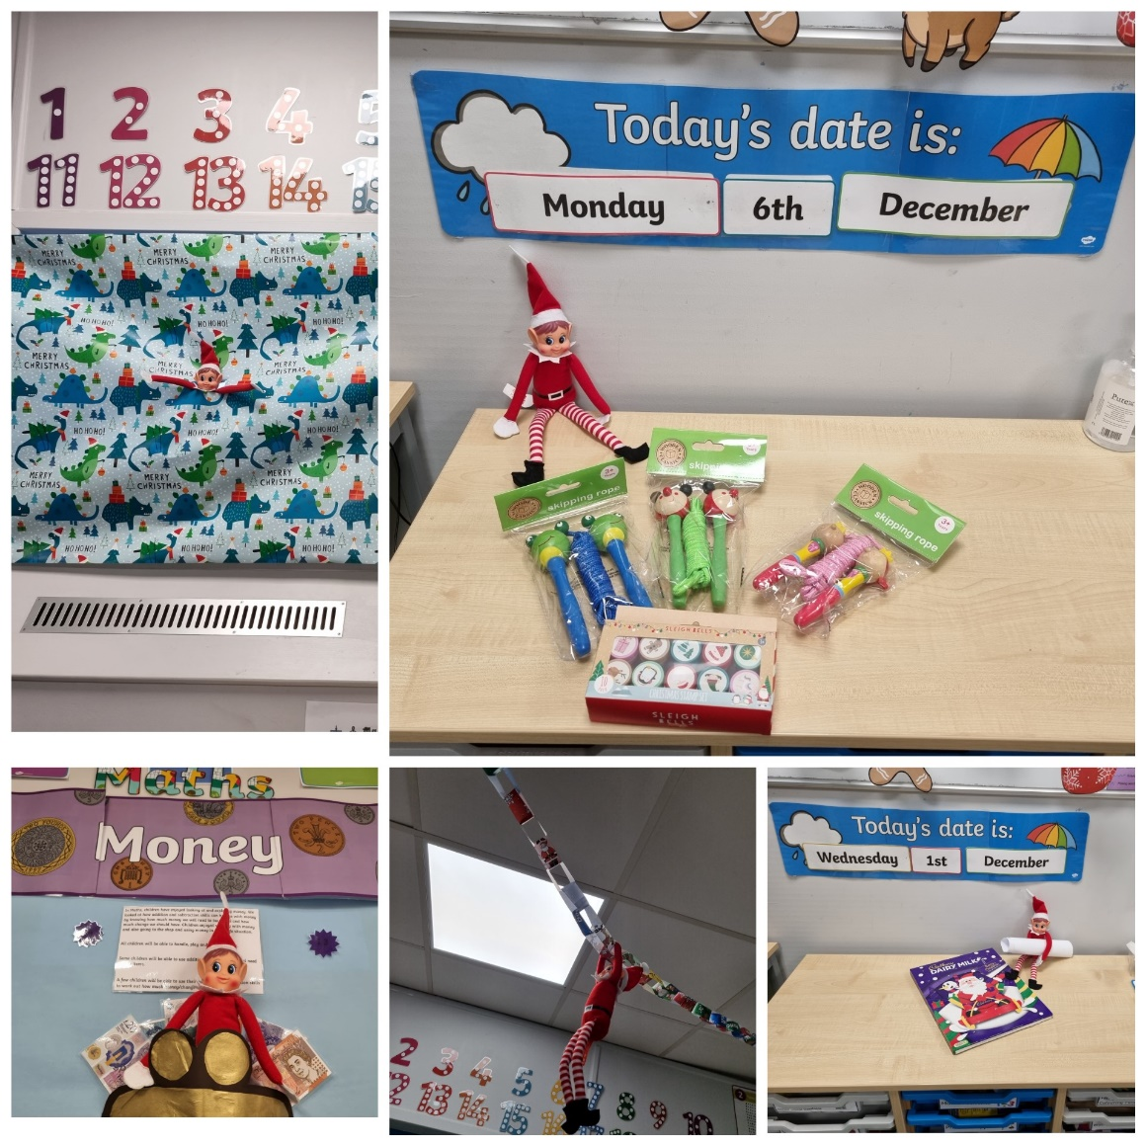
We had Alfie the elf come to visit us on the run up to Christmas. Here are some of the things he got up to!

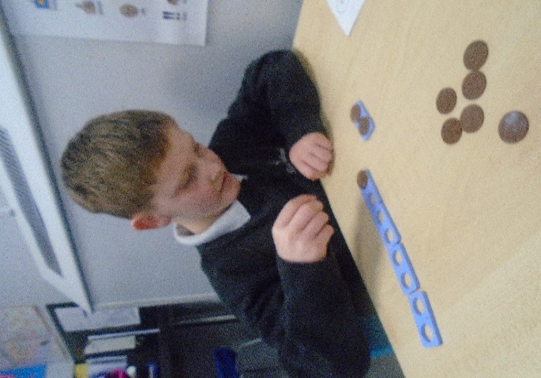
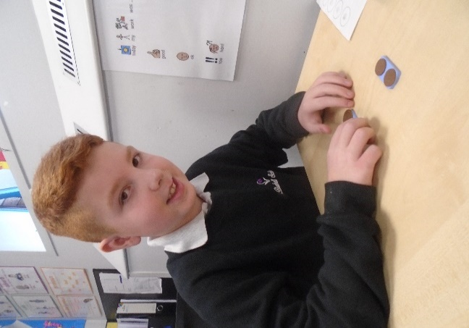
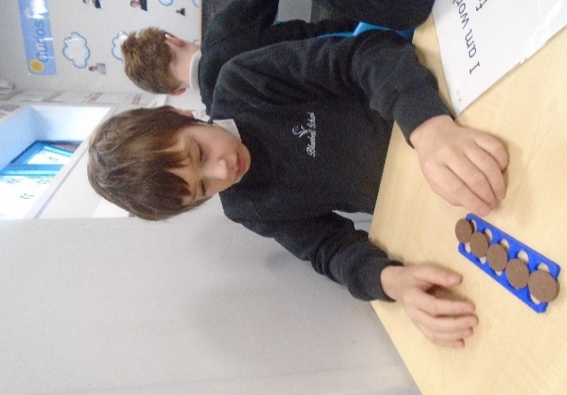
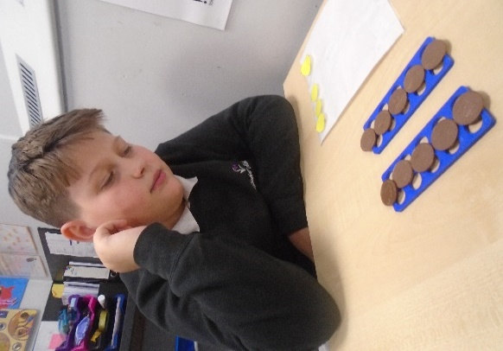
In Maths, the children looked at money and were able to look at all the different values of money and explore when they might use this in real life situations. Pupils also used coins and Numicon to help them count in two’s.

In English, children read many different stories from Africa. They loved reading ‘we’re going on a Lion hunt’. They had lots of sensory fun with this story. Children were then able to recreate their own stories.

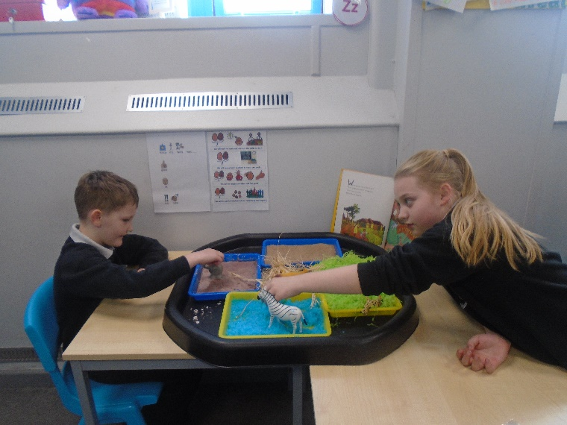

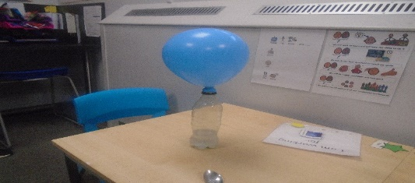
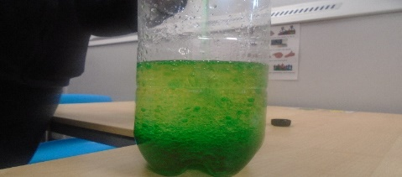
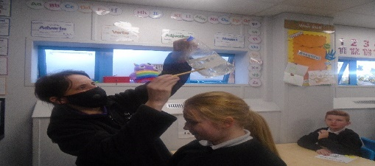
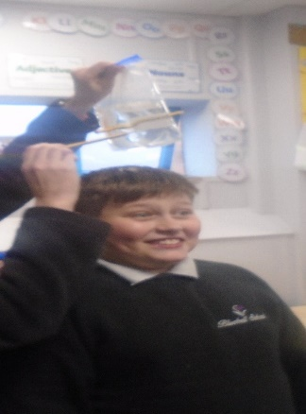
In Science, we celebrated world Science week and took part in lots of fun Science experiments. Children created a lava lamp and made a balloon self-inflate! We were able to push pencils through a bag without making any water leak.

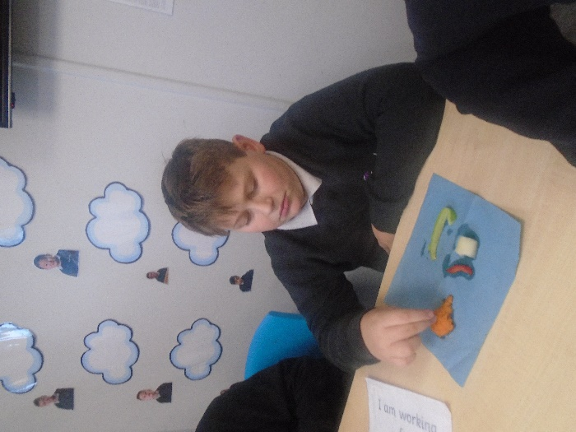
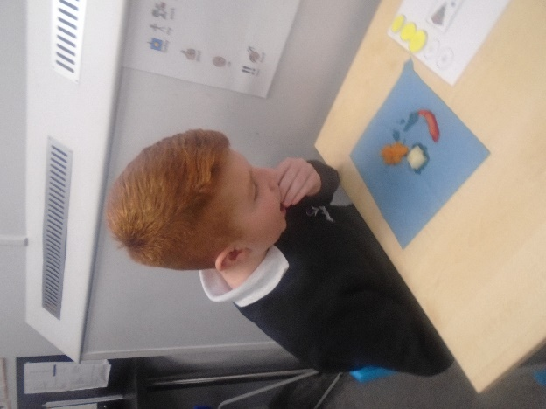

In Topic, children were able to try different foods you would find in Africa. They were able to smell, feel and taste the different items.

Staff would like to wish all children and their families a Happy Christmas and a New Year. Enjoy your well-earned break and we look forward to seeing you all in the New Year!!!

Class Middleton Team

Steelite
Over the last few weeks, we have continued to learn all about the Victorian era.
We have been looking at Victorian Dolls houses and the children have been extremely busy planning, sketching and making their own furniture to complete a fantastic Dolls house. They also made a dolly peg.

We are now focusing on geography and how Staffordshire towns became an important link for the different trades. We have learnt how transport links and why train lines were so important. We have also been learning about watermills and their importance.
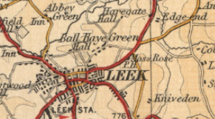
Topic

Steelite’s theme this term is The Victorians

Maths
in maths, we have been working on finding pairs of numbers and working out addition and subtraction facts. we have also looked at multiples and found multiplication facts. pupils have learnt about the different methods that HELP TO work out certain calculations, and also made their own beaded line using cereal bits!

In Science, we have been exploring shadows and how they behave; we have also conducted our own experiments and drawn our own conclusions.

Steelite have been extremely busy and have been amazing during practical activities, which they have really enjoyed. They have been off-site several time and represented the school beautifully. I wish them a lovely break and look forward to welcoming them back in the New Year.
English
Steelite have been learning short stories and the different genre that can be used. we identified the different features and compared it to traditional stories. we moved on to predicting the endings to the stories. we have recapped punctuation and the importance of using it correctly in our writing.
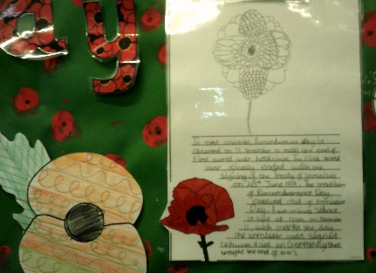
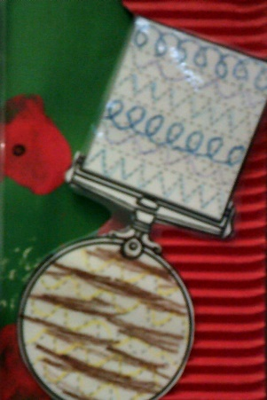
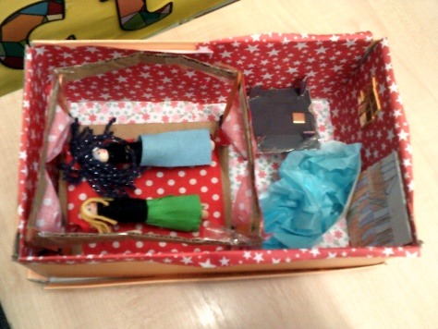

Here are a few pictures of what the children have been getting up to during the last few weeks.
We have respected our fallen; we wrote poems and talked about the importance of remembering why we celebrate our heroes.
We have had some lovely history lessons and made our own dolls house.
We went to the Pantomime and met the wicked witch…Oh yes we did!
Not forgetting the day Steelite met Dancer and Prancer! What a great day. The children loved them.

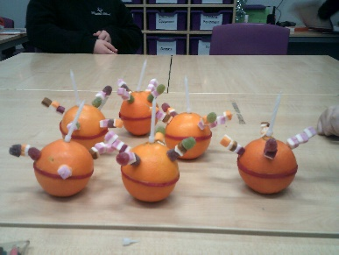
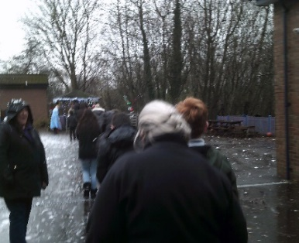

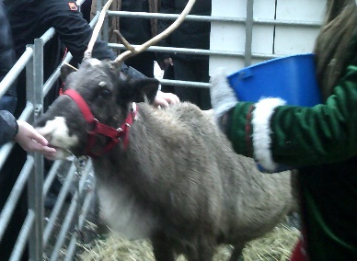

Churchill
Churchill class ended the term extremely well. Pupils have continued to develop friendships and achieve their targets! They have produced some excellent work.
In Science, Churchill class have explored ‘Plants and Plant Reproduction’. We have investigated how plants reproduce, how seeds are dispersed and the importance of photosynthesis.
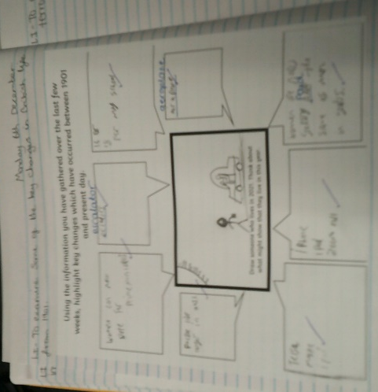
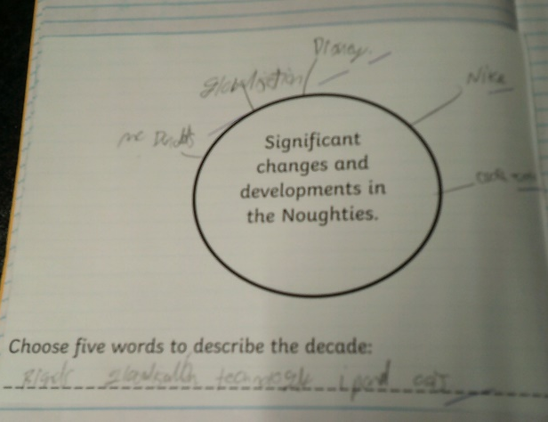
During our Topic sessions Churchill class have explored ‘Change over Time’. We have explored life in the 1950s all the way to present day. We highlighted the most significant changes, developments and inventions which have occurred over this time period. Pupils couldn’t imagine life without the technology which we have in 2021!
During our English sessions, we have explored a wide variety of texts. We started by looking at ‘Twelfth Night’. We analysed the role of different characters and explored how comedy is created throughout the play script. Over the last few week pupils have enjoyed exploring the text ‘Madame Doubtfire’. We uncovered the themes deception and disguise and the impact these have on the text. We finished the term by watching the film ‘Mrs Doubtfire’. It was great to see the text come to life! We found it very funny.
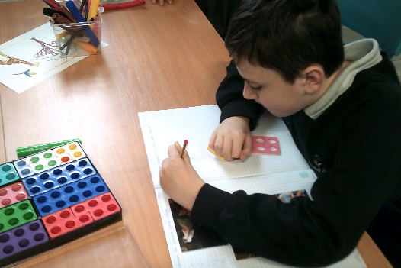
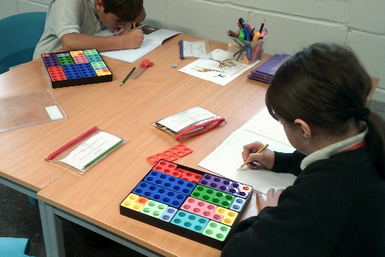
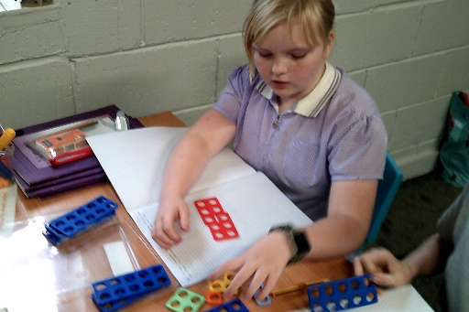
In Maths we have mastered place value, addition and subtraction. We have also spent time working on multiplication and division. We particularly enjoyed working on money, identifying coins and notes and working out worded problems.
A highlight of this half term has been our Social Skills sessions. Pupils have developed an ability to work as a team and communicate well with peers. Pupils enjoyed taking on group challenges!
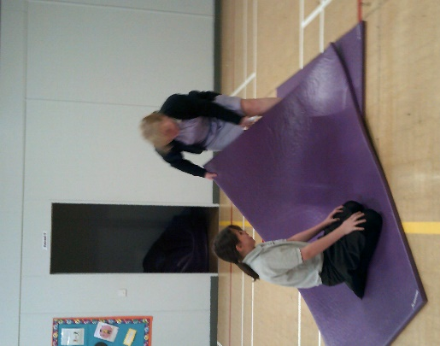

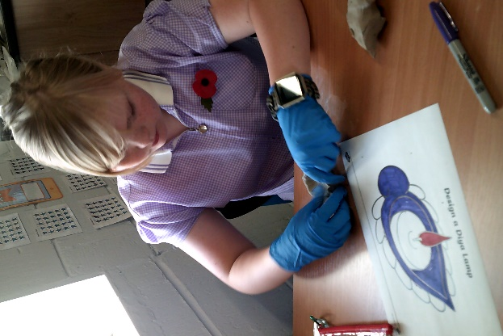
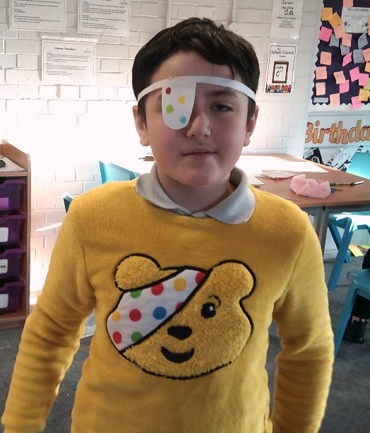
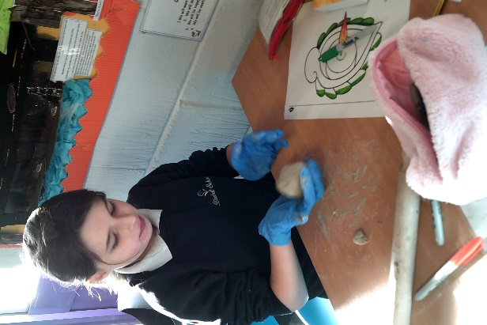
Throughout this half term Churchill class have explored and celebrated lots of diversity events.

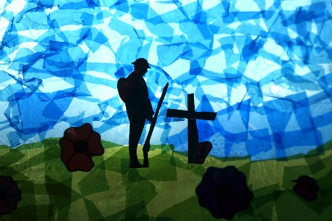
The class worked together to create a beautiful display for Remembrance Day.
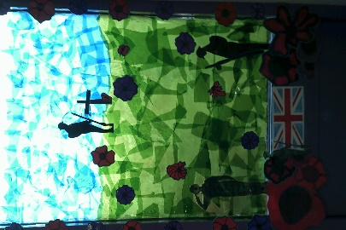
Well done for all your hard work Churchill class. Have a lovely break. Merry Christmas!

Lauren and the Churchill team

Beswick

Class Beswick have had a wonderful and festive half term. We have been very busy continuing to explore our exciting topics with a sensory/hands on approach to our learning. Look at some of the fun we have had, while participating in learning…
During our maths lessons, we have been looking at Symmetry. Children have enjoyed the hands-on approach within the classroom, such as using Numicon to support learning. We have also been developing our life skills by handling money at the shops and during role-play opportunities. The children have also been practicing time within the timetable throughout the day.
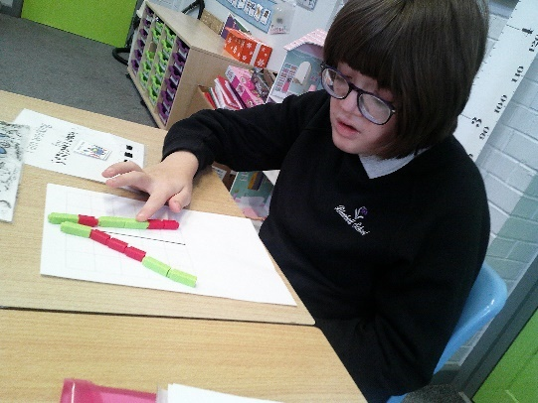
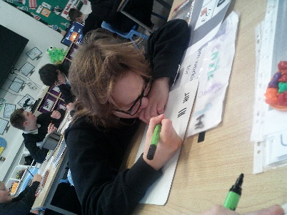
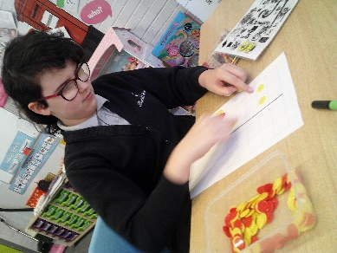

Within the autumn term in English, we have continued to look at our Step-Up project called ‘Have Your Say’. This has included lots of work on formal writing and communication, such as letters and emails. Class Beswick have been working on their formal writing skills throughout this half term. They have completed lots of wonderful work in regards to this, such as focusing on what types of communication they can use formally and informally. The children have developed their skills even further by planning and writing their own formal letter of complaint for a holiday.

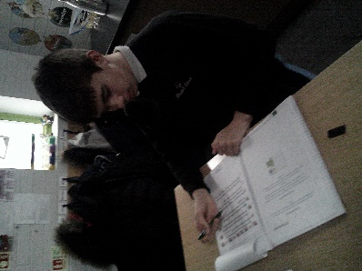

Within our science lessons we have continued with the previous topic of solids, liquids and gases. However, within this half term the children are now developing their scientific knowledge and skills even further by identifying how to separate different solids and liquids from one another, for example, evaporation and dissolving. Class Beswick have been exploring this topic with a hands-on sensory approach to deepen their scientific understanding and knowledge. We have started to complete lots of practical investigations to specifically look at evaporation within the classroom. The children are very enthusiastic about this topic and are looking forward to starting a new similar topics within the next half term.

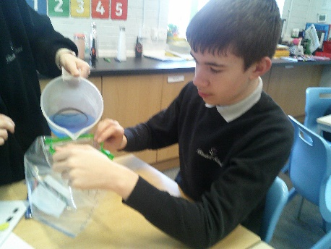
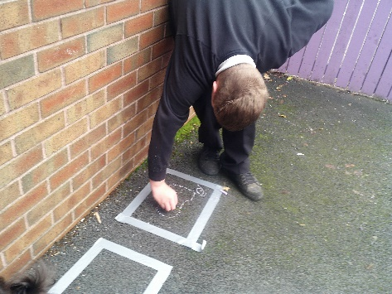
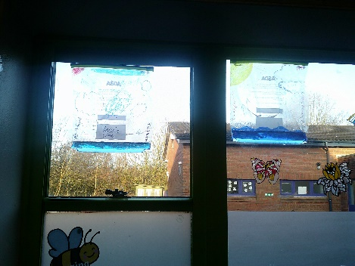

Wedgwood
Class Wedgwood have had a great term and we have been doing lots of learning and having plenty of fun!
English
During English we have been working so hard in our read, write Inc. lessons. We have enjoyed practising our writing with Fred and we have all started to sound out words. We have read many books during this term and started to write Christmas poetry. This week we have received letters from our class Elf Alfie! We all read our letters out to our friends independently. We are busy writing Christmas cards to our family.
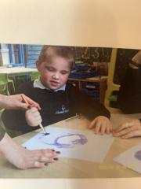
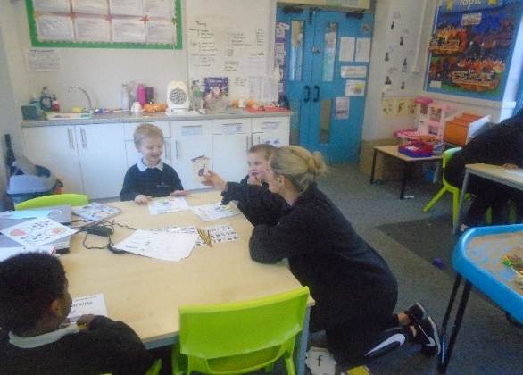
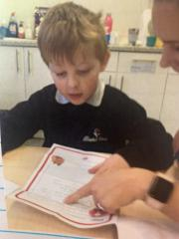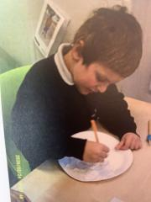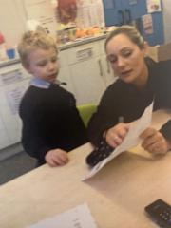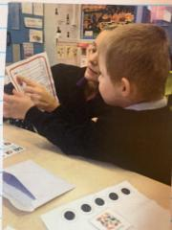

Maths.
This term during Maths, the children have been counting in two’s and learning fractions. The children have used pancake toppings and pizzas to practise their fractions! We have done lots of numicon activities and practised division and making a half.

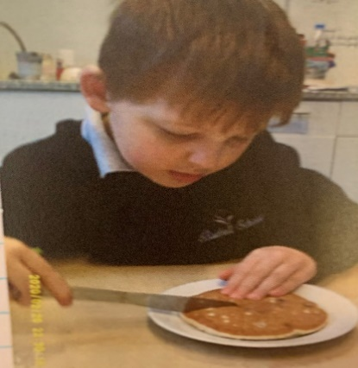
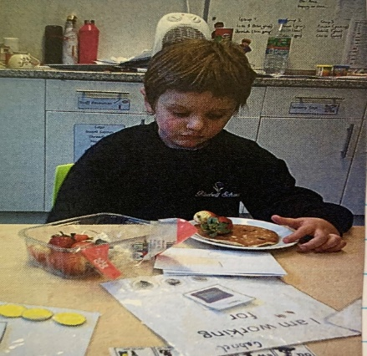
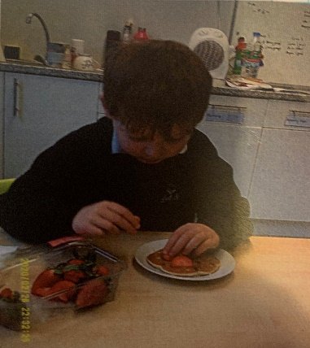

Doulton
Independence week
Doulton Newsletter December 2021.

Team Bluebell had some special visitors this week, we all enjoyed the reindeer visiting Bluebell and two of our own playing Anna and Elsa, The children enjoyed dancing in the snow and the festive music!
The children have enjoyed an offsite trip to the train station and have chosen the correct platform and ensured they had the right money for their ticket. They were also able to safely get to their destination and showed great maturity and beautiful manners to the local community.
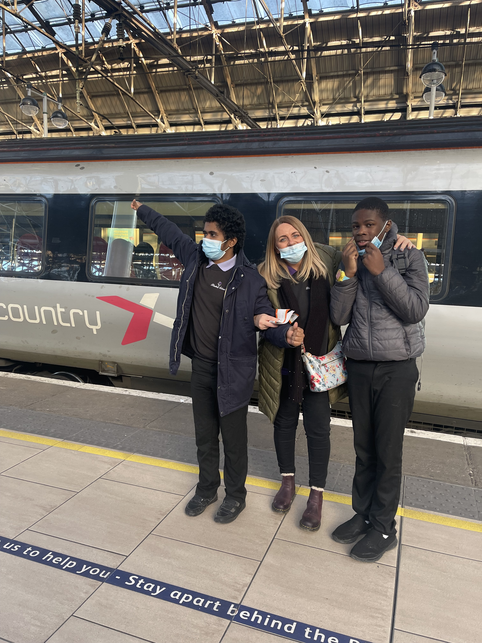
The children have had a great time during ‘Independence week, they have learnt invaluable life skills and worked beautifully as a team.
Team Doulton wish you all a very Merry Christmas and a happy new year.
Dawn, Samantha, Hayley, Andrea and Markus

This term, Class Doulton have focused on ‘Independence’ where the children have worked on independent life skills. Pupils have chosen a recipe, made a list of ingredients needed and followed the recipe to prepare and cook there chosen meal.

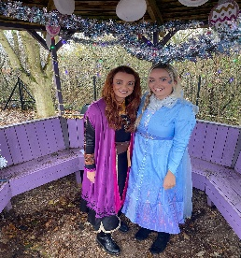
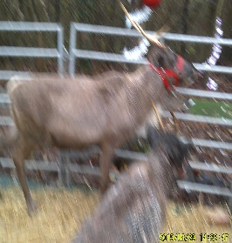

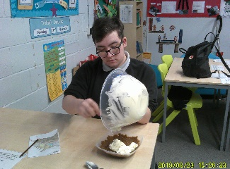

Twyford
What a great half term it has been. The class have adapted really well to not one but two new students arriving in our class this half term. The class have made these students feel very welcome and settled into the Twyford class family. We have been learning lots of interesting things within a range of different subjects on top of still showing great progress across the curriculum.

In English we have been looking at reality and appearance. We have explored a number of different texts. We started by looking at ‘Twelfth Night’ and analysed the role of different characters and explored how comedy is created during the play script. Over the last few weeks in English, pupils have enjoyed exploring the text ‘Madame Doubtfire’. We uncovered the themes deception and disguise and the impact these have on the text. In Maths this half term, we have looked at the four main operations addition, subtraction, division and multiplication. Students started off with 2 digit numbers before moving on and challenging themselves with more advanced work such as multiplying a 3 digit number with a 2 digit number. In Science we have been looking and finding out about respiration including why we breathe out carbon dioxide. We looked at what main organs are involved alongside why it’s important that we breathe in Oxygen. Students produced some lovely drawings of a pair of lungs with labelling. During the second part of the half term, students have been looking at plant and animal cells.

In Topic this half term we have been looking at the different decades between 1950 and the noughties. We looked at important events that happened during these decades, for example John Lennon from the band the Beatles was assassinated in 1980 and the space craft ‘the challenger exploded on take-off in 1986. Students were also able to design a brilliant poster/presentation on the changes in technology in the last 70 years. We saw examples of the first few mobile phones and computer products and were surprised at how much the first computer cost in 1951, which was 1.2 Million pounds! In RE we have been looking at how women have been treated differently to men within the church. We found out that up until the 1990’s the church didn’t allow women to be vicars of the church. We also found that women weren’t allowed to do other jobs within the church that men could. In PSHE we have been looking at positive family relationships and how there are many different types of families, for example a nuclear family is where there is a mother, father and children, whereas an extended family can include grandparents, aunties, uncles and cousins.

In French during autumn 2 we have been looking at money. Students were able to identify what each coin or bank note represented. Pupils were then given a number of shopping lists with some prices and they nee ded to see if they had enough money to buy each item. In PE this half term we have completed two different activities. On a Tuesday we have continued our invasion theme, with students learning skills in football and hockey. Within this we have been able to identify a number of different passes and shooting techniques. Our other PE lesson on a Friday we have carried on attending the stoke ski slope to take part in tubing. Students have really enjoyed going down the slope alongside others.

Finally, it has been another fantastic half term in class Twyford and both I and the staff team wish you a great and safe time over the Christmas holidays and we look forward to welcoming you back in the New Year.

Nathan
Twyford Class Teacher

Aynsley
Class Aynsley continue to show great resilience and effort at Bluebell School. They have displayed a mature and sensible manner around the school which has ensured a positive feel in the building and staff are very proud of their efforts.

Pupils have continued to engage in all of their core subjects, as well as vocational qualifications where two of our pupil’s attend college weekly to complete a mechanics course. In English, the class has learned about writing letters and produced autobiographies, in preparation for their English coursework. In Maths, the topics studied this half term were angles, fractions and shapes. A variety of theoretical and practical activities ensured good engagement in these lessons and added to the independent learning of each pupil.

In Science lessons pupils learned about human biology, health, disease and the development of medicines and cells, genetics, inheritance and modification. Pupils were able to demonstrate a really good understanding of these topics as well as completing some fantastic work, where they were able to create a range of displays on each topic.

The class are all continuing to work through their BTEC qualifications and Topic modules, this has allowed class members to study subjects that suit their particular interests and allowed some pupils to spend time off-site in a one day a week college setting.

We very recently took part in an Independence Study week, where pupils took part in a range of activities, both in school and off-site, to promote the development of skills to support Independence. Pupils thoroughly enjoyed this week and really engaged in the activities, which included a surprise whole school visit to the pantomime.

Staff continue to be impressed with the pupils in class Aynsley and the mature attitude that the pupils are displaying in ever challenging circumstances. We wish everyone in Aynsley a Merry Christmas and a Happy New Year.

Rob O’Sullivan
Aynsley class teacher

Coalport
Coalport Newsletter
During this term Class Coalport have spent time focusing on ‘Independence’ and developing their independent life skills. The students caught a train to Crewe to purchase ingredients to prepare a three course meal of their choice.

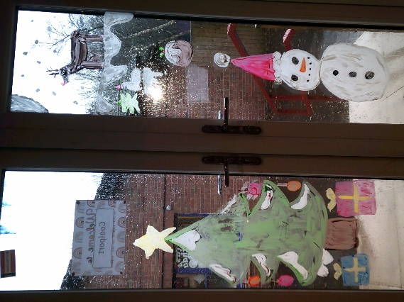
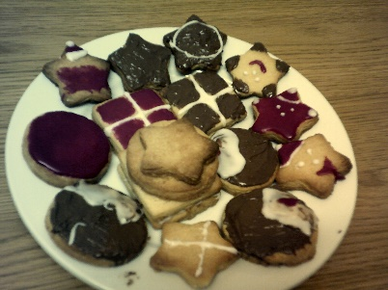
For the run up to Christmas we have enjoyed lots of festive activities. We visited the local theatre to watch the pantomime ‘Treasure Island’, which all the students really enjoyed. We also had a visit from reindeers and had fun decorating our classroom with festive decorations.
Myself and all the staff from Coalport would like to wish you a very merry Christmas and look forward to welcoming you back in the New Year.
Rebecca (Coalport class teacher)
In English our Year 10 students have continued working on Macbeth, and our Year 11 students have been completing past exam papers in preparation for their Igcse exams next year. In Science, students have enjoyed studying neurons and mitosis, and in Maths students have been learning about scatter graphs and frequency tables.

