Newsletter

The start of a new academic year is often filled with both excitement and apprehension; a time of reflection about past successes and consideration of our future goals.
For us all at Bluebell, the start of this academic year has been particularly filled with hope and anticipation for the fresh challenges that we face.
Staff and students have worked tirelessly during the first half-term and I am sure that you will agree, have completed a range of outstanding work. Students have made an excellent start to this academic year and we are all really proud of their efforts.
We have participated in many National events such as; National Fitness Day, European Day of Languages, Dyslexia Awareness week, National Poetry Day and many more.
It would be remise of me not to mention the unprecedented and unfamiliar times that we are currently living in as we continue to fight COVID-19 and it has not been the way that we wanted to end the half-term. However, the safety of students and staff remains our highest priority.
I would like to thank all parents / carers for your unwavering support and understanding in such difficult circumstances. At Bluebell School we are a family and the triangulation of support between pupils, staff and parents / carers will ensure that all of our pupils flourish in these challenging times.
My door is always open to parents / carers and I welcome an open dialogue so please feel free to contact me on 01782 897012 or cbarker@bluebellschool.co.uk should you wish to discuss anything.

At Bluebell School we have 4 key learning intentions for all pupils.
Intention 1 Maximise behaviour and skills for learning. Pupils will want to learn and have the skills to learn.

Intention 2 Reach full academic potential. Pupils will develop appropriate knowledge, skills and understanding enabling them achieve to the best of their ability academically, creatively and physically.

Intention 3 Rebuild and nurture Pupils will be rehabilitated, enabling them to develop self-worth, a positive identity, confidence and contentment.

Intention 4 Prepare to make a positive contribution to the advancement of British society. Pupils will leave the school to engage in further meaningful study or employment. They will be community-spirited, respectful, law-abiding young citizens in full support of democracy and individual liberty.

Finally, at Bluebell School we strive for continual improvement and we believe that pupil voice should be the loudest in the school.
As a result we will be undertaking a number of exciting improvements during the year:
• We have completed a student survey asking pupils what they would like to have inside and outside to enhance their experience and have ordered equipment based on pupil requests.
• We have renovated the Sports Hall and created a new classroom that looks amazing.
• We have opened our school for 6th Form students for the first time.
• We are now offering an even more broad range of qualifications for students, based on student voice and qualifications that students have asked to study.
• We have begun to undertake exciting trips, where restrictions have allowed.
Wishing you all a very happy and safe half-term. We look forward to seeing you all on Monday 1st November.
Kind Regards

Craig Barker
Headteacher

Minton
Minton class have had a great start to the year! All children have settled beautifully into their new class and have made positive relationships with both staff and their peers. I am so proud of the determination the children have shown with all of their work and activities and cannot wait to see what is yet to come!

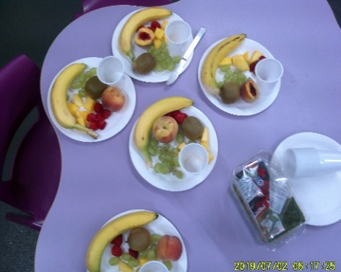
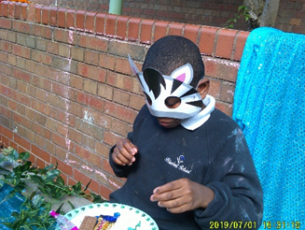
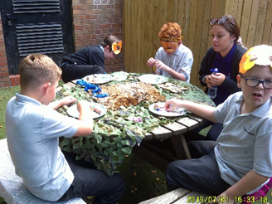

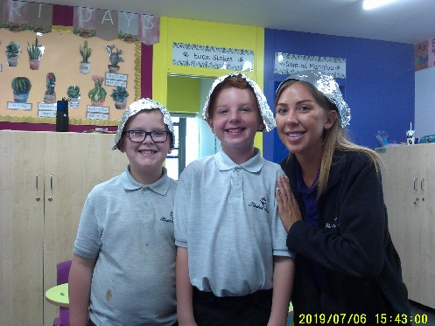
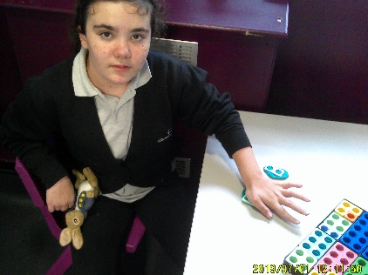
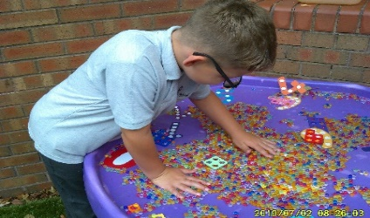
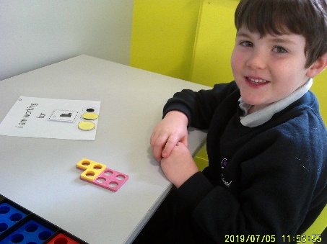
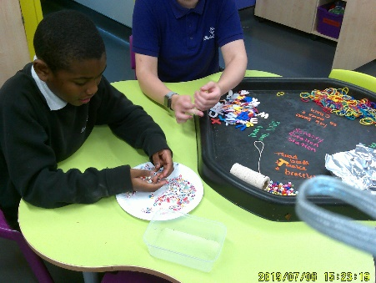
Class Minton had a great afternoon using different sensory materials! There were many different activities for the children to participate in, such as foam, orbs, elastic bands, creating their own sensory bags using glitter and slime and some children used the tin foil to create their own foil hats and glasses!

The children in Minton thoroughly enjoyed having a jungle tea party based around our new topic Africa! All children created their own African animal masks and even decorated our outside area to resemble a jungle! Children loved tasting the different exotic fruits from our new story ‘Handa’s Surprise’ and then finished off with our favourite biscuits!

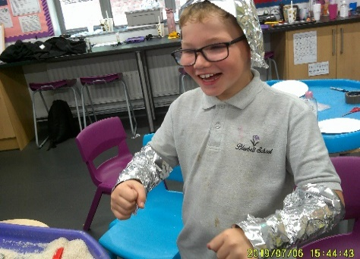
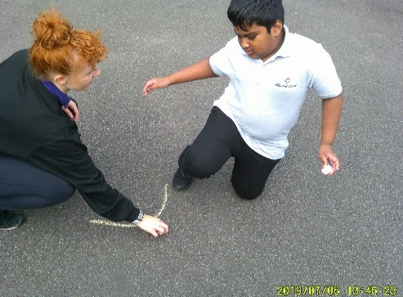
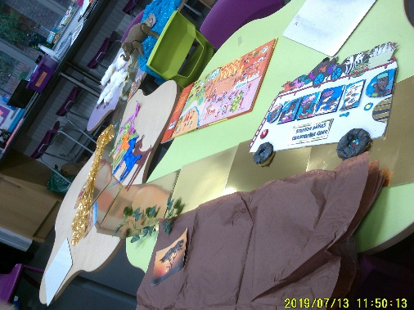
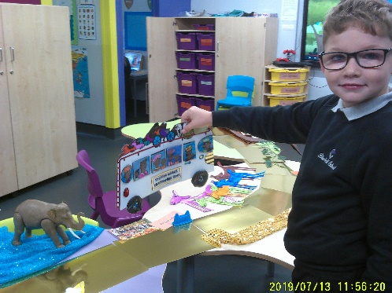
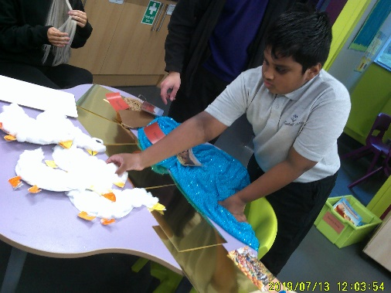
For English, children have been taking part in lots of fabulous activities! We have started looking at a new book called ‘The Bobo Road,’ and children had a great afternoon participating in a sensory story where they had to find the different parts of the story and had opportunities to feel the different animals and ride on a bus!

During maths, the children have been exploring a range of key skills. Some children have looked at the different numicon and have been completing different activities with them; some have been using the greater than and less than symbols with different resources such as cubes and number rods. Finally, some have been exploring different times tables and using numicon to help them!

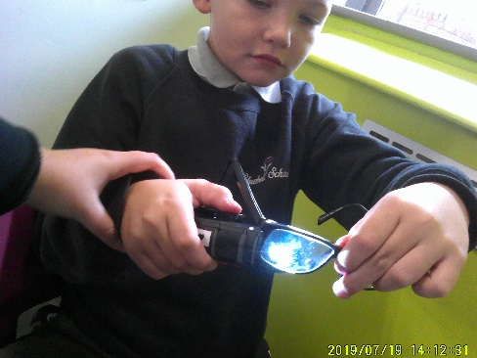
In Science, children had great fun exploring light and dark! Children looked at their shadows throughout the day to see how they had changed and how they could make different shaped shadows in the dark using a torch and their hands! Children then finished off the half term by looking at transparent, translucent and opaque objects, finding different objects around our classroom and school to test with the torch.

A big well done to class Minton for all their hard work and efforts this term. The staff team and I hope you have a fantastic half term break. We look forward to welcoming you back in November.
Abbey & Josie

Beswick
Class Beswick have had an exceptionally positive half term. We have been very busy exploring our exciting topics with a sensory/hands on approach to our learning. Look at some of the fun we have had while participating in learning…
During our maths lessons, we have been looking at number facts. Children have enjoyed the hands-on approach within the classroom, such as Numicon number hunts, grouping Numicon and other objects within the room. We have also been developing our life skills by handling money at the shops and during role-play opportunities. The children have also been practicing time within the timetable throughout the day.
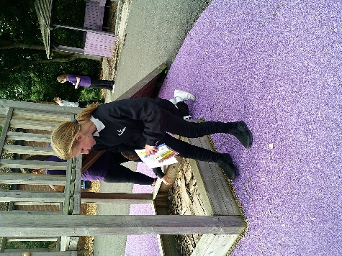
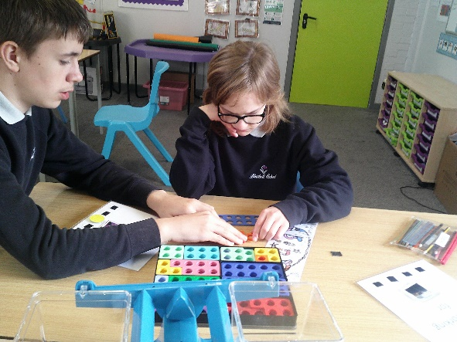
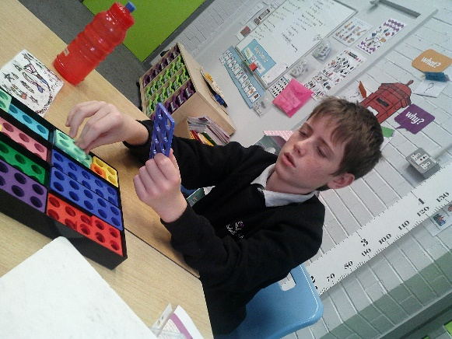

Within the Autumn term in English, we have started to look at a new Step Up project called Have Your Say. This has included lots of work on formal writing and communication, such as letters and emails. Class Beswick have been working on their formal writing skills throughout this half term. They have completed lots of wonderful work in regards to this such as focusing on what types of communication they can use formally and informally. Within the next half term, the children will progress their skills even further to plan and write their own formal letter of complaint.

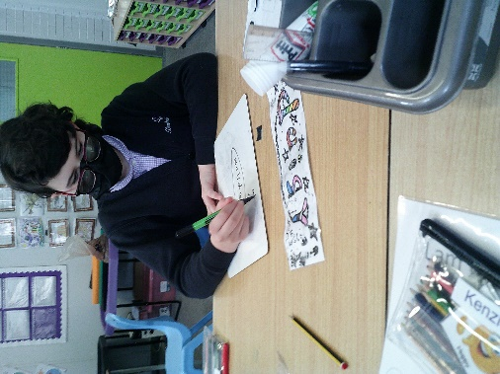
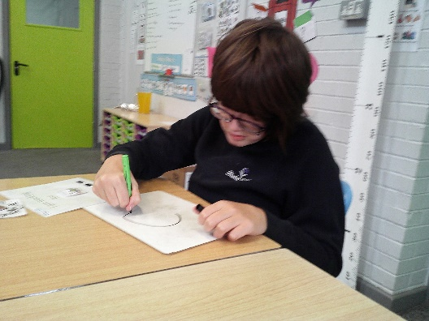
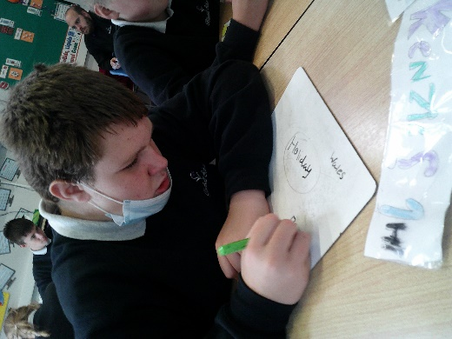

Within our science lessons we have continued with the previous topic of solids, liquids and gases. However, within this half term the children are now developing their scientific knowledge and skills even further by looking deeper at separating different solids and liquids from one another, for example, how the filtration process works. Class Beswick have been exploring this topic with a hands-on sensory approach to deepen their scientific understanding and knowledge. We have started to complete lots of practical investigations, such as filtration within the classroom. The children are very enthusiastic about this topic and are looking forward to continue with their learning within the next half term.

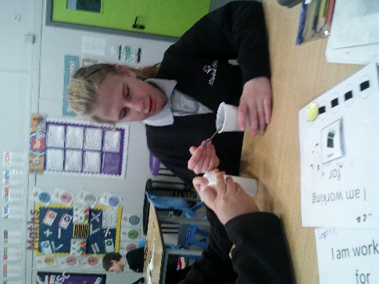
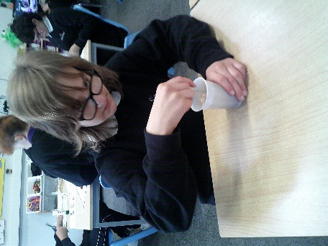
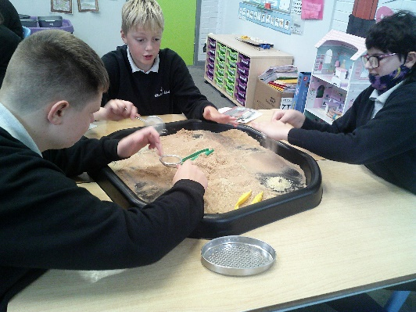

Dudson

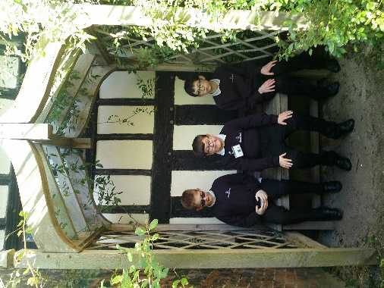
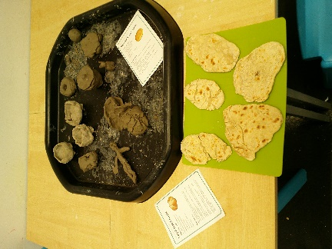
What a busy start to the school year we have had! We have enjoyed exploring our topic of ‘Peasants’. The children have all followed traditional cooking recipes, made clay pots to store ingredients in and explored a real house from the Middle Ages to compare to the present day.
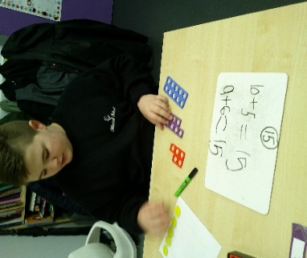
During our English lessons, some of us have been completing activities based around the story ‘All aboard for the Bobo Road’. Others have been looking at communication and have completed tasks, learning how to make a complaint letter.
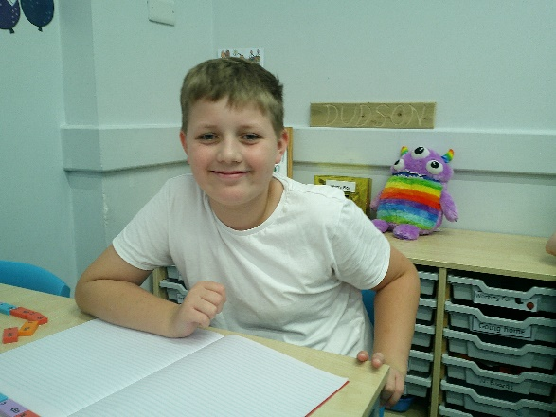
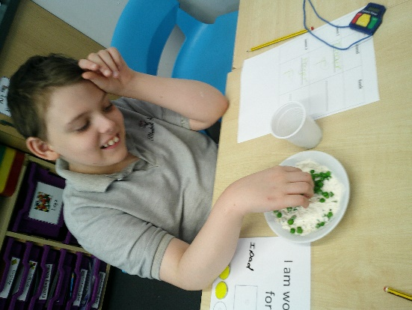
In Science, some of us have been exploring light, day, night and shadows, whilst others have been taking part in experiments based on separation and filtration.
In Maths, pupils have been working hard finding combinations of numbers up to 20 whilst the others have been rounding numbers up or down to the nearest multiple of 10.
We have also enjoyed spending time in the local community, woodland walks and weekly swimming sessions.
Well done to all of Class Dudson for a fantastic Autumn term so far!

Wade -
Class Wade had a lovely start to the new school year and have settled into their new class really well. We have taken part in lots of activities and had lots of fun whilst we learn!

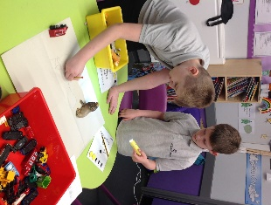
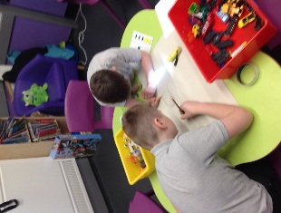
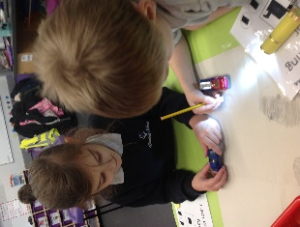
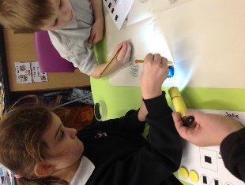
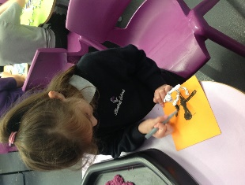
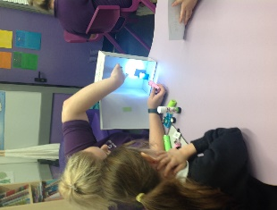
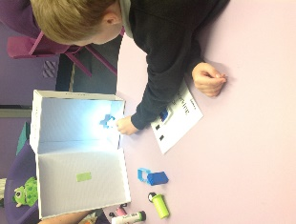
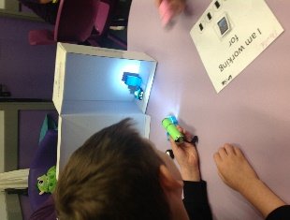
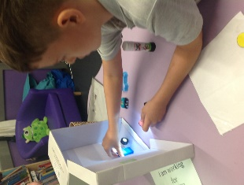
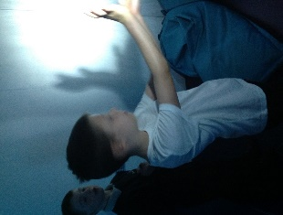
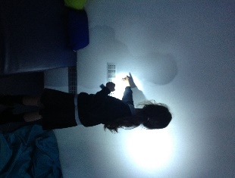
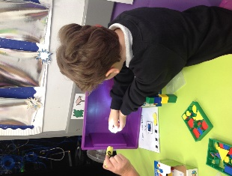
In Science, we have been looking at light and shadows. We have had lots of fun exploring light and manipulating shadows. We have taken part in many activities to begin to understand how and why shadows form and have even created some shadow figures for our display!

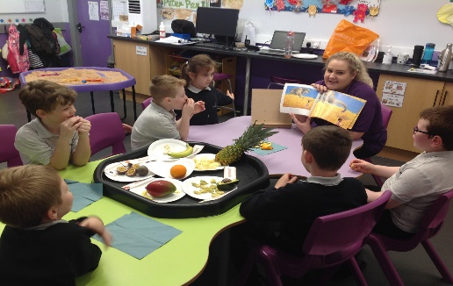
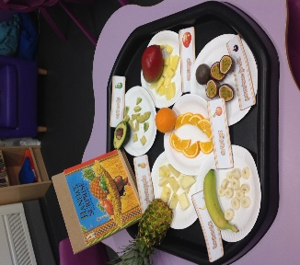
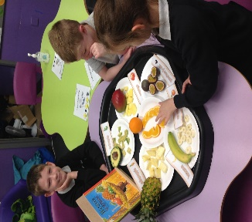
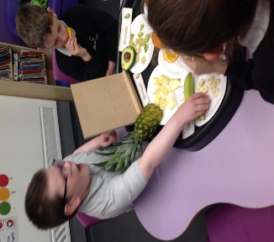
During English we have looked closely at two stories in particular this half term; Hand’s Surprise and All Aboard for the Bobo Road’. All children participated well in the food tasting activities whilst reading Handa’s surprise. This enabled us to begin to describe the fruits using real experiences. We also enjoyed exploring our local community through a fun bus journey to Packmoor. Using this experience, we were able to compare our community to the African community from our book (All aboard for the Bobo Road).

In Topic, we have really enjoyed our new area of focus ‘Benin Africa’. We began the term looking at where Africa is in the world and some of the traditional aspects associated with Africa. We then moved on to focus on art and design technology. We looked at the history of Benin Africa and created some sketches of the Oba from the Benin kingdom. We also created our own mask and clay leopard statues, which are all proudly presented on our display board in the classroom!
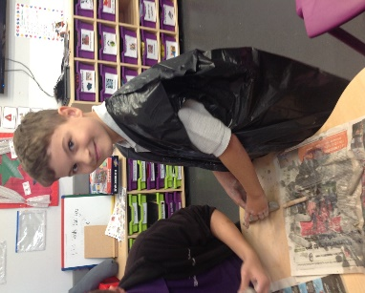
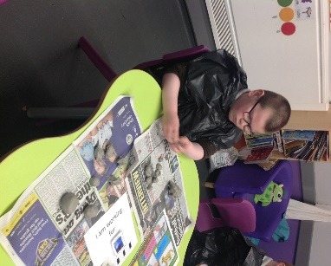
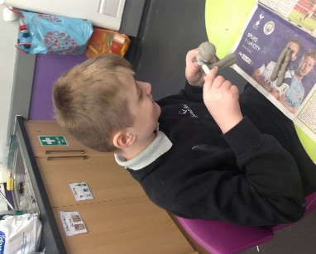
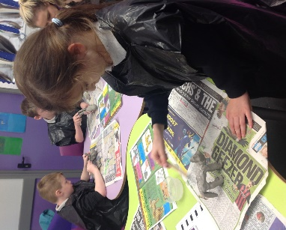
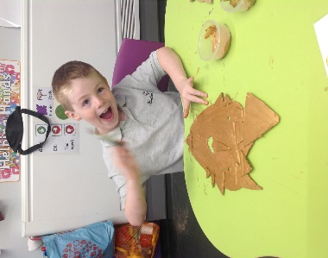
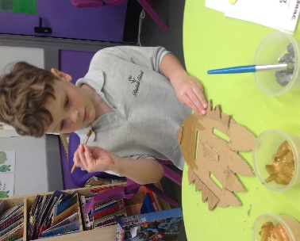
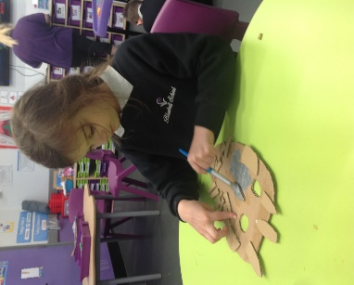
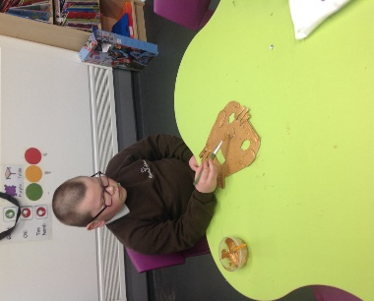

During Maths, we have built on many key skills using the Numicon to support. Some of us have been further exploring the numicon in order to develop of number knowledge and some of us have been using greater than and less than symbols using a range of resources such as, numicon, number rods, multi-link cubes and objects from around the classroom, in order to compare size. Others have been using the numicon to support with addition, subtraction and counting and some of us have been looking at grouping numbers, focusing on grouping objects into 10’s.

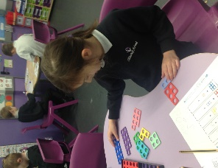
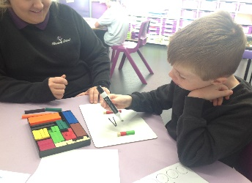
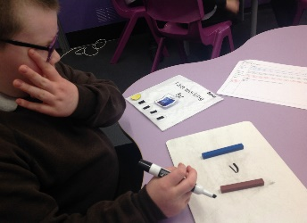
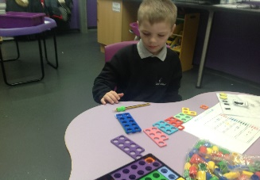
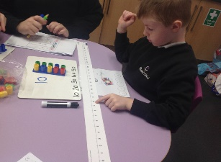
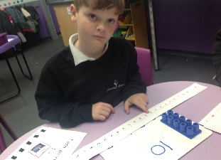
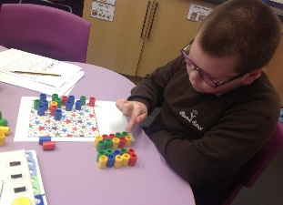
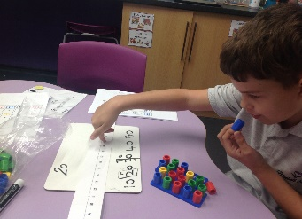

We have enjoyed participating in our diversity and health and wellbeing work this term and have taken part in many activities in order to understand different areas of focus. We particularly enjoyed learning about first aid, celebrating Roald Dahl day and participating in our own vote to nominate our school council member, where Jack won the votes of his classmates and now represents class Wade in the school council, well done Jack!

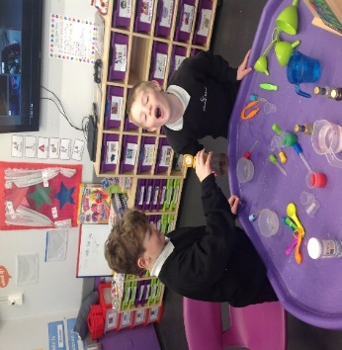
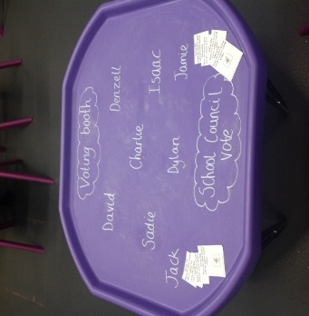
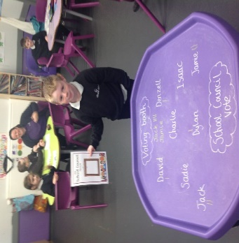
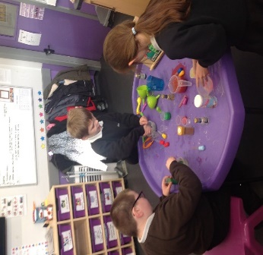
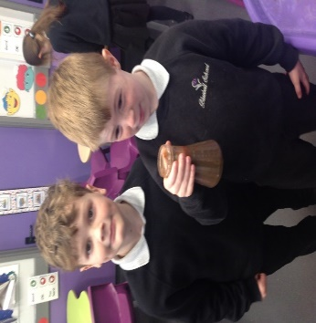
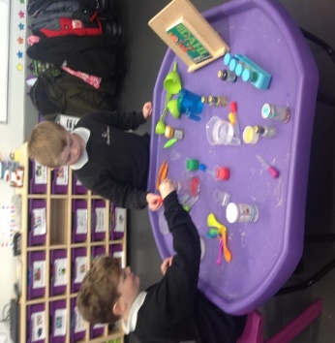

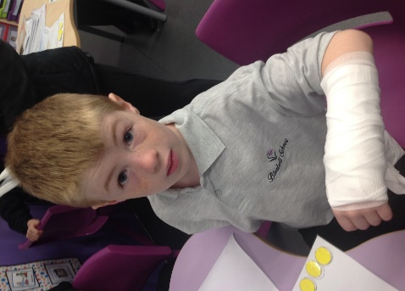

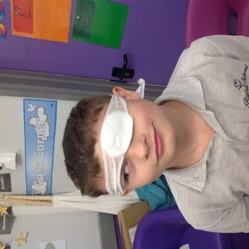

We would like to wish you all a lovely half term break and look forward to seeing the children back in school in the new half term!

Moorcroft
In Maths this half term, the children have covered a range of different topics. We have been spending extra time using Numicon to support learning. Some of the children have been using the Numicon to create pictures and some have been demonstrating their understanding of symmetry.
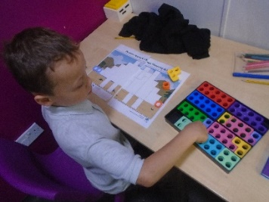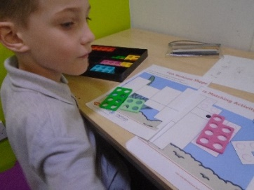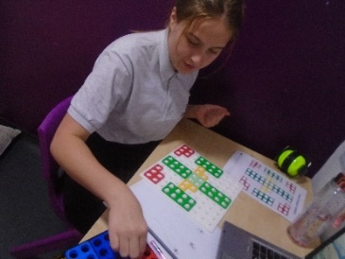
In Science, we have covered a range of topics. One being electricity, where the children have been able to identify the difference between mains electric and battery operated. They then moved onto looking at how circuits work and created their own. We also completed an experiment to see if we could increase the brightness of a light bulb by increasing the amount of electricity in the circuit.
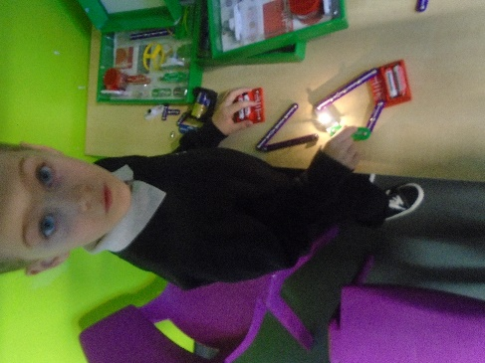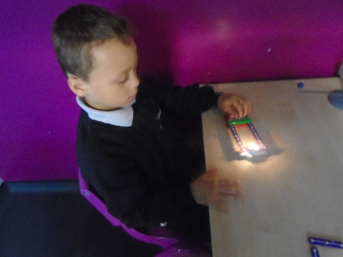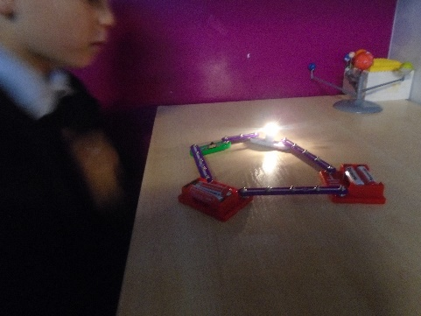
Some of the children have been looking at nutrition and the importance of having a balanced diet. We have been looking at foods that the children eat and identified the different nutrients in each food to determine whether they are good or bad for us.
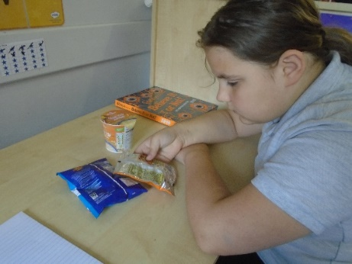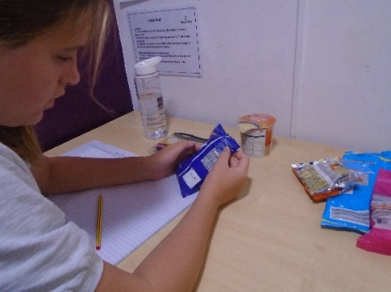
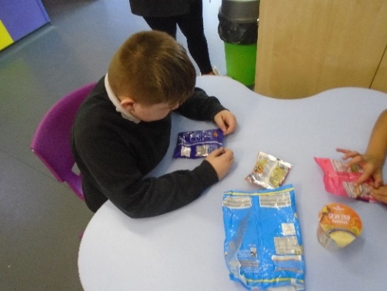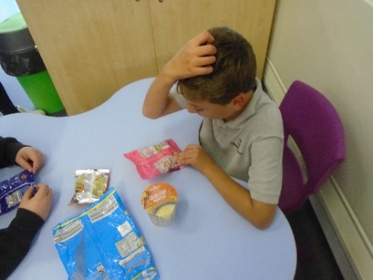

The children have really enjoyed PE this term, specifically gymnastics. We have been able to use different gymnastic equipment as well as learning different floor moves. The children have used this time to also help their peers develop their gymnastic skills by teaching and encouraging each other.

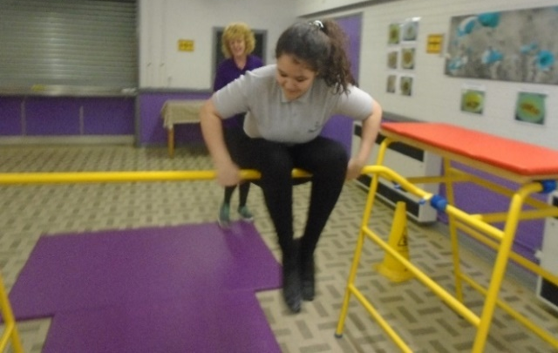
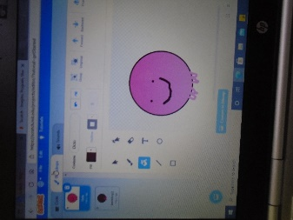
The Key Stage 2 children have been designing their own toys throughout this half term. They began by drawing their designs which included an input and an output. From this, they then used ‘Scratch’ to design their toy in more detail and then add their inputs and sounds to their toys.
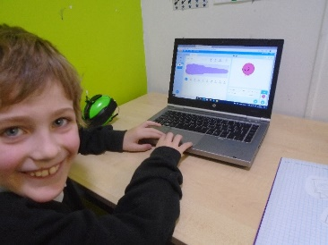

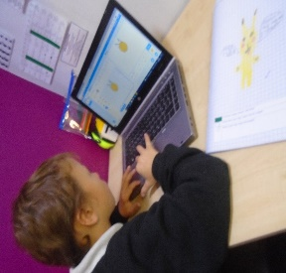

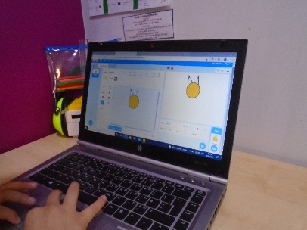

Spode

What a great first half term we have had back at school! The children have all settled well into their new class and they are creating great relationships with both staff and their peers. The children are all working extremely hard within their academic lessons and towards their individual targets.
In maths this term we have explored a range of different topics. The children have learnt about shapes, focusing on the names of basic 2D and 3D shapes and learning to be able to identify the properties of given shapes. During our next focus we explored symmetry and finding a half or quarter of a range of different shapes. The children really enjoyed partaking in a range of practical activities to develop their learning. During our main focus of the half term we have developed our understanding of a range of different addition methods. The children focused on appropriate methods to stretch and challenge them even further.
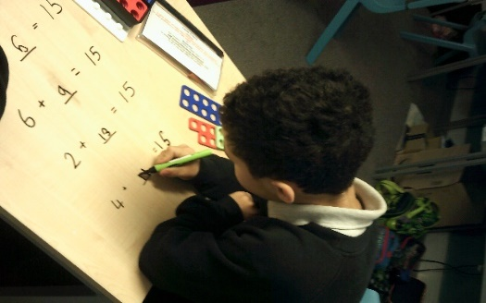
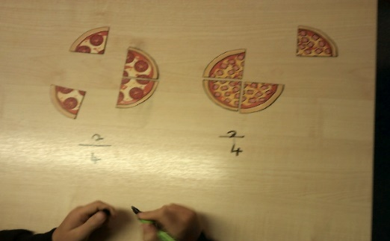

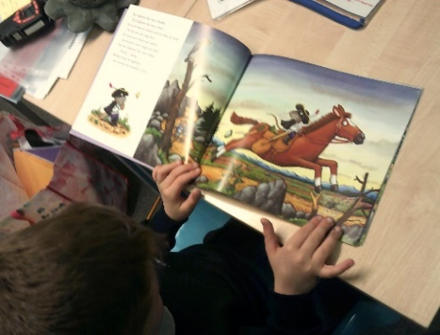
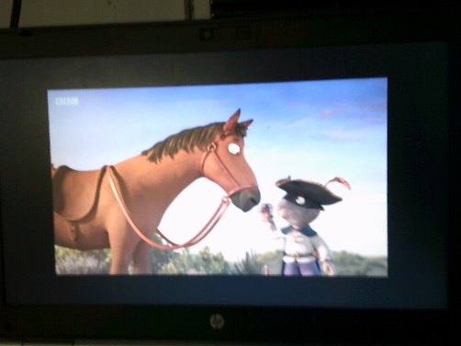
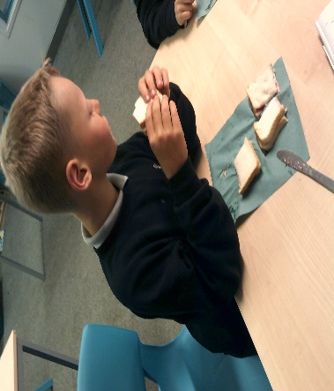
In our English lessons this term, we started by focusing on instructions and explanation texts where the children discovered the features used within both types of writing. They then looked at a range of classroom items and things we see in daily life to identify where we would see and find instructions. The children stated the purpose of instructions and how they help and what they are used for. The children finished this topic by writing their own set of instructions and then followed them to make a jam sandwich. During the second half of the term we have explored narrative stories where we have focused on The Highway Rat. During this topic the children have completed some amazing work. The children really enjoyed creating a wanted poster for the rat and have used some great language choices.
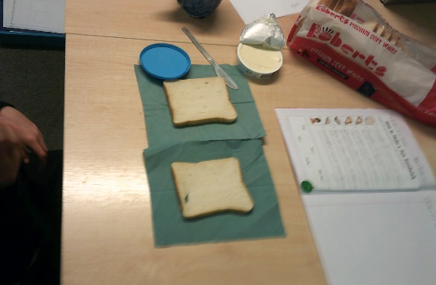

In science this term we have completed a large amount of practical work which the children have really enjoyed. Our topic for the term has been electricity, we began the term by looking at safety around electricity the children created some great posters. We then moved on to learn about circuits looking at the circuit symbols and how to draw a circuit. The children then used our circuit kits to great effective complete circuits which lead to our next focus of conducting and insulating materials. The children practically tested the materials within a circuit to see if it completes or breaks the circuit.
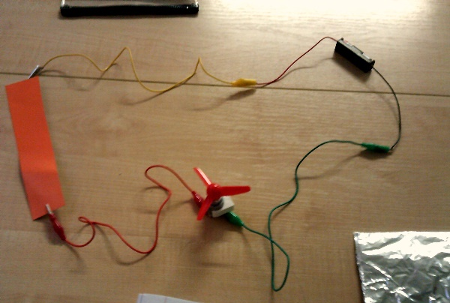
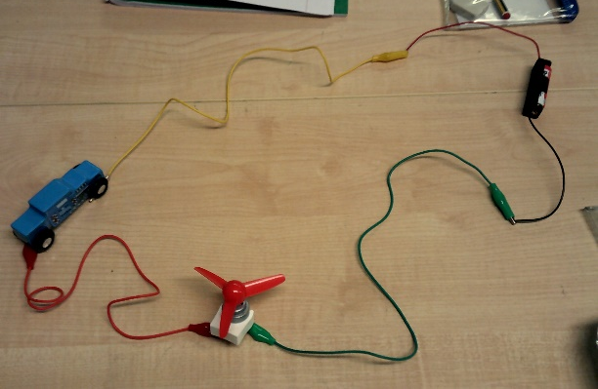

The children have engaged well in all other academic subjects and have really enjoyed our topics. The children have also completed some amazing work for our diversity events throughout the term.
We have had a great half term and I can’t wait to welcome the children back in November to continue some exciting topics and for the children to continue to grow and develop.

Have a lovely half term and a much needed break.

Charlotte and class team

Middleton
Class Middleton started the term with a vote for our new school council member. Drum roll please………….. Tom became are new school council member. Well done Tom!
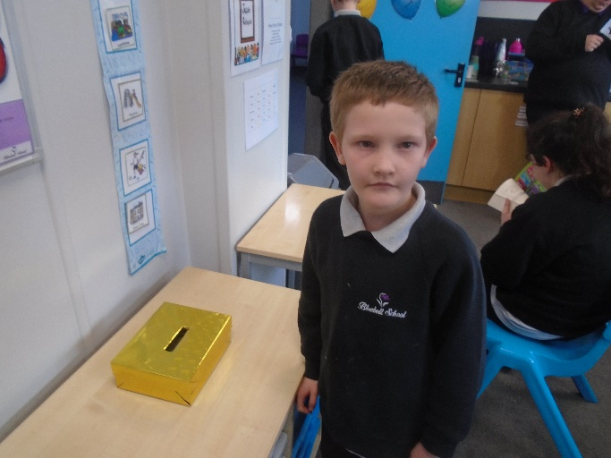

In Middleton’s Maths lessons, children have enjoyed exploring the Numicon. They have been able to use Numicon to help count, add and subtract.

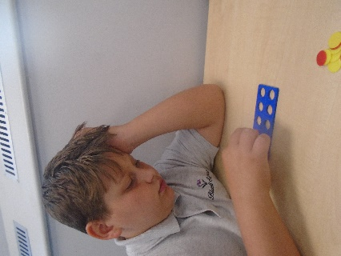
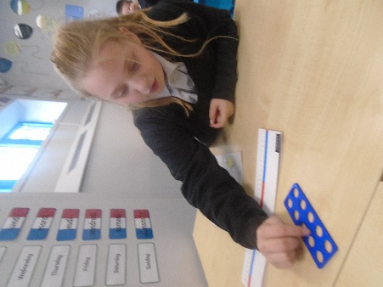

In Science, children have enjoyed exploring light. They have had fun making different shadows and seeing how they change during the day. They were able to use torches to help them read in a tent that we created from blankets.
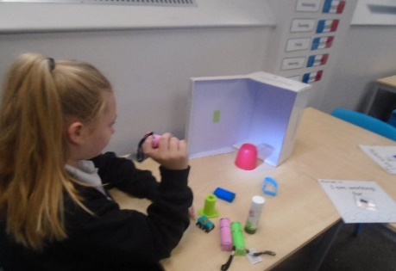
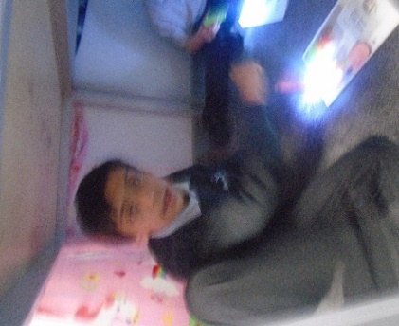
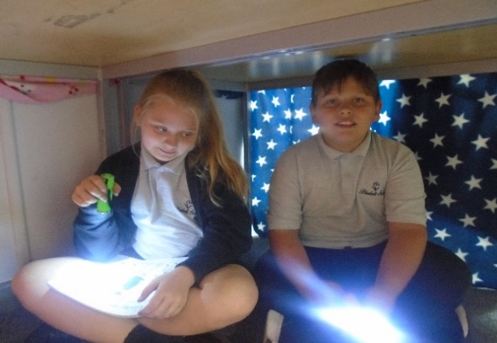

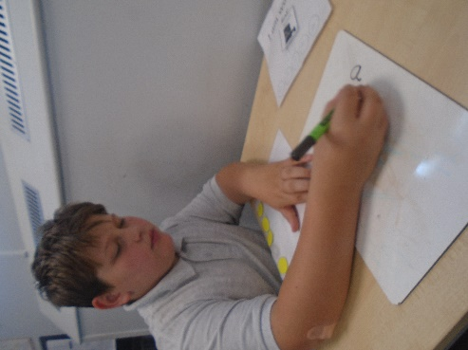
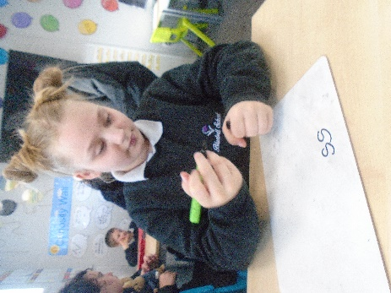
In English, children have enjoyed looking at tales from Africa. They started by reading Handa’s surprise and enjoyed tasting all the different fruits from within the story. They have been working very hard to improve their handwriting skills.

In ICT, the class have looked at how we can communicate without using words. Children had a great time directing their peers around the playground using symbols.
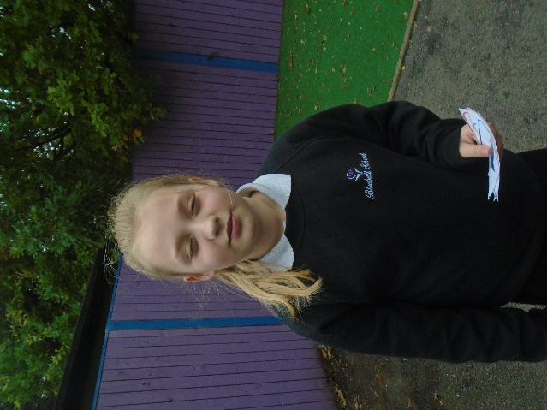
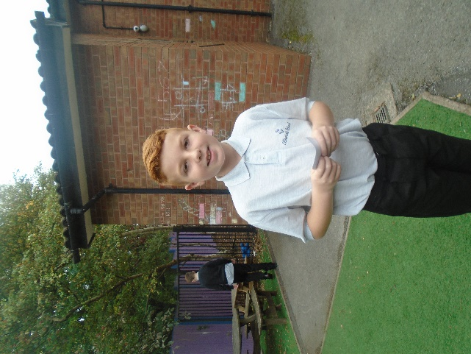

In Topic, children have looked at artwork from Africa. Children had great fun creating their own Africa mask and their own leopard statues.

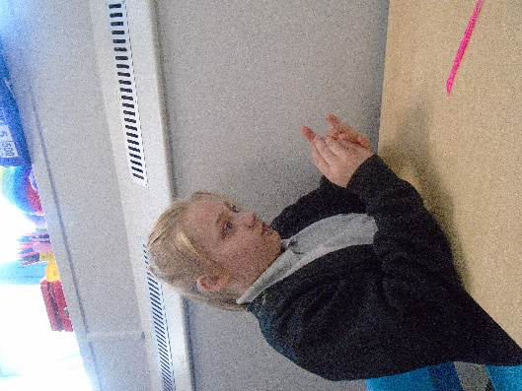
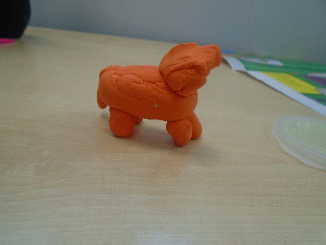

All staff would like to thank children for their hard work this term! We wish children an amazing half term break and will see them in November!

Wedgwood
English
During the Autumn term in English, the children have been enjoying their read, write inc. lessons. They have practised their sounds using playdough and air writing. The children have received lots of Fred frog stickers and we have also explored lots of books as a class, including ‘Peace at Last’ and ‘The tiger who came to tea’. The children have planned their own tiger’s tea party and wrote out party invitations for their friends and created characters from the story. The children took part in a sound walk and used their imagination to think of different places that Mr Bear could go to sleep.

Maths
During the autumn term in maths, we have explored numicon and created number lines using playdough and paint. We have used number rods to compare sizes and recognised which sizes were the longest and shortest. We have also used conkers for threading and created our own conker number tree in the classroom.

Science
In science we have explored lots of different materials and discovered materials and their properties. We have carried out many experiments this term that involved the children making predictions. We have made teddy an umbrella to keep him dry during our science lesson and then tested it out using pipettes and water. The children had so much fun creating a protective case for an egg in preparation for carrying out the egg experiment. The children had to drop their egg from a height to test to see if their creation had worked!

Topic
During Topic, the children have been learning about the great fire of London. We have shared stories and the children have created their own fire scenes using lots of different materials. The children have enjoyed making their own Tudor houses using cardboard boxes and straws. We have been on walks around the area to see what materials the buildings are made from and also created a display all about the great fire of London in the classroom.

Class Wedgwood have had a fantastic start to the year this term. We have loved welcoming James and Junior as new children into the class. James and Junior have both settled well and are great new additions to class Wedgwood. We are having a super time doing horse riding and are looking forward to the second half of the term.
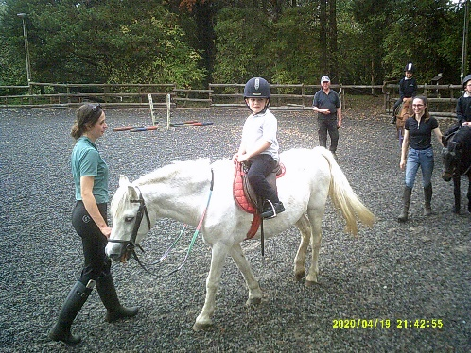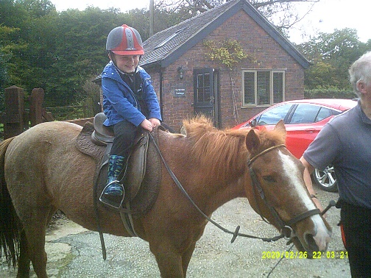

Steelite
Over the last few weeks, we have been learning all about the Victorians. We have also discovered Queen Victoria and her reign.

The children have especially enjoyed looking at the significant inventions from the Victorian era. We looked what life was like for the poor and then compared life against the rich and wealthy.
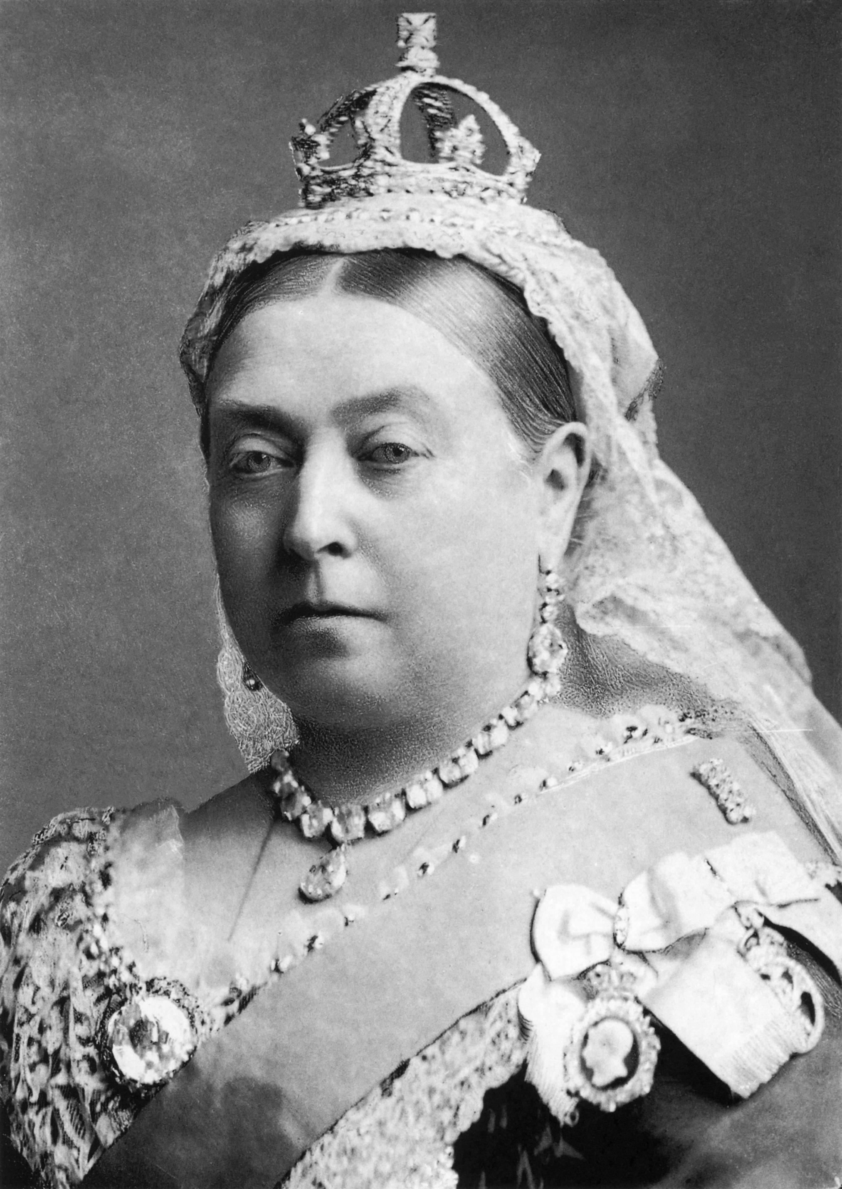

Steelite demonstrated a keen interest in the railways and how it has affected the landscape. The also looked at noise pollution and the loss of land.

Topic
Maths
in maths, we have been working on estimating. we have also worked on finding pairs to ten and place value. class Steelite have used different strategies including column and compound to work out a variety of sums. Numicon has also been used to assist pupils in working out a range of number problems.

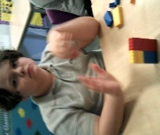

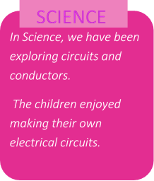
English
Steelite have been learning about instructions, listening to and explaining their own to others in the class. the children have ALSO ENJOYED LEARNING ABOUT the narrative poem ‘The highway man’, where we particularly enjoyed creating work for our display.
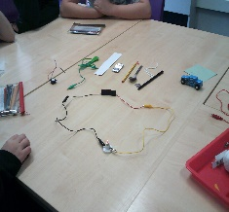

Steelite have settled in beautifully they have had a brilliant term. The children have all produced some excellent work and shown real enthusiasm. It has been a joy to teach the many topics we have covered. I wish them a lovely break and look forward to welcoming them back.

Churchill
Churchill class have had a brilliant start to the year. It has been great to build friendships with new classmates and work towards new targets.
In Science, Churchill class have explored ‘Nutrition’. We have investigated why we need nutrients, how they are used by the body and the main nutrients present in different foods. Pupils have enjoyed completing lots of practical activities.

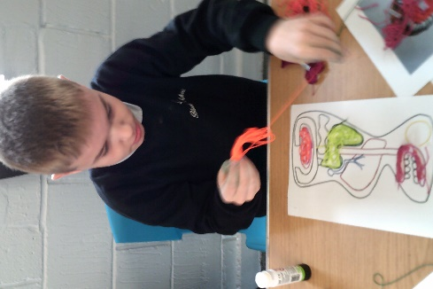
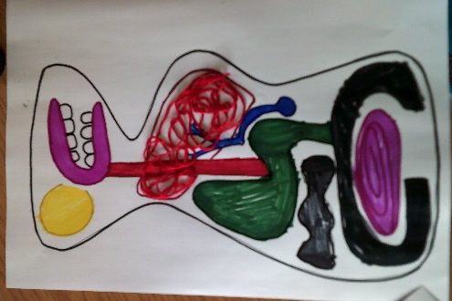
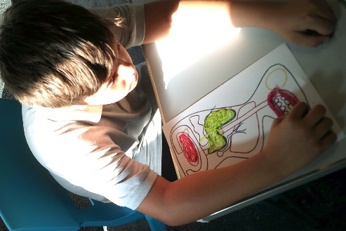

During our Topic sessions Churchill class have explored the population distribution and growth. We have explored highly populated places and the impact of this. We have also been developing our ability to locate different countries and build our knowledge of these places. We have enjoyed exploring these locations using globes and Google Earth. Pupils worked extremely hard to create a display which shows key things you can find in urban areas.
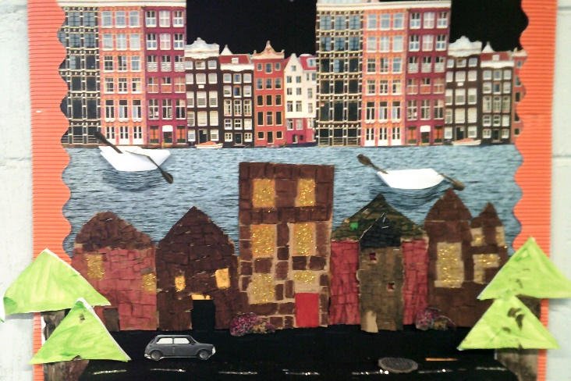
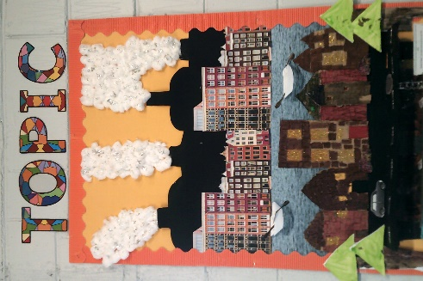

During our English sessions, we began by exploring biographies and autobiographies. Pupils can now confidently identify the differences between them and their key features. We then went on to look at how relationships are portrayed in different texts and have produced some excellent analyses.

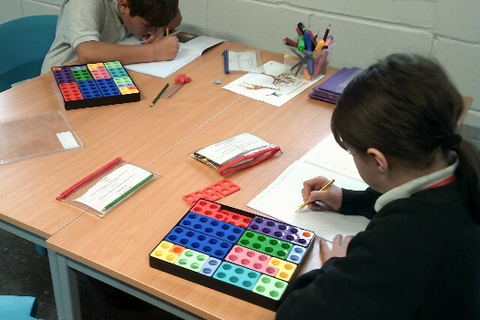
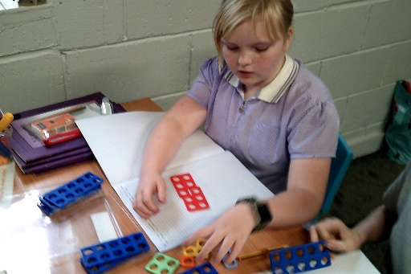
In Maths we have mastered place value, addition and subtraction. We have also spent time working on multiplication and division. The class particularly enjoyed working on shape, identifying properties and creating our own polygons.
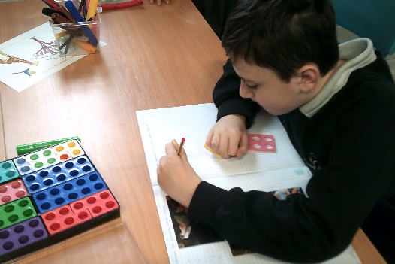
A highlight of this half term has been our PE lessons. The class have developed skills required to send and receive and have transferred these skills into different team games.
Throughout this half term, Churchill class have impressed us with their ability to identify positive thoughts, write them down and share them with class members.
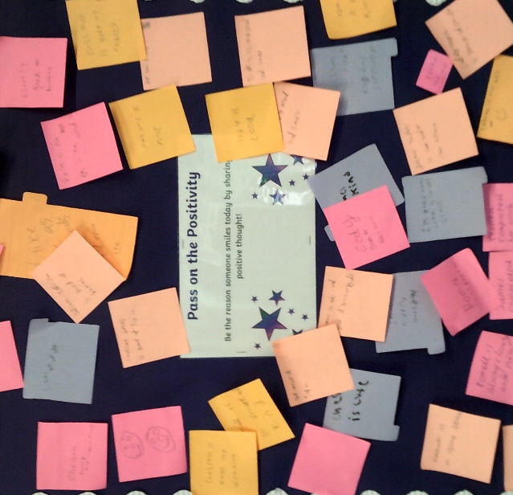

Well done for all your hard work Churchill class. Have a lovely break and we look forward to seeing you after half term for lots more fun!

Lauren and the Churchill team

Doulton
Over the last few weeks we have been learning all about how to behave appropriately in the community and went out to buy our own hygiene products.
During enrichment we have also visited a local café and ordered our own food. We have also made our own tea and toast in school. As part of our diversity work as a class we have been practicing our first aid skills.
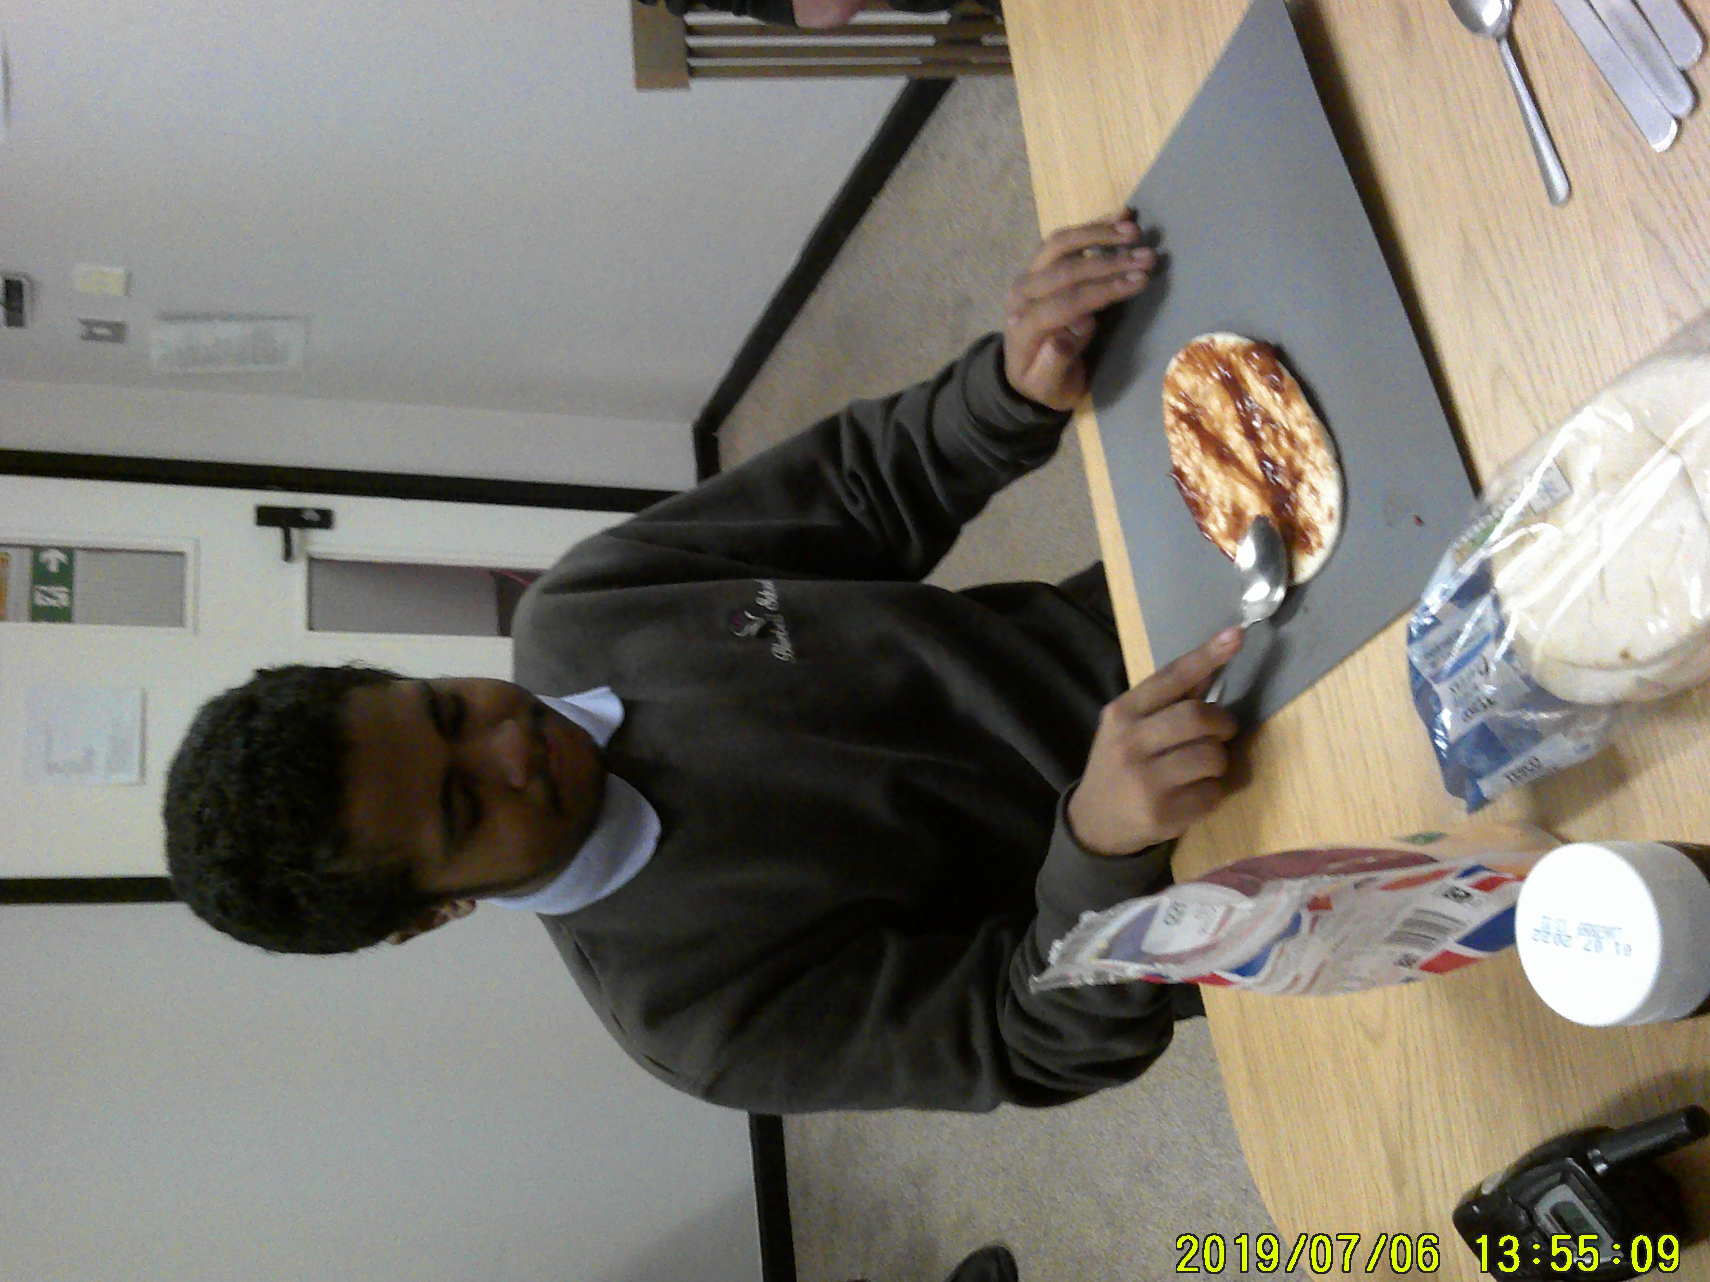
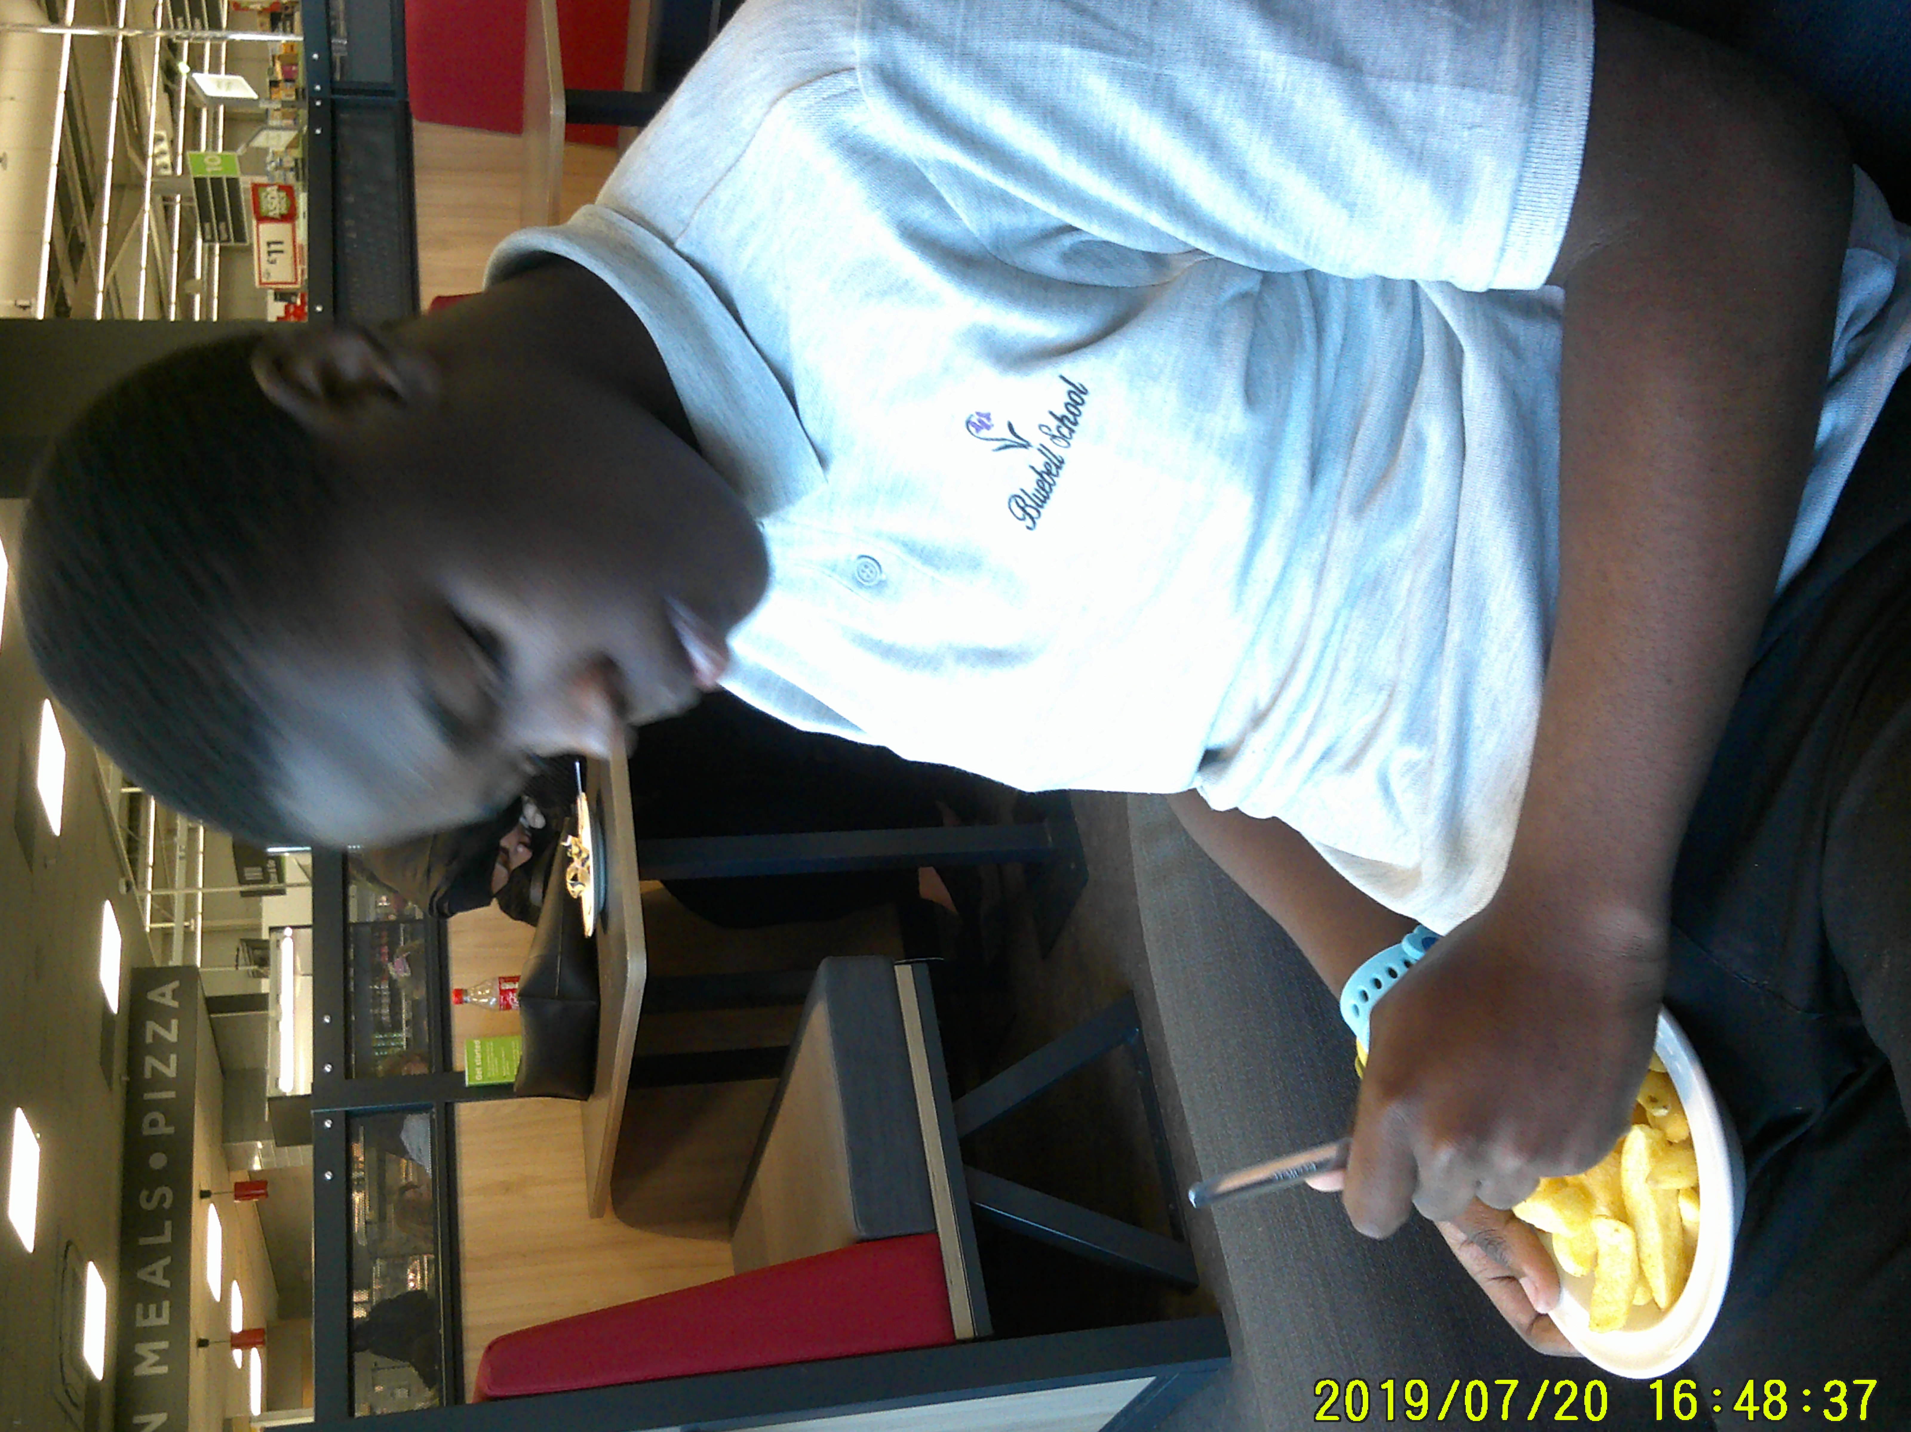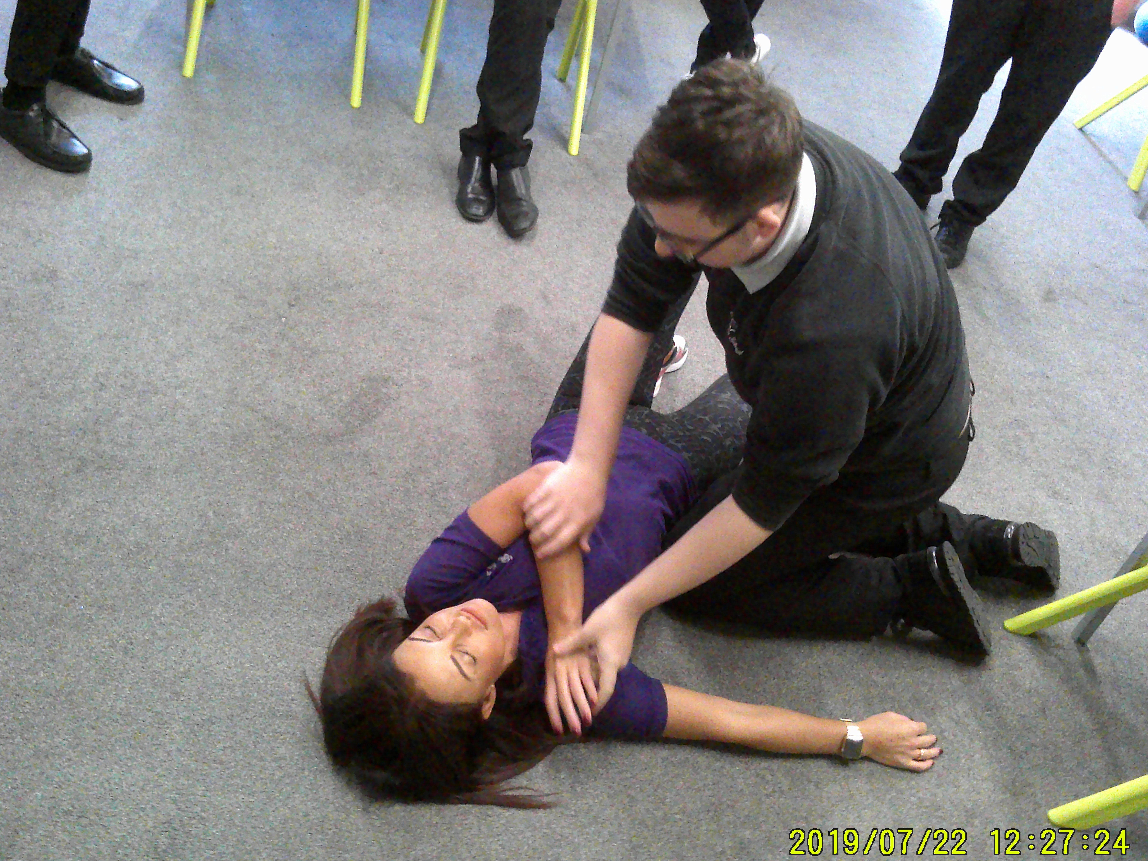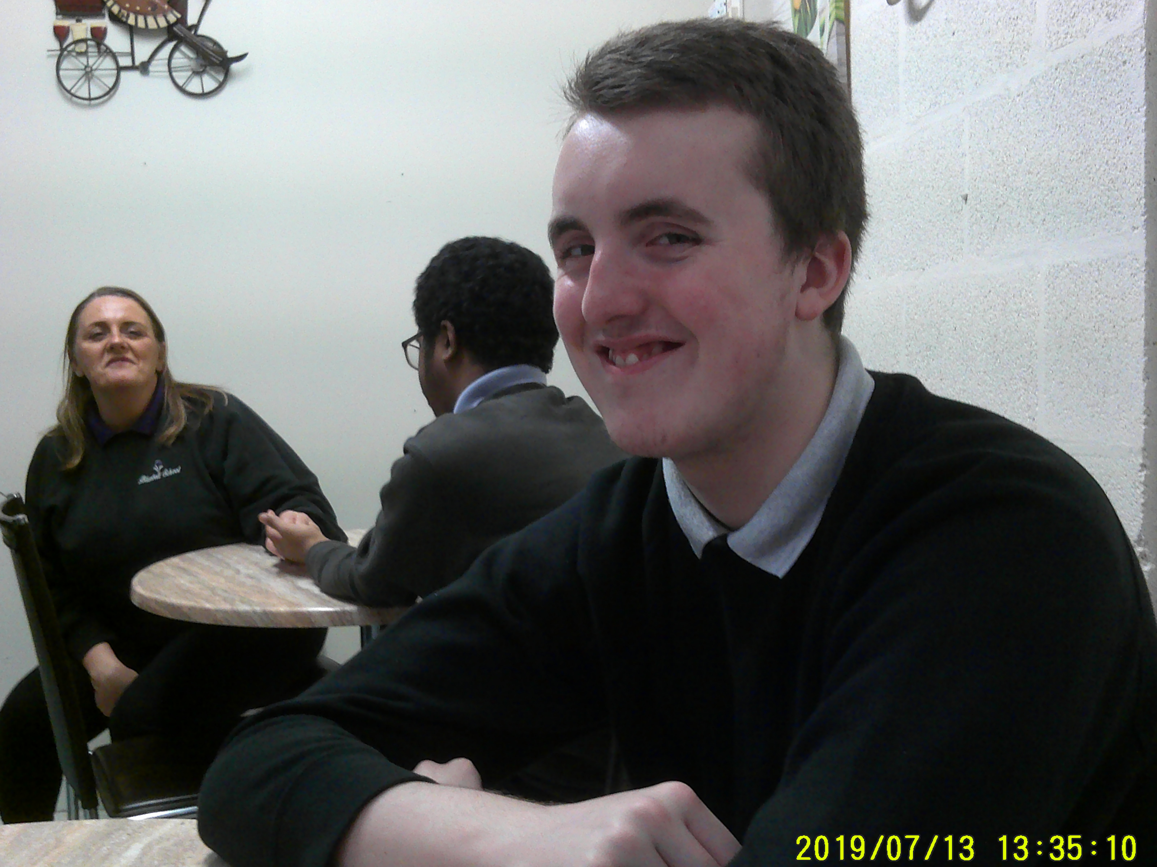
ENRICHMENT
Maths
in maths we have been working on order of operations, multiplication and multiplying decimals. we have also used our knowledge to complete multiplication sentences.

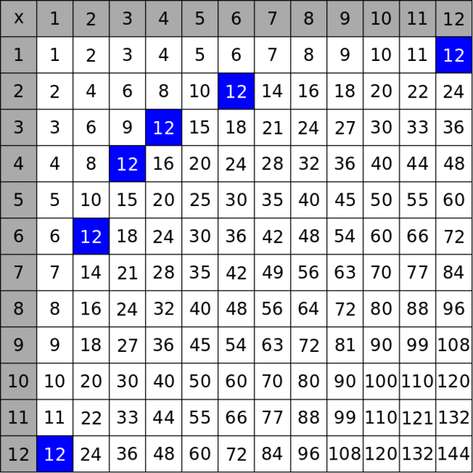

English
In English, Doulton have been learning about the world of work and investigated different jobs whilst identfiying the skills needed for these roles. We have created our own C.V’S AND worked on our interview techniques.

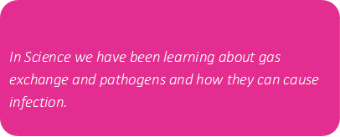
Science
Doulton have had a lovely start to the new term, they have worked really hard building relationships within the class. Well done, hope you have a lovely half term and we look forward to seeing you very soon.
Dawn and the class team
Twyford
Class Twyford have settled back into life at Bluebell after what has been a very difficult year. They have adapted well to a brand new teacher and are already starting to show progress across the curriculum.
In English we have looked at poetry around the theme of relationships. We have thought about how some relationships may last a lifetime and survive great physical distances, while others may start and finish over a relatively short period of time. We discussed that however long they last, relationships are an important part of their lives. We have created an acrostic poem about what makes a great friendship and thought about what we desire in a best friend.
In Maths we have looked at 3D shapes and roman numerals. Students have designed their own 3D shapes using playdough, which we loved doing during the lesson. We have also looked at roman numerals. During the first few lessons, pupils were getting the hang of what each symbol means and then once comfortable were able to create their own. In science lessons students have been learning about nutrition, human health, diseases and the development of medicines and vaccines to fight disease, a topic that pupils have been particularly engaged in and eager to learn about given their knowledge of the pandemic.

In Topic we have been looking at urban and rural areas. Students were able to research different urbanisation areas such as Tokyo and Shanghai. Once they had found a variety of areas they were able to come up with both benefits and negatives to living in such a big city with a high population. In PE this half term, we have taken part in two separate lessons each week. Our Tuesday lesson has been based around invasion sports such as Basketball, Football and Netball. Within this topic we have looked at the different throwing techniques in netball and how we can manoeuvre ourselves into space to receive the ball. Our second PE lesson of the week has seen us take part in tubing sessions. Students have really enjoyed socialising during these lessons with other peers and having a really good time on the slopes.

Finally, we have thoroughly enjoyed getting to know each and every one of you in class Twyford and am proud of the way that you have welcomed new staff and students to Bluebell. Myself and the staff team are wishing you a well needed break over half term and I can’t wait to see you all again soon.

Nathan & Kay (Twyford Class Teachers)

Coalport
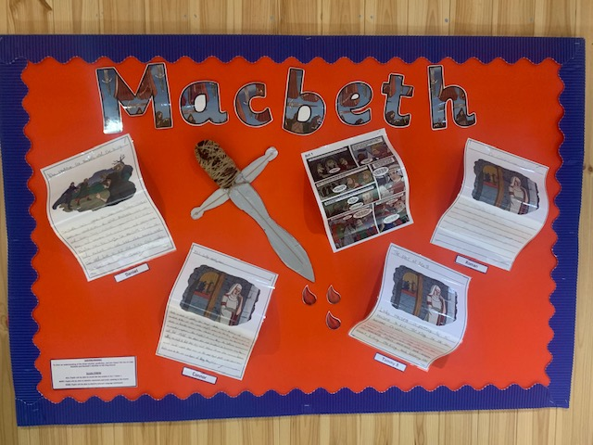
In English, students have started studying Macbeth in preparation for their GCSEs. They have performed sections of the play in class, and spent time debating who is to blame for King Duncan’s death!!
Other students have studied Act 1 Scene 1 of Romeo and Juliet and created storyboards to depict the ancient feud between the Montagues and Capulets.
For diversity, we completed work for mental health awareness, Halloween, Black History Month, and World Space Week. Students particularly enjoyed finding out 10 amazing facts about satellites and about the solar system. They chose their favourite planet and created a fact file about it.
In Maths, students have been learning about decimals and the Year 11 students have completed past GCSE papers in preparation for their exams.
In Science students have been studying reproduction and the respiratory system. They then moved on to learn about diseases and the history of antibiotics and they enjoyed completing a timeline of key events relating to the topic.
During adventure PE students went tubing at the ski slopes; something which they all really enjoyed! Students have really enjoyed socialising during these lessons with other peers and having a really good time on the slopes.

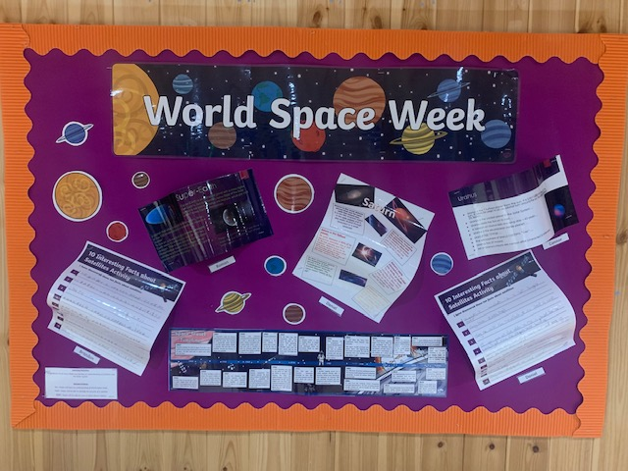
During RE, students have researched about spirituality and spent time learning about the Golden Dove award. We debated who we thought should receive the award and if we were to invent our own spirituality award what it would be.
In PSHE we have thought about our future careers and what attributes we would require for our chosen vocation

