Newsletter

What a great start to the Summer Term we have had!!!
Despite the ongoing challenges that COVID-19 continues to throw at us, we have enjoyed numerous events and created an array of breathtaking work. We are incredibly proud of all students who have continued to excel both academically and socially. I am sure that you will agree that the standard of work, celebrated in this newsletter, which students have completed in the face of great adversity is outstanding and makes us all at Bluebell very proud.
During the first half of the term we have celebrated many national and local events including; Captain Tom Moore’s ‘100 Challenge’, Autism Awareness, Eid al-Fitr, volunteering in the community.
Once again, I can’t thank all parents / carers enough for the great support that you have given all of the staff at Bluebell throughout this academic year so far.
KEY DATES
School closes for students on Thursday 22nd July 2021
School re-opens for students on Tuesday 7th September 2021
REMINDERS
Could I please remind all parents / carers that on the day(s) that students have PE, they should arrive at school in trainers, tracksuit bottoms / shorts and school polo shirt and school jumper.
At Bluebell School we have 4 key learning intentions for all pupils.
Intention 1 | Maximise behaviour and skills for learning | Pupils will want to learn and have the skills to learn.
Intention 2 | Reach full academic potential | Pupils will develop appropriate knowledge, skills and understanding enabling them achieve to the best of their ability academically, creatively and physically.
Intention 3 | Rebuild and nurture | Pupils will be rehabilitated, enabling them to develop self-worth, a positive identity, confidence and contentment.
Intention 4 | Prepare to make a positive contribution to the advancement of British society | Pupils will leave the school to engage in further meaningful study or employment. They will be community-spirited, respectful, law-abiding young citizens in full support of democracy and individual liberty.

My door is always open to parents / carers and I welcome an open dialogue so please feel free to contact me on 01782 897012 or cbarker@bluebellschool.co.uk should you wish to discuss anything.
Kind Regards

Craig Barker
Headteacher

Minton
We began the summer term in our new classroom ‘Minton’ and have adapted really well to our classroom move. We have had lots of opportunity to explore our new classroom and have been having lots of fun whilst we learn!
During science, KS1 have been learning about different plants and KS2 have been learning about electricity.
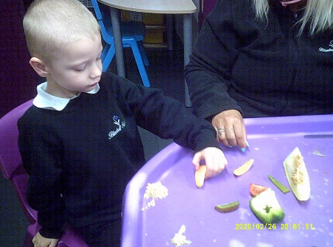
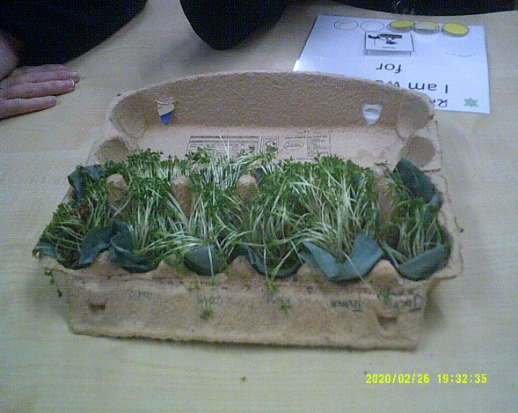
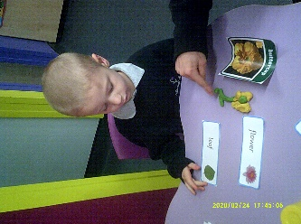
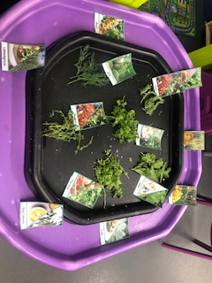
KS1 have been busy learning about different plants, parts of a plant and plants we can eat. So far we have planted our own beanstalk, sunflowers, mixed flowers, cress (which we tasted) and we are moving on to growing our own vegetables. We particularly enjoyed the activity where we got to explore plants with seeds as we got to taste lots of yummy fruit and vegetables!

KS2 have been learning about electricity. We have been exploring sources of energy and electrical circuits. We have really enjoyed using the electricity resources to create our own working circuit. So far we have used batteries to power a lightbulb, music box, a fan and have even worked out how to add switches to our circuits.

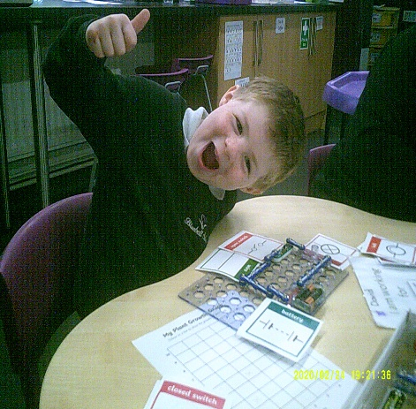
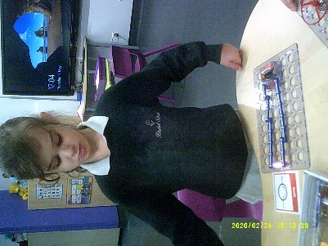
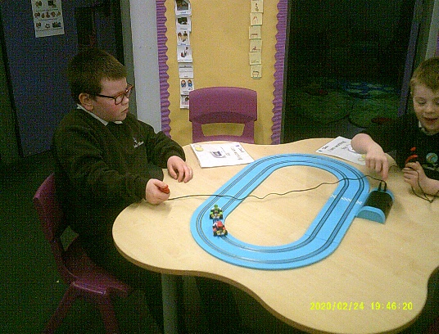
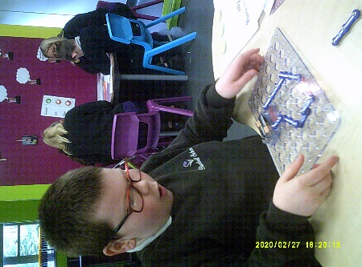

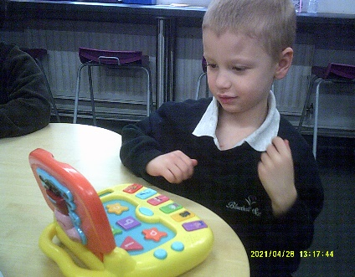
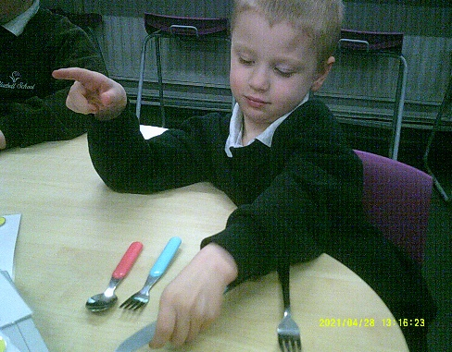
In topic, KS1 have been learning about timelines linking this with old and new toys. We looked at toys from the Victorian times and followed their progress right through until the present day. We have really enjoyed comparing old toys to the toys we play with now. We have been able to recognise the changes in toys through time. We then adapted one of our favorite toys to make it suitable for a younger child and created a replica model using foam clay.

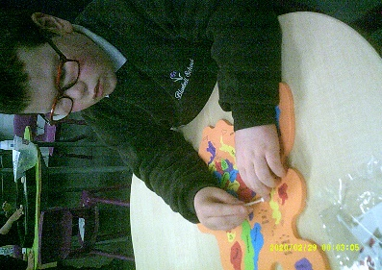
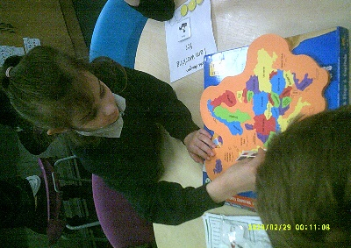
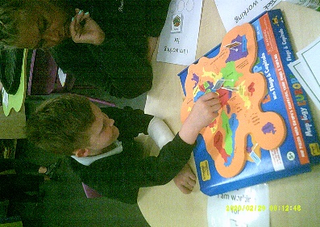
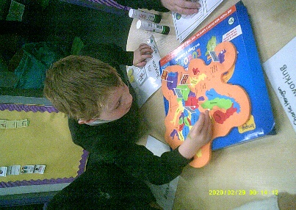
In KS2 we began by learning about artists from around the world. We took part in recreating some pieces of art from famous artists such a Vincent Van Gogh. We are now beginning to link this to our Geography topic, focusing on Europe.

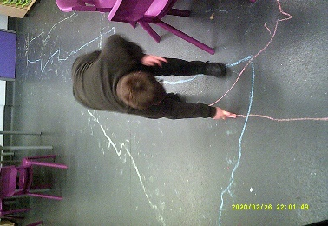
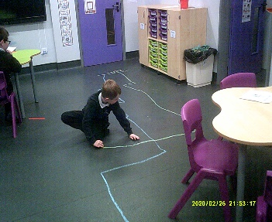
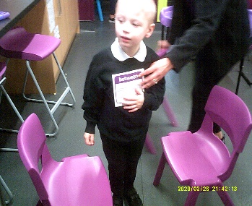
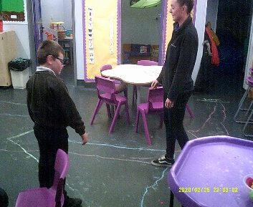
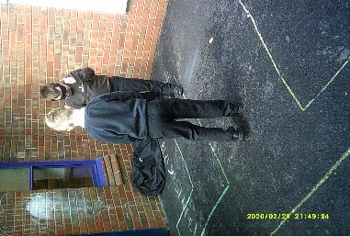
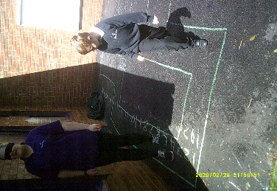
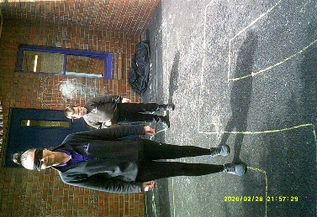
In our math’s lessons we have been looking closely at direction, movement and prepositional language. We have really enjoyed this area of Maths, particularly because we were able to direct our friends and staff around our paths and maze whilst blindfolded!

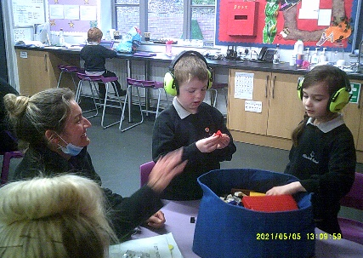
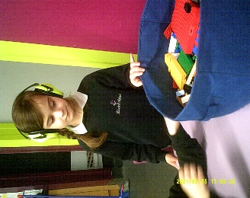
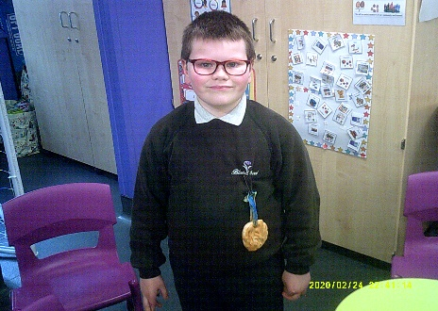
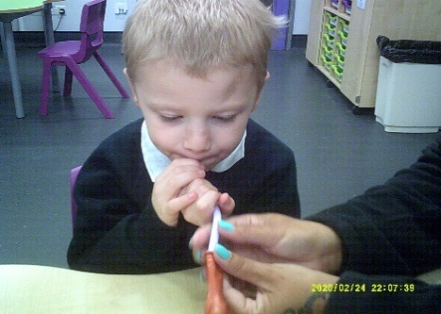
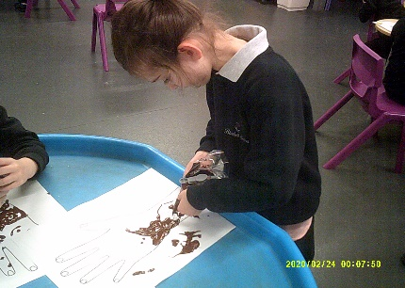
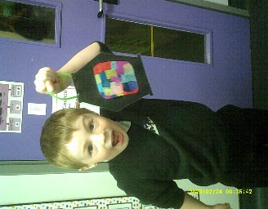
We have taken part in lots of Diversity work this half term including celebrating the life of Prince Phillip, Deaf awareness, Asthma awareness, VE Day, Eid and Shavuot to name a few. We have explored lots of crats such as painting, weaving, making salt dough, creating our own medals, creating lanterns and using piping bags to create Henna patterns!

Beswick

Beswick have had a wonderful beginning to the summer term! The children have settled back into their busy timetable extremely well after the Easter holidays. We have been very busy completing lots of practical themed work in all subjects.

This half term in maths, we have been learning about multiples of specific numbers, directions and money. We have had the chance to complete lots of practical activities. We have made our own maps using directions to arrive at a specific place. We have completed lots of different activities including making our way around a maze within the playground. We have also used lots of Numicon to support our understanding of different multiples of various numbers.

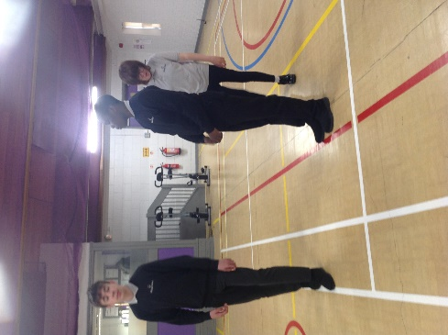
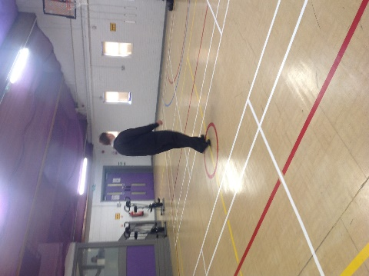
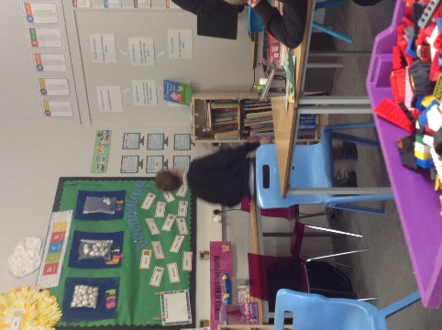

In English, we have started to look at job advertisements, their features and what makes them stand out. The children have also looked specifically at job and careers they might be interested in when they grow up and move onto further education.

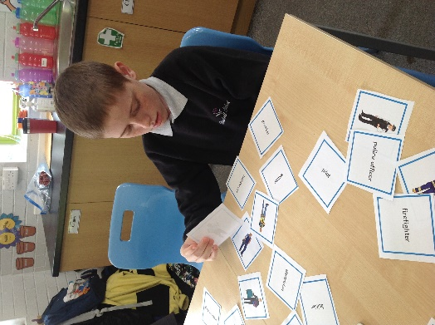

The children have been learning about changes to different states of matter in science. This has been a particularly practical topic this half term. We have had the chance to complete lots of experiments related to solids, liquids, gases, irreversible and reversible changes.

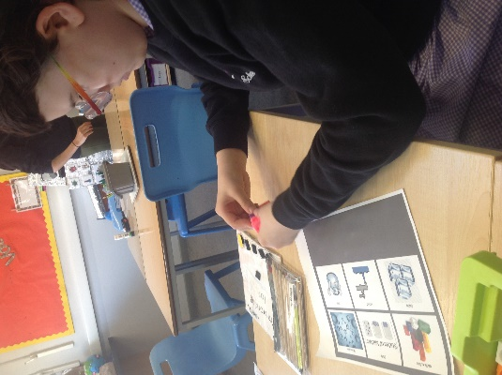
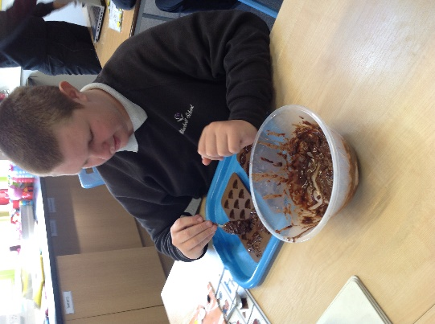
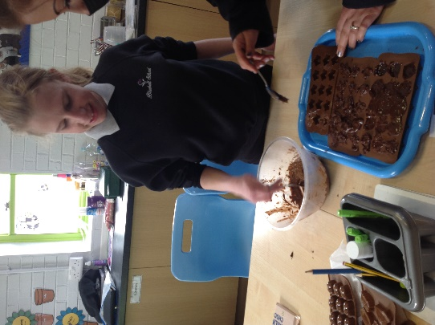

It has been a fantastic half term teaching class Beswick and we are looking forward to completing lots of summer activities over the next half term.

Dudson
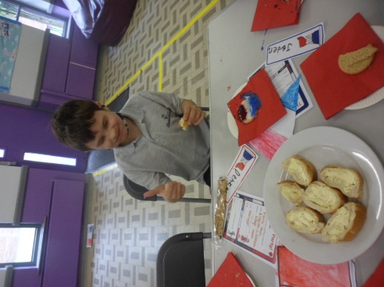
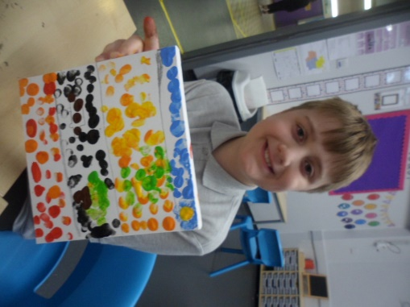

In our topic lessons, class Dudson have been learning all about ‘Modern Europe’. The children have looked closely at the famous art work of Van Gogh and Cezanne. They have all created mosaic style canvas paintings and used mosaic tiles to bring their designs to life. They are currently learning about the countries in Europe.

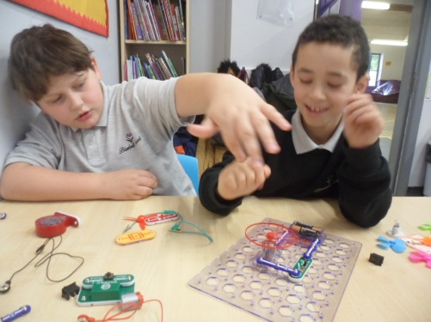
In Science the focus has been ‘Electricity’. The children have been identifying appliances that use electricity, finding the differences between mains electricity and battery powered energy. Over the last two weeks they have all been creating real circuits to power fans and light bulbs.

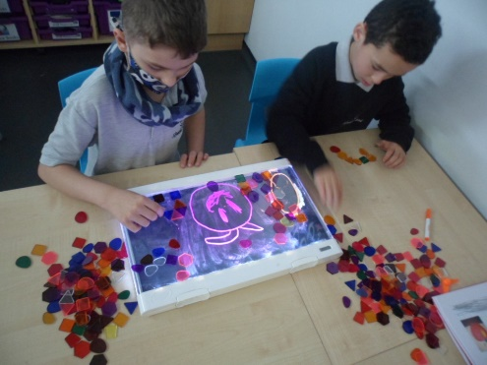
In Maths there has been a variety of learning from beginning to multiply, doubling, addition and subtraction. Recently all of the children have been using rulers to measure items and adding the measurements together to find a total. Recently they have been learning to use directional language and directing their peers around the outdoor area to find a variety of hidden objects, using language of half turns, full turns, left and right.

In our English lessons, we began the summer term by reading Peter Pan. The children have created character descriptions, designed treasure maps and explored their 5 senses in Neverland. Then we moved onto the story of ‘Charlie and the Chocolate Factory’. The children identified words that they found unusual, created delicious recipes and baked a treat from the story.
Class Dudson have also enjoyed weekly horse riding sessions, cricket and badminton during PE lessons and a variety of Diversity themed activities.

Wade
Class Wade have had an exceptionally positive half term. We have been very busy exploring our exciting topics with a sensory/hands on approach to learning. Look at some of the fun we have had, while participating in learning…
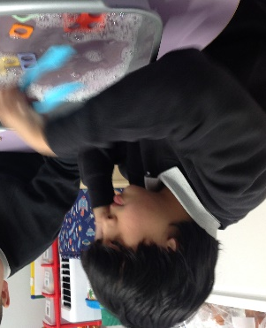
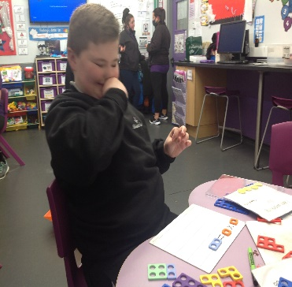
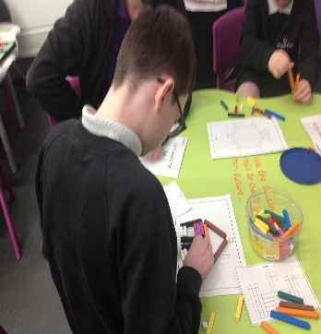
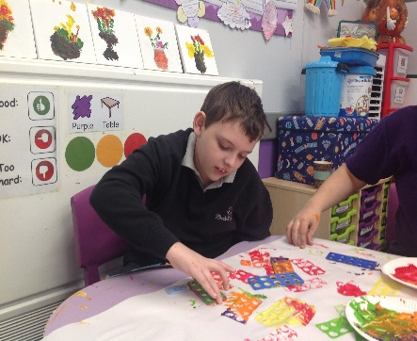
During our maths lessons, we have been looking at position and direction. Children have enjoyed guiding each other around the classroom to find various objects. Children used key vocabulary such as forward, backwards, left/right, half tern and full turn to direct their peers. We have also been developing our life skills by handling money at the shops and during role-play opportunities. The children have also been practicing their number skills by printing with the numicon resources.

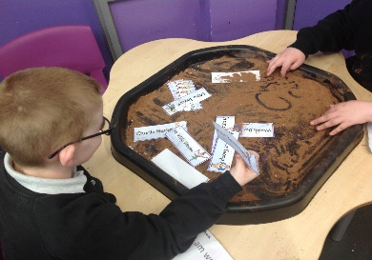
The summer term began with a new topic of adventure stories in English. We have looked at the adventure of Peter Pan and Charlie and the Chocolate Factory. The children have enjoyed creating pirate maps, dressing up, making cakes and creating new inventions for the chocolate factory. We have also been very busy practicing our phonics, spelling and handwriting following the scheme of Read Write INC.
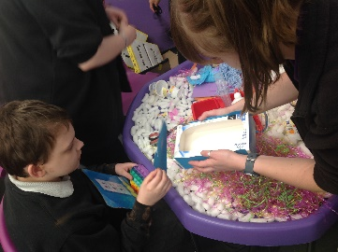
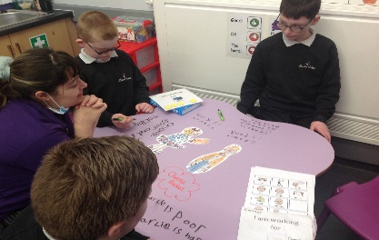
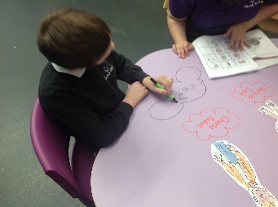
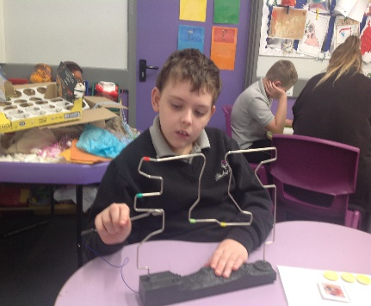
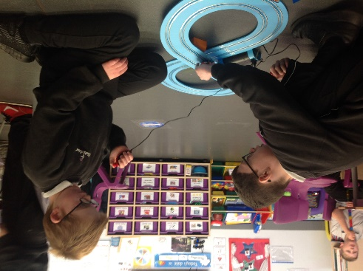
We have been busy scientists this half term, participating in a range of experiments related to our topic of: Electricity. We have created our own circuits, designed our own buzz wire game, participated in an electricity hunt around school and looked at toys that use mains or batteries. We have loved becoming scientists to work on our STEM skills. As a group, we have been busy designing and making games, junk modelling and taking part in construction challenges.
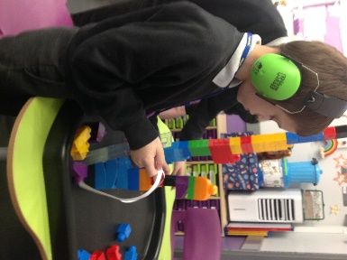

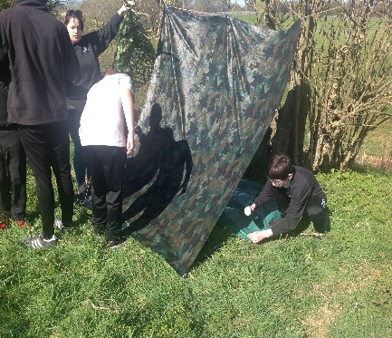
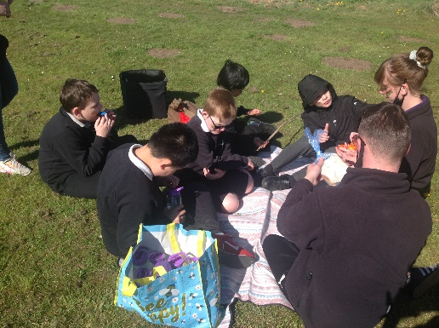
This term, Class Wade have enjoyed exploring the outdoors. We have been working hard to develop our confidence, communication and team building skills through weekly forest school sessions and horse riding sessions. As well as this, we have been enjoying team games during our weekly PE coach session with ASM Sport. Look at the fun we have had…

We have also been learning key independence skills by taking part in a French banquet and looking at diversity events within the calendar such as Eid and World Nurses Day.
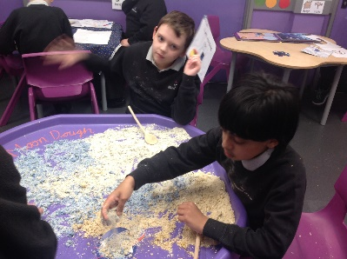
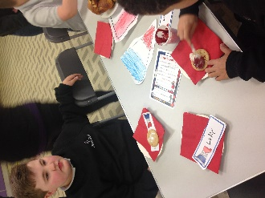
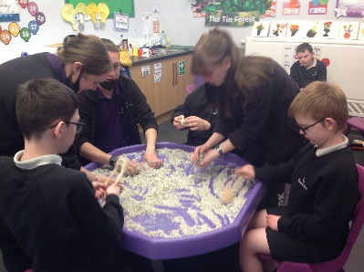

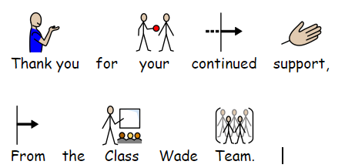

Moorcroft

In Science this term, we have been learning about shadows and how we are able to see. At the beginning of the term, we made our own dens to see how much light we could block out and how well we could identify different objects in the pitch black.
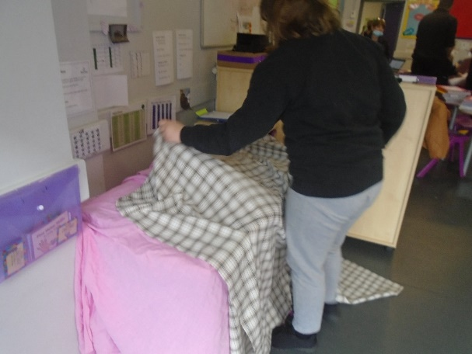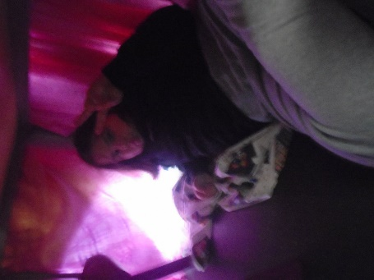
We have also used Lego to create towers, shone a touch on them and looked at how shadows decrease in size the closer the light source gets to the object.
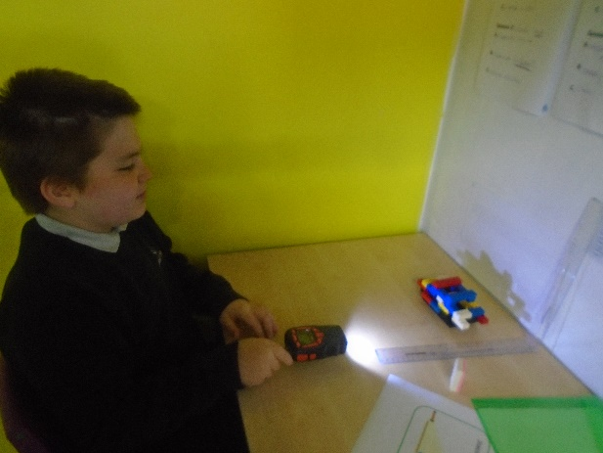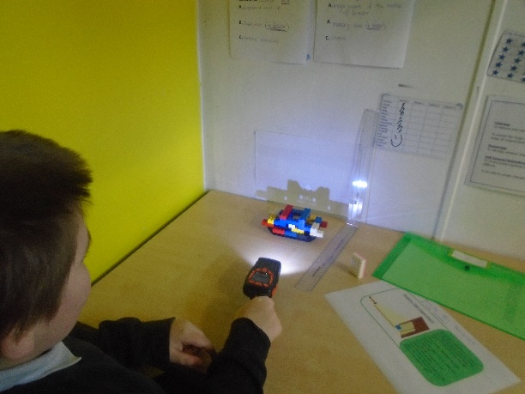
Another topic we have covered is ‘Electricity’. We have identified objects across the school that required electricity to work and those that need some form of energy to work, such as, controllers and radios. The children have enjoyed learning about circuits and have tried to make their own.
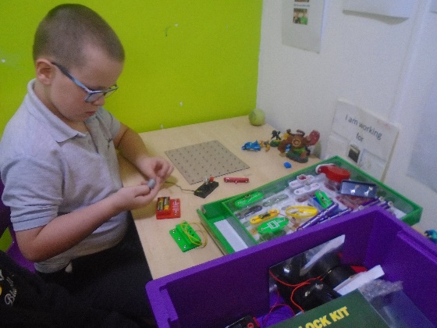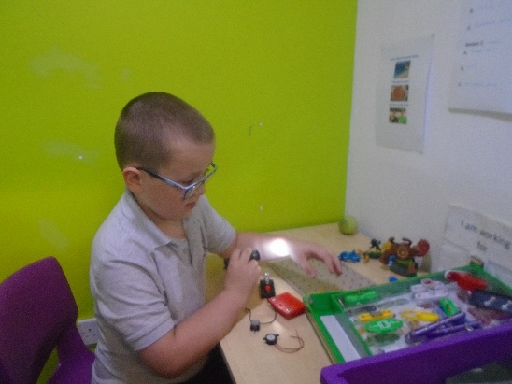
Maths:
In Maths, we have been learning about directions and quarter and half turns. The children have practiced their turns by being blind folded and listening to directions.
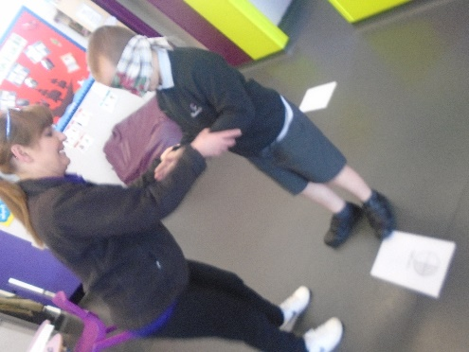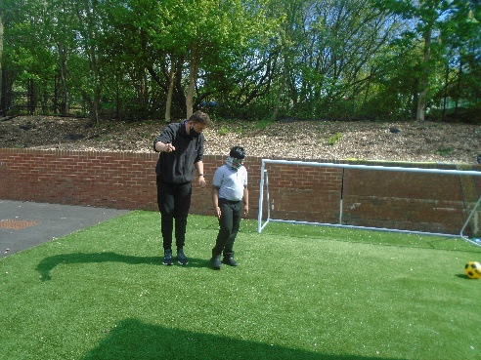

Some of the children have been developing their number recognition along side their counting skills.
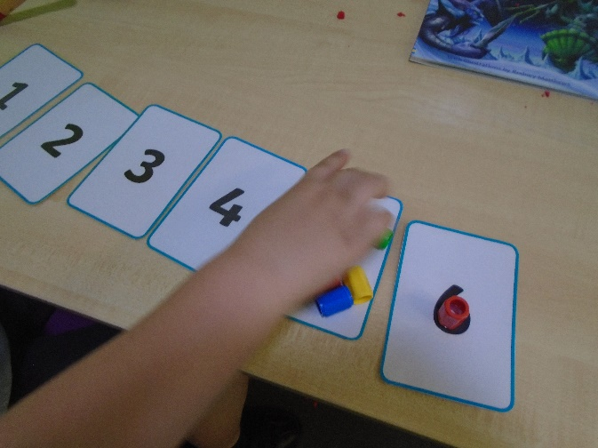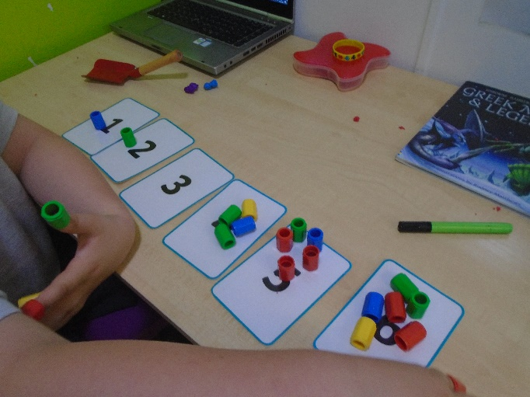

Spode
What a great half term we have had to start our summer term. The children have had a great attitude towards their learning and have showed great engagement within their sessions. The children have also maintained positive relationships with both staff and peers.
In maths this term the children have shown some great progression within their knowledge. We have focused on symmetry where the children have explored symmetry in a range of shapes and they have also used their knowledge to draw their own symmetrical images. Another topic we have covered this half term is shapes where the children have explored both 2D and 3D shapes and their properties. The children have also began to explore perimeter and area.
The children have also had some great fun exploring a range of other curriculum areas. In topic, the children’s favourite subject was art where we have explored insect art and created some wire insect sculpture, they created some AMAZING mood boards to show their ideas and inspiration. We also explored human and physical features within Africa and created our own African biome models.
In science the children have been exploring energy, looking at a different types of energy and what energy sources are renewable or non-renewable.
In PSHE the children really enjoyed and engaged well in our lessons based around global warming and how we can help to prevent increased greenhouse gases.

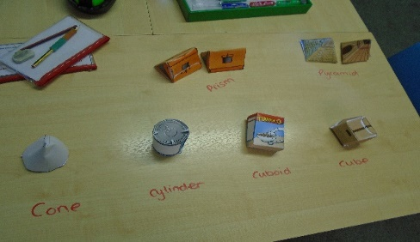
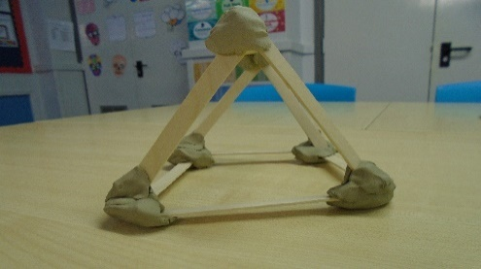
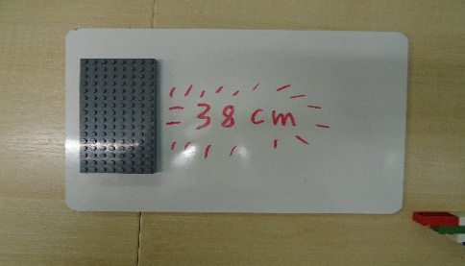

In English the children have worked hard on a range of areas to improve their writing skills and comprehension skills. This half term our focus is science fiction with the overarching topic of ‘Out of This World’. Throughout the term the children have created some amazing work. The children have created their own sci- fi character and detailed description. They used their understanding of the genre to create their own book blurb. They had some amazing ideas and some of their drawings were incredible.

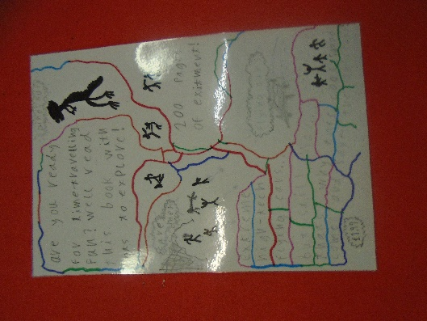
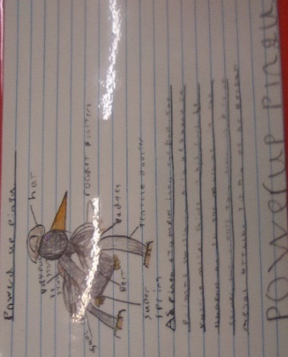
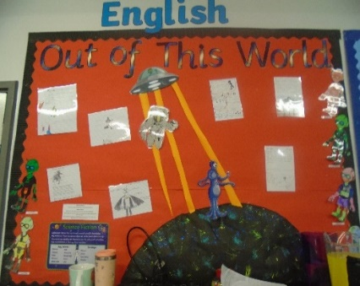

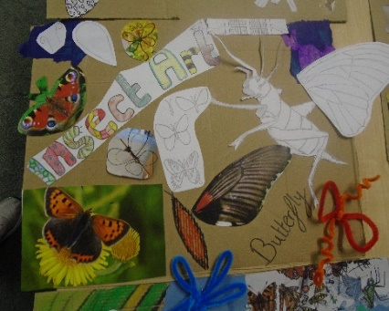
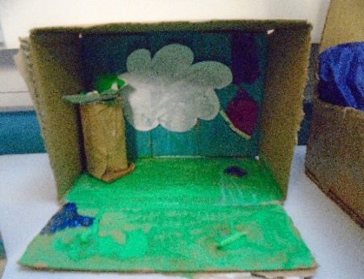
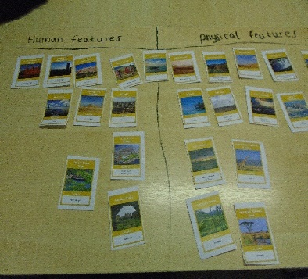

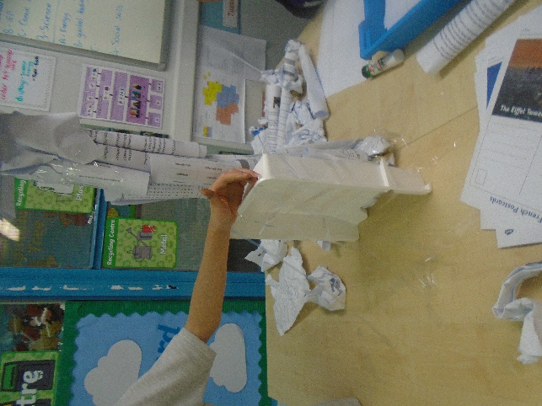
The children have shown they can work together as a team and worked extremely hard on being positive with peers. Over the term the children have impressed staff with their positive mindset and attitude to their education.
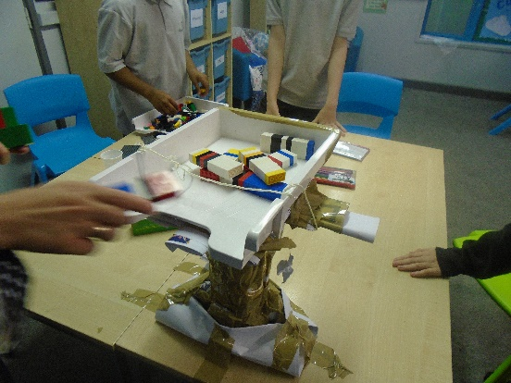

Well done class Spode on a super term in school! Staff are impressed with the children’s attitude and improvement in their academic achievements and creativity.

Have a great half term and I can’t wait for our final term of the school year together to celebrate many more achievements

Middleton
Middleton have had a great term so far, we welcomed new girl Honeyrose to our class where she has made lots of new friends and settled very quickly. The boys have been great explaining the class rules.

In topic we have been learning about World War Two. We had great fun making our own Anderson shelters using the craft box and Lego. We have also looked at Winston Churchill and his inspirational quotes.
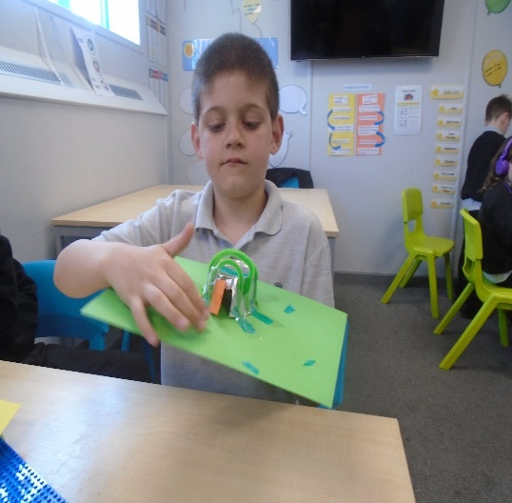
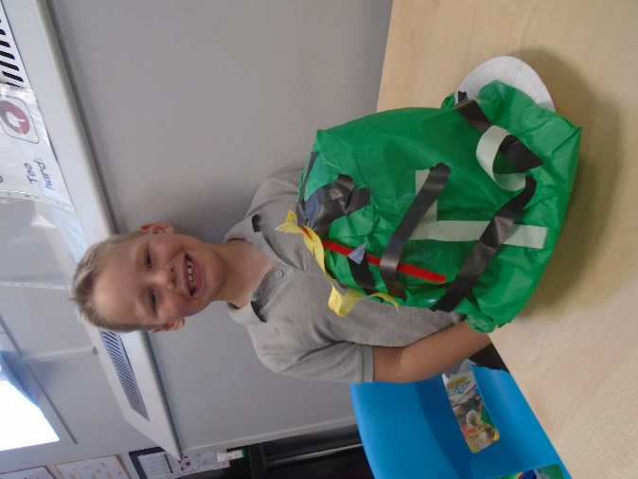
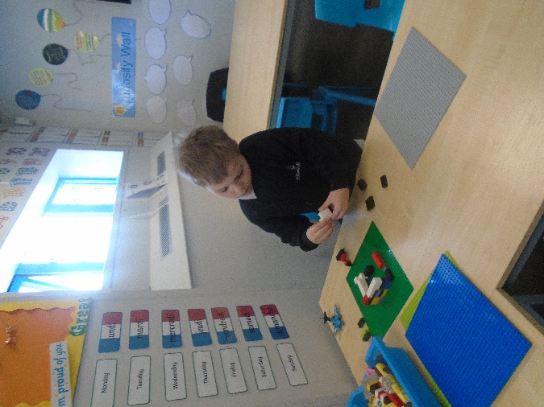

In Science we have explored light and how shadows are made, children had great fun creating shadows on different surfaces.
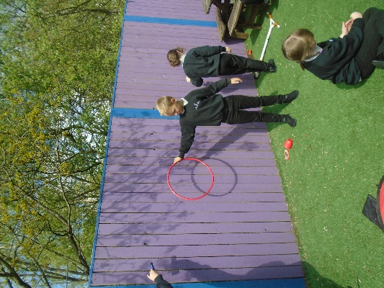
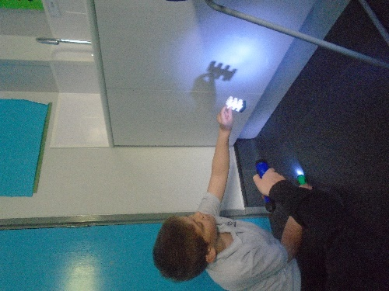
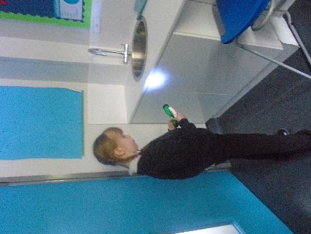

In English we have looked at biographies and autobiographies. Children were able to create some lovely pieces of work for our English display. They were also able to write some super biographies for Roald Dahl.
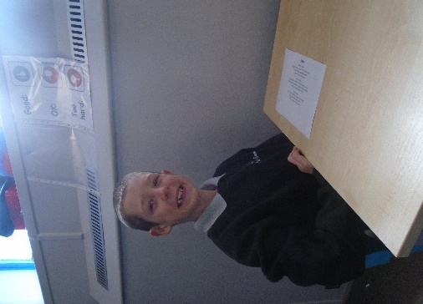
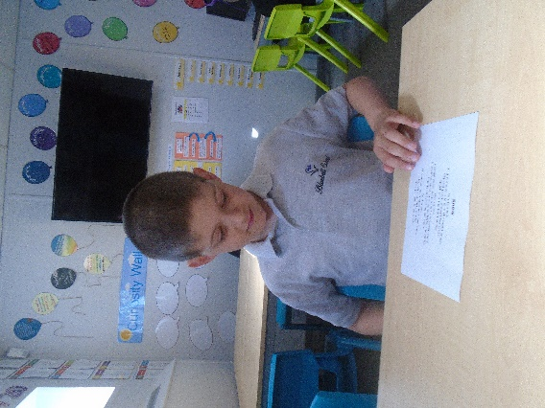

In Maths, we expanded our knowledge on multiplications where children had great fun playing timetables superheroes to apply their knowledge they have learnt about multiplications.

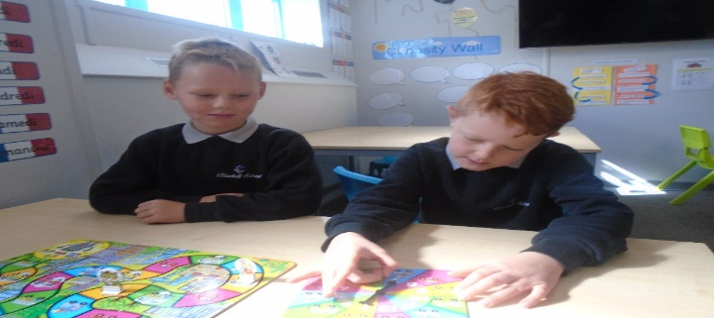
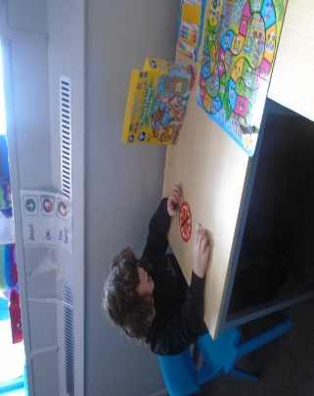

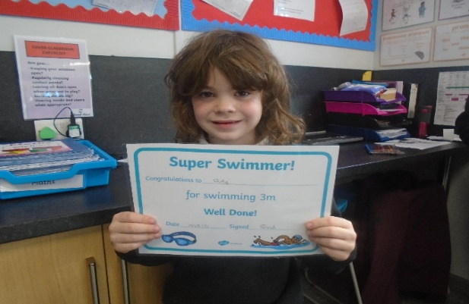
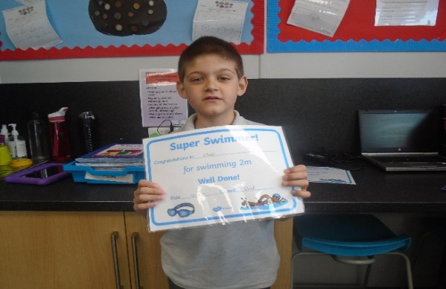

We have had a great term, we look forward to seeing you all after half term.
Steelite
Over the last few weeks we have been learning about WW2, the children have had a great time creating their own honor medals and building an Anderson shelter. The children also created their own memory boxes and also learnt about Winston Churchill’s famous speech.
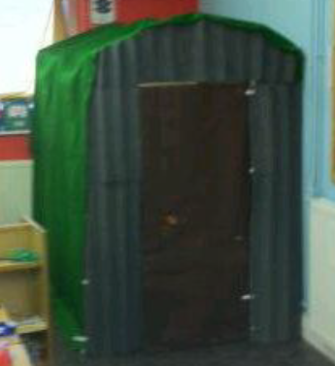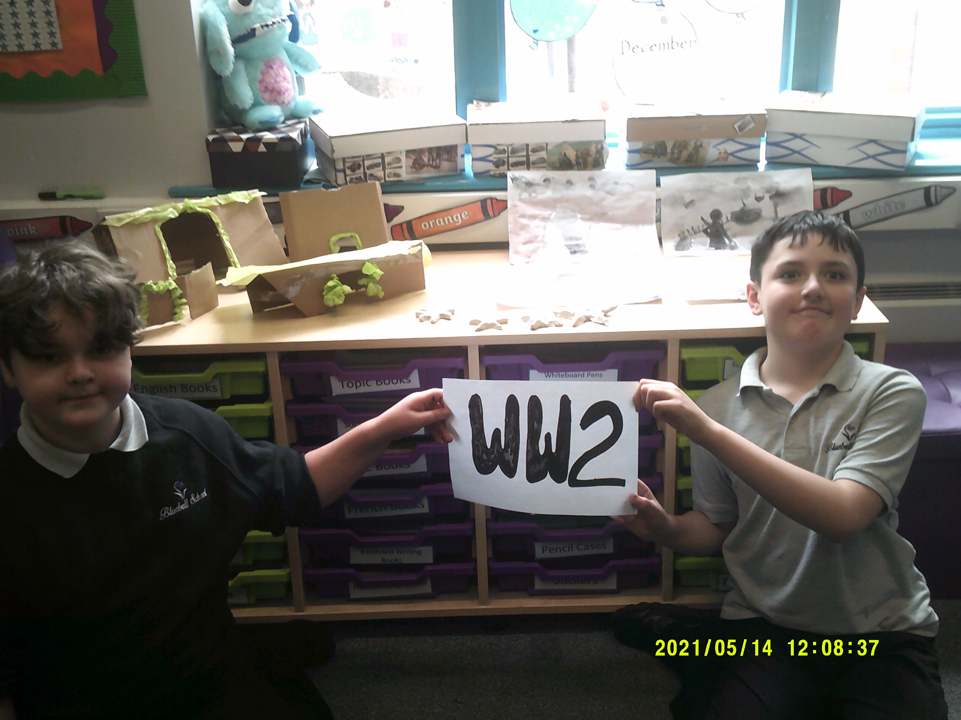

Steelite have had a lovely term. The children have all created some beautiful work, and have especially enjoyed the creative side of their learning. Have a wonderful half term class Steelite and we look forward to another great term with you all!

Topic
Maths
in maths we have been working on money, place value and fractions. the children enjoyed completing an outdoor numeracy challenge.

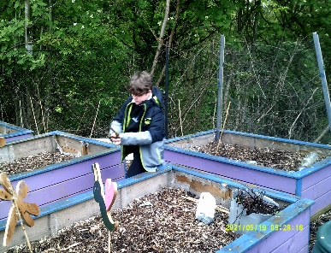

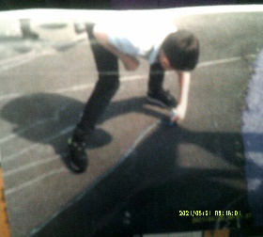
English
Steelite have been learning ABOUT AUTOBIOGRAPIES and have begun to plan and write their own versions. at the beginning of term the children explored different types of poetry.

In Science we have been exploring shadows and how light travels. The children enjoyed creating their own light-boxes and found different ways of creating shadows with different items.

Wedgwood
Wedgwood class have had a brilliant start to the Summer Term. It has been great to return to our off-site trips over the last few weeks. We have particularly enjoyed going off to PE and climbing each week.
In Science, Wedgwood class have explored ‘light’. We have investigated sources of light and how it travels, whilst also looking at shadows and how the eyes enable us to see. Pupils have enjoyed completing lots of practical activities.
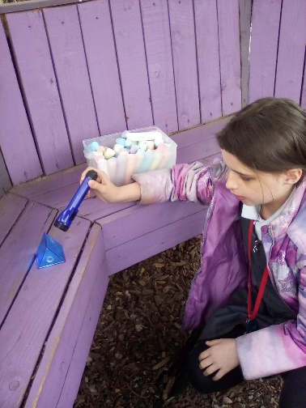
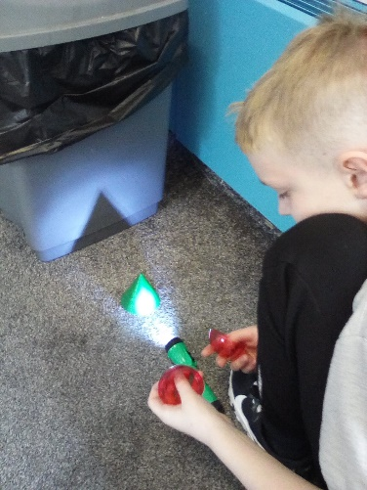
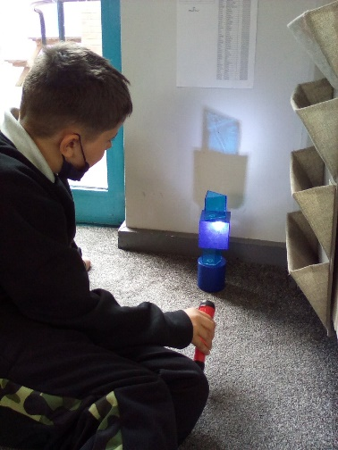
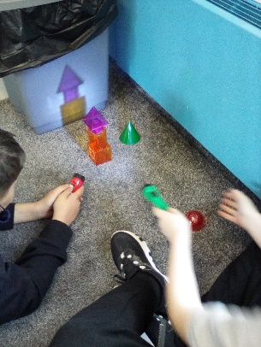
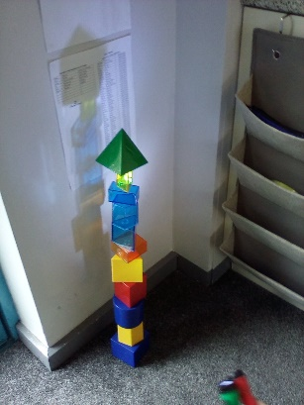

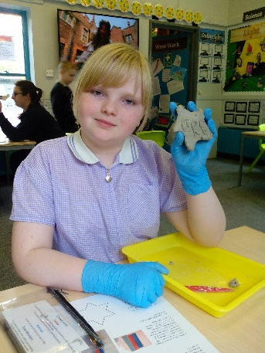
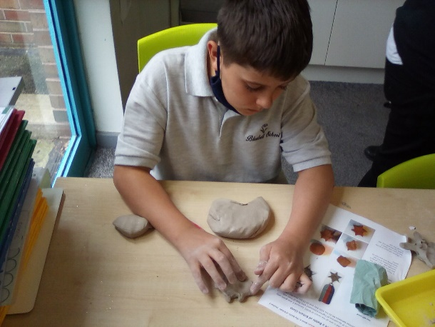
During our Topic sessions Wedgwood class have taken a journey back to World War 2. We have explored the events which led up to the war, how life changed for those living in Britain and looked closely at ‘The Battle of Britain’. We got creative and made our own medals which could be awarded to Churchill’s ‘Few’.

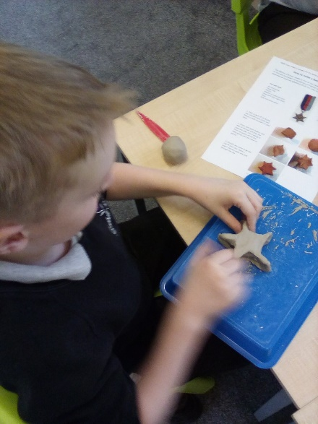
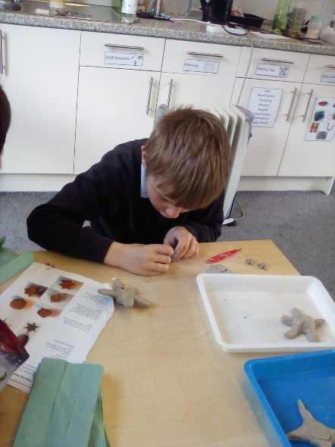
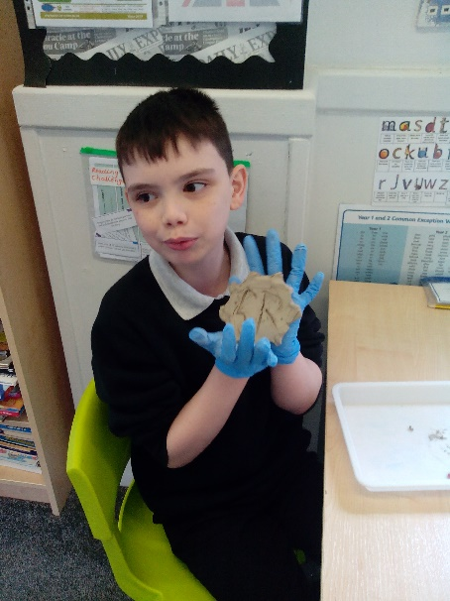

During our English sessions, we have explored biographies and autobiographies. Pupils can now confidently identify the differences between them and their key features. Our learning has led up to children writing their own autobiographies. They were great to read, we definitely have some budding authors!
In Maths we have continued our work on addition, subtraction, multiplication and division. We particularly enjoyed working with money.
A highlight of this half term has been ICT. The pupils of Wedgwood class have composed some amazing digital music sequences. They have impressed us all with their skills.

Throughout this half term Wedgwood class have impressed us with their ability to welcome new children into the class and make great friendships.
Well done for all your hard work Wedgwood class. Have a lovely break. We look forward to seeing you after half term for lots more fun!

Lauren and the Wedgwood team

Doulton

Class Doulton have settled into this final term of the year very well. The children have all adapted positively to staff changes. In English we have been looking at science fiction and within this we have looked at what makes the film or book science fiction along with what type of language maybe used in this genre. In Maths we have covered area and perimeter of shapes, once confident enough students have been able to identify and workout their own shapes from around the classroom and on the playground. Science this half term we have been looking at different energy’s like nuclear, kinetic and wind. With these we were able to find out both the advantages and disadvantages.
In Topic this half term we have covered two specific areas, the first one being on the planet and how we need to start recycling and reusing items more. The students created posters on how we could help the planet become greener, for example using plastic bottles for something else once it’s been used. The other topic has been on art, where the students drew some different insects and then with this have been able to create wire models.

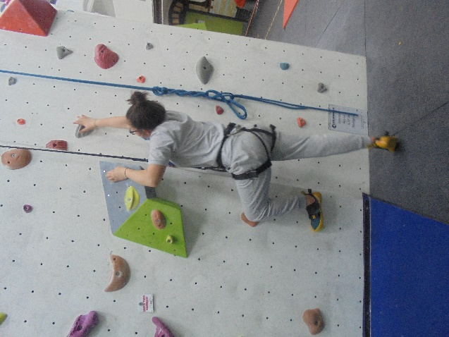
In PE we have been focusing on invasion sports learning different skills in both football and basketball. This has included learning some of the basic rules for basketball like the point scoring system and the rules around dribbling. In the Friday PE session, with the roadmap out of lockdown easing, we have been able to go on some climbing lessons. The students have loved these activities over the last couple of weeks and are looking forward to doing something similar over the next half term.

I have thoroughly enjoyed getting to know each and every one of you in class Doulton and am proud of the way that you have been able to adapt so well to change. Myself and the staff team are wishing you a well needed break over half term and I can’t wait to see you all again soon for our last half term.
Nathan
Class Doulton

Twyford

During this term, Twyford class has worked incredibly hard as they approach the final weeks of a long but enjoyable school year. Despite some staff rotation and new faces, the pupils continue to do themselves proud and complete a range of tasks within class.

There has been plenty of hard work going on in the core subjects this term with the level of challenge increasing in areas such as Maths and English. Within our English lessons, we have completed several practise papers, looking at creative writing and analysing information that has been presented in various passages. Despite the length of writing and amount of concentration required to complete these mock papers, all pupils should be very proud of their efforts in class this term.

In our Maths sessions, we have again been looking at a series of past exams, identifying key areas that may be including in future papers. These include ratios, sequencing, probability and equations. During our Science lessons, we have studied topics such as forces, energy and movement. Pupils have been able to measure their own speed and convert this into force whilst using their Maths skills to calculate acceleration and mass.

In our afternoon sessions, pupils continue to work towards their individual BTEC qualifications, completing a range of theoretical and practical tasks. Lots of activities have been completed, with cooking, painting and social trips to name a few. These have been enjoyable sessions that has allowed for a more hands-on approach to learning and there has even been time to squeeze in a reward trip to Bon Pan Asia for all of their efforts.

The class team would like to thank each pupil for their hard work and efforts in class and wish everyone a great half term break.

Dan and class Twyford

Aynsley

It has been a busy half term here in Aynsley, we have had a lovely six weeks getting to know one another and producing some excellent classwork and learning new skills.

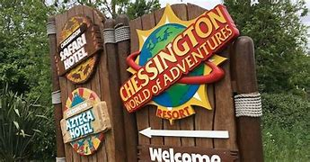
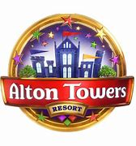
In Math’s we have been focusing on exciting project work to allow them to use Math’s skills in the outside world. Year 11 have been completing a ‘Math’s in Real Life’ project where they have been looking at living costs, wages and how much it costs to run a car. The students have embraced this and thought about their purchases wisely! Year 10 are completing a theme park project to support their knowledge for their functional skills qualification. We have been looking at how much profit each park makes and ensuring we have our place value correct. I have been really impressed with their dedication – well done!
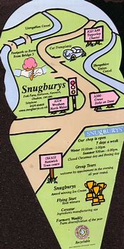
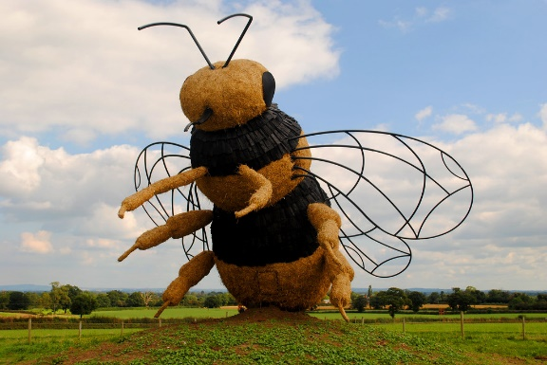
In English, we have been focusing on project work again. The students have been planning a school trip and creating a persuasive presentation to entice their peers to attend. Our class then had the opportunity to actually attend their trip during our social skills sessions. We went to Snugbury’s in Nantwich for a very wet ice cream – we love the Great British Weather!

In Science Year 10 have been learning out forces and speed of movements. We have been able to implement some Maths into our learning too. We have taken part in some physical experiments to calculate our speed when running up and down the playground. We were quicker than we thought! Year 11 have been amazing with preparing for their final assessments, we have been very proud of their hard work!

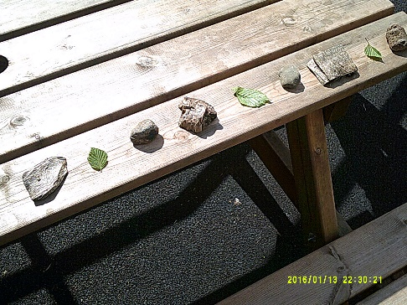
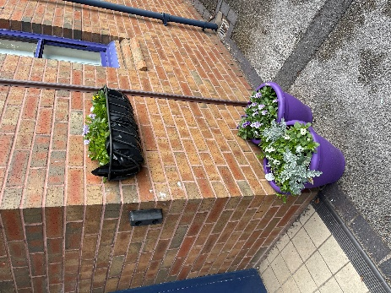
During enrichment, students have been completing some planting to place around our grounds. We have potted some lovely plants purchased from our local garden center placed them at the entrance to school. They look lovely!
We have also been out for some lovely walks in our local community including a stroll along the canal, a trip to Bathpool and completing some numeracy challenges in our school grounds.

It has been a lovely six weeks working together! I have been made to feel so welcome and I am very much looking forward to welcoming everyone back after the break.
Coalport
Class Coalport have been working extremely hard this term. As a class, we have been looking at expanding our skills in comparative writing. The children looked at two similar texts to identify and give their opinions on two extracts. We have also been looking at different places around the world and created our own travel broche for English. The children have enjoyed looking at different places around the world and what tourist attractions there are to see.
Our Sen Students have been revising for their exams and completing them for English. A job well done guys.
In Maths, we have been exploring and recapping different topics. We continued to look at budgeting and the different ways we can buy expensive items. We have also been recapping our long and short multiplication.
Our Sen Students have been continuing their studies for their exams and completed these with success.
In Science we have been looking at speed. The students have been looking at how to calculate the speed and explored stopping distance and how to calculate it.
Our Sen Students have been enjoying learning about renewable energy and the benefits they have on the earth. The children have created their own Hydro dam to show how we can create energy.
The pupils have been brilliant throughout this term and have engaged well with their peers. I hope you all have a well-deserved rest and will see you after half term
Jamie
Coalport class teacher.

