Newsletter
What an incredible way to finish off the 2021-21 academic year!!!
This year has been without question the most challenging year in educational history and yet thanks to the outstanding team of staff who provide amazing care and commitment to each and every student everyday, we have emerged stronger. I am incredibly proud to lead such a dedicated team of professionals.
During this year, we have survived and thrived through 3 lockdowns, positive Covid-19 cases, a school break-in and a snow day! However, due to the unwavering support of parents / carers, the students at Bluebell School have continued to make huge progress, both academically and socially.
There have been so many personal and school-wide achievements this year that it would be remise of me to single any out. However, I will say that I am immensely proud of the growth that has been shown at Bluebell School and I look forward to seeing more and more as we enter the 2021-22 academic year.
Once again, I can’t thank all parents / carers enough for the great support that you have given all of the staff at Bluebell throughout this academic year so far.
KEY DATES
School closes for students on Wednesday 21st July 2021
School re-opens for students on Tuesday 7th September 2021
REMINDERS
At Bluebell School we have 4 key learning intentions for all pupils.
Intention 1 | Maximise behaviour and skills for learning | Pupils will want to learn and have the skills to learn.
Intention 2 | Reach full academic potential | Pupils will develop appropriate knowledge, skills and understanding enabling them achieve to the best of their ability academically, creatively and physically.
Intention 3 | Rebuild and nurture | Pupils will be rehabilitated, enabling them to develop self-worth, a positive identity, confidence and contentment.
Intention 4 | Prepare to make a positive contribution to the advancement of British society | Pupils will leave the school to engage in further meaningful study or employment. They will be community-spirited, respectful, law-abiding young citizens in full support of democracy and individual liberty.

My door is always open to parents / carers and I welcome an open dialogue so please feel free to contact me on 01782 897012 or cbarker@bluebellschool.co.uk should you wish to discuss anything.
Kind Regards

Craig Barker - Headteacher
Safeguarding Update
We know that during lockdown many of our children spent increased amounts of time on their internet-enabled devices such as mobile phones, laptops, tablets and gaming devices. The internet can greatly enrich all our lives but I would want to take this opportunity of reminding you of the harmful and abusive on-line experiences children can be exposed to, even from people they know, or they think they do!
‘Sexting’ is the term used when children and young people are encouraged to send inappropriate sexualised pictures of themselves. We know this is an increasing activity between youngsters, but rarely do they understand that they break the law when they send an indecent picture of themselves, even if it is to someone they see as their boyfriend or girlfriend. Most worryingly, they do not always appreciate that they lose control of their image the moment they press send! Chat rooms and social media platforms are favoured places for those who would wish to exploit children. Many dangerous adults hide behind convincing fake profiles and actively seek to groom children into sexual activity.
Here at Bluebell we recognise the importance of children being safe when enjoying time on- line with their friends or playing internet based games. We are constantly trying to educate our pupils about how to stay safe when using their devices. We would ask you all to support us by reassuring yourself that your child(ren) understand how they can keep themselves safe and checking up on who they might be talking or communicating with. You might find the two websites below particularly helpful but don’t hesitate to contact me at any time if you feel you need further support with this.
Teaching Your Child about Internet & Online Safety | NSPCC
Parents Protect - Internet Safety

Minton
Maths
During maths lessons this term we have been learning about money. We have explored all of the different coins in sensory play. We have created our own shop display and made labels to show the prices of different items. The children have enjoyed creating growing patterns using 2d shapes and numicon animal pictures.

English
During English we have explored reading in our local environment, we have read road signs that give us information and keep us safe. We have enjoyed being out in our local area reading signs and the information that they give us. We have explored the seaside and used holiday brochures to research different types of holidays.
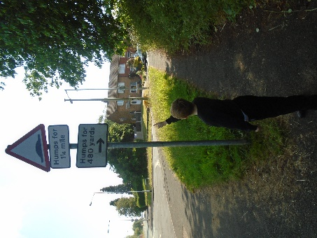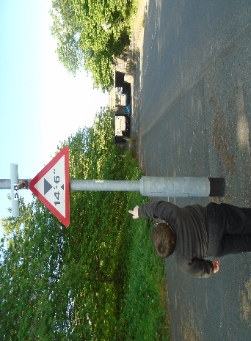

Science.
During science we have enjoyed planting seeds and recognising what a seed needs to grow. We have understood the process that a seed goes through to grow into a fully grown plant. We have discovered the seasons and how the weather changes with each one. The children have explored different energy sources and where they come from. They have particularly enjoyed setting up simple circuits in class.

Topic.
The children have thoroughly enjoyed the work that they have done about Florence Nightingale this term. They have created fabulous old and new hospitals and been able to compare them with each other. The children have started to learn about Christopher Columbus and created his boat using junk modelling.

PSHE
During PSHE the children have thoroughly enjoyed the topic of caring for animals and have visited Glebe farm and fed lots of different animals.

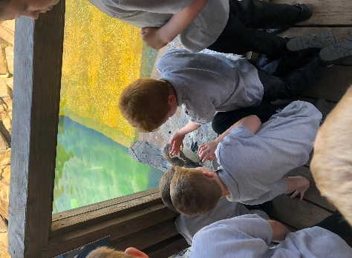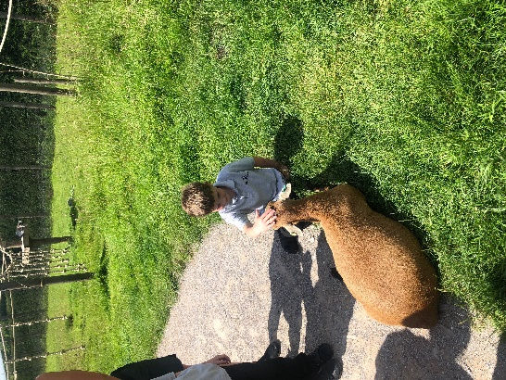

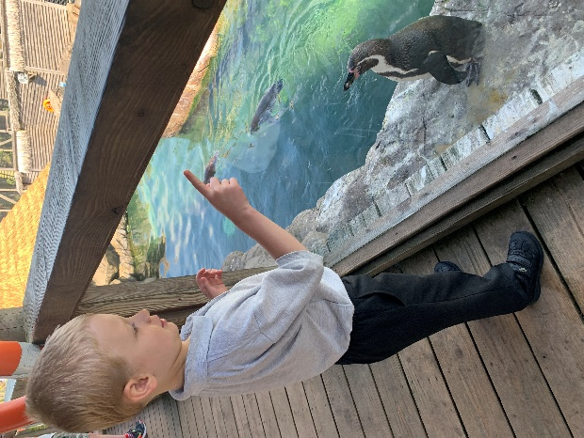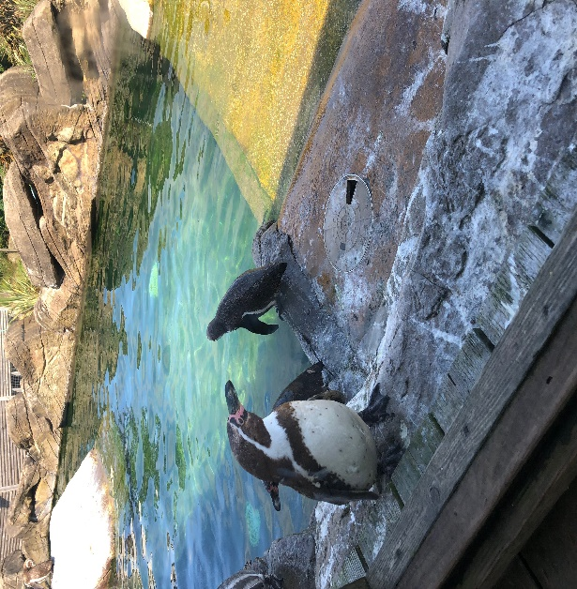

At the end of the term we visited Peak Wildlife and had a fabulous time! We have had a fantastic summer term and look forward to welcoming everyone back in September!

Beswick

Beswick have had a wonderful end to the summer term! The children have been very settled considering the summer holidays are fast approaching. We have been very busy completing lots of practical themed work in all subjects.

This half term in maths, we have been learning about subtraction, repeating patterns and rotation. We have had the chance to complete lots of practical activities. We have made our own repeating patterns while also rotating the shapes to make the pattern vary from each other. We have completed lots of different activities including going outside to find various natural objects to make repeating patterns out of. We have also used lots of Numicon to support our understanding of subtraction.

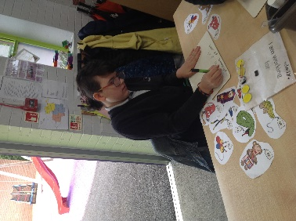
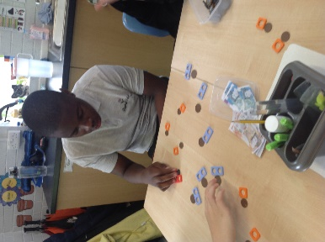
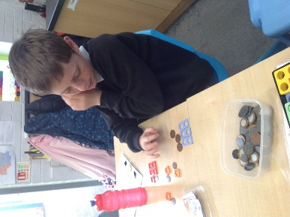

In English, we have continued to look at job advertisements, their features and what makes them stand out. The children have also looked specifically at job and careers they might be interested in when they grow up and move onto further education. At the end of this topic the class went to the beach to specifically look at what different job opportunities there might be on their visit.

The children have continued learning about changes to different states of matter in science. This has been a particularly practical topic this half term. We have had the chance to complete lots of experiments related to solids, liquids, gases, irreversible and reversible changes.

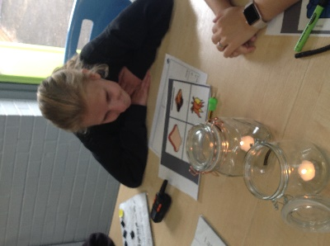
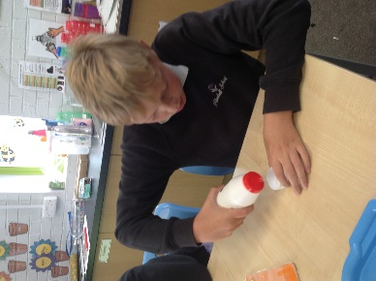
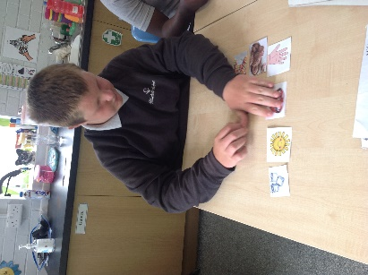

It has been an absolute pleasure to teach class Beswick over this academic year. We have completed some fantastic work across all subjects within the curriculum. Well done Beswick, have a lovely summer and see you in September!

Dudson
Class Dudson have had a super end to the Summer Term!
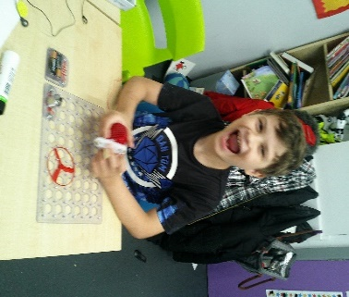
We have continued to explore electricity and magnets in Science. The children have enjoyed taking part in experiments and creating a variety of electrical circuits.
In English we have been focusing on holidays and beaches. All children created a ‘story mountain’ and have created characters and a beginning, middle and end to their own stories. The children have enjoyed sharing these with each other. We have also been focusing on text in the environment and we have explored the local area to identify road signs.
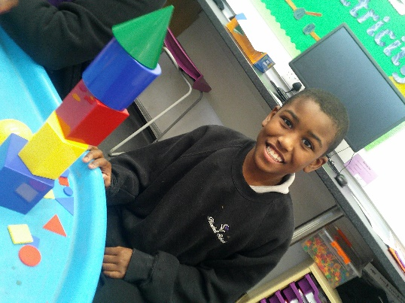
In Maths, we have focused on shape and pattern. The children have created and completed a variety of patterns and learned about what ‘rotation’ is. They also continued to build their skills using money. All children practiced coin recognition, adding two totals together and using a variety of coins to make given amounts.
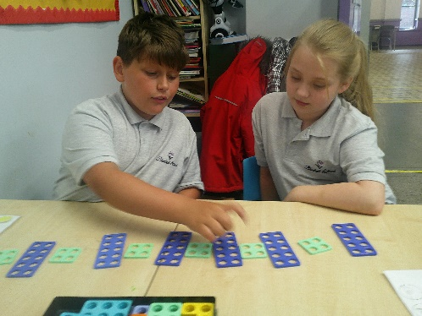
During Topic lessons, we moved to learning about Europe. The children designed and created healthy Italian meals, created sketches and watercolour paintings of European landmarks and built 3D models of British buildings.
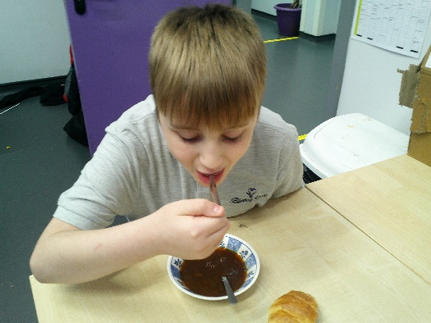
In PSHE we have been learning about ‘Rules’ and why we need them in school and the wider world. All children also designed their own board game with rules and shared this with their peers. Our French lessons have also been lots of fun, learning about life in France. The children have recently created food reviews of a variety of French food – the favourite being onion soup! The class Dudson staff team are S0 proud of all of their achievements over the year, we hope you all have a fantastic summer! From Kirstie, Emma, Hayley, Sophia and Ben.
Wade
Class Wade have had an exceptionally positive summer half term. We have been very busy exploring our exciting topics with a sensory approach to learning and enjoying all of the fun things that the summer term brings. Take a look at some of the fun we have had, while participating in learning…
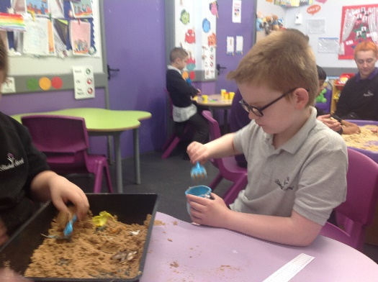
Within English, we started our themed topic of the seaside. We have enjoyed exploring holiday advertisements, sensory seaside stories and participating in our phonics RWI sessions. Pupils enjoyed planning and writing their own seaside story and used all of the learning we have completed throughout the year such as handwriting, spelling and story structure knowledge to write a final piece of English work for our Special Writing Books.
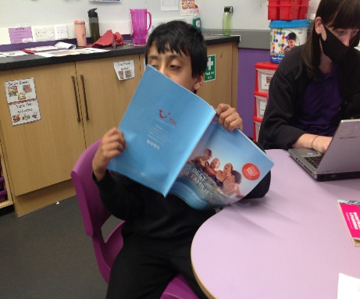
During Maths lessons this term, we have been learning about money. We have explored all of the different coins in sensory play. We have created our own shop display and made labels to show the prices of different items. The children have enjoyed creating growing patterns using 2D shapes and numicon animal pictures.
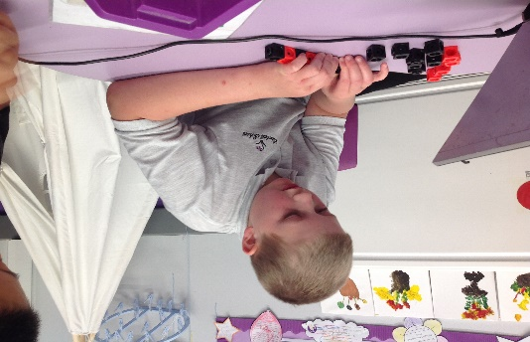
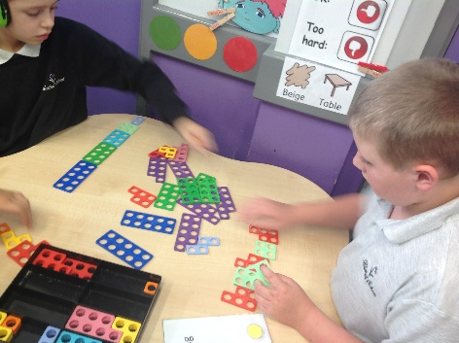
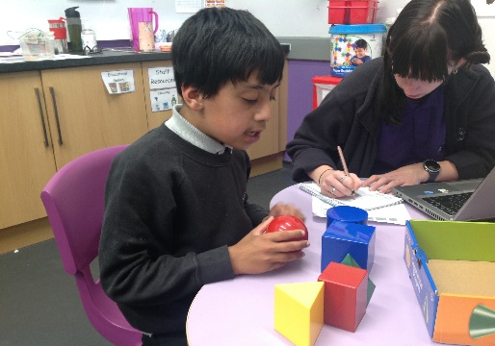
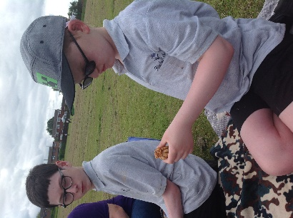
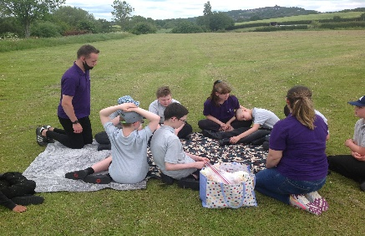
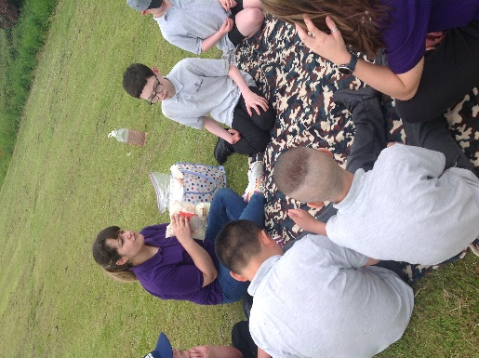
During Topic lessons, we moved to learning about Europe. The children designed and created healthy Italian meals, created sketches and watercolour paintings of European landmarks and built 3D models of British buildings. We have looked at a range of countries within Europe and have tasted many new foods. Look at some of the fun we have had…

We have also been on some exciting school trips. We enjoyed our time at Peak Wildlife! We had a lovely time seeing the animals and playing in the park. We even made our own picnic and enjoyed an ice-cream.
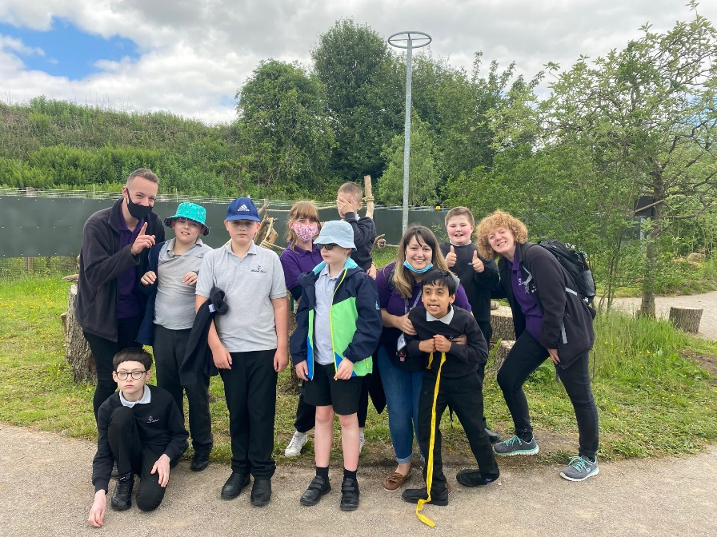

Thank you for all your support throughout this academic year! We look forward to welcoming the children back in September. Have a lovely summer break!

Moorcroft
We have had a brilliant end of the year in the Moorcroft. The children have particularly enjoyed swimming again and going offsite for PE lessons.

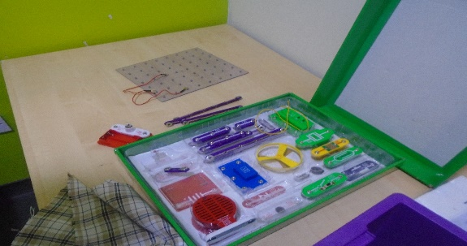
In Math’s Moorcroft have worked really hard learning all about repeated pattern and rotation and have also been learning about direction.

This term in science we have been learning all about electricity and circuits, and explored reversible and non- reversible changes. We have also investigated how our eyes work by building forts to test how much light is needed to see.
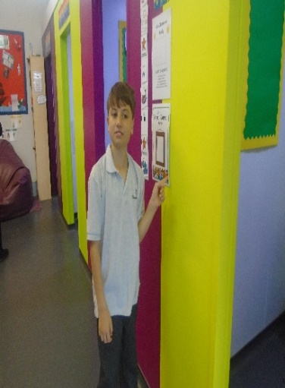
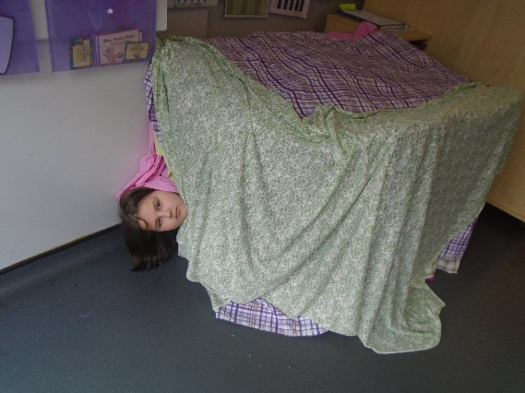

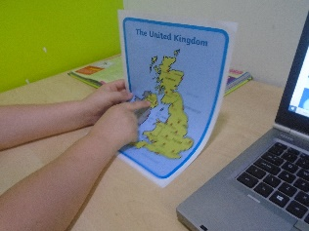
In topic we have explored different landmarks and created a fact file on our chosen place, we have then enjoyed tasting food from different countries and identified local dishes.
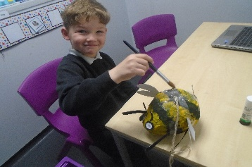

We have had lots of fun this term Moorcroft, here’s wishing you an amazing summer holiday and we look forward to welcoming you back in September,
Kate, Dawn and the class team.

Spode
What a lovely last half term we have had in class Spode. The children have worked extremely hard and have shown the amazing progress they have made throughout the academic year. The children have engaged in a range of exciting activities and have had a positive can do attitude towards topics.
In maths this term the children have covered a range of different topics but have particularly enjoyed symmetry and time. In our symmetry topic the children had a great time using the flags from the euro football tournament to draw lines of symmetry and to complete the missing half ensuring they are symmetrical. Following this they used tier knowledge to complete some difficult symmetry tasks using a mirror to help them. During our time topic, the children enjoyed creating their own clocks and exploring the meaning of the numbers around the clock, they then used this knowledge to partake in a range of time challenges. The children also looked at capacity and using a balance.
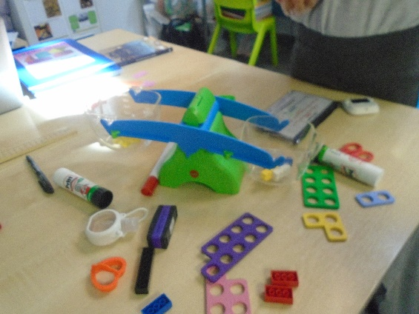
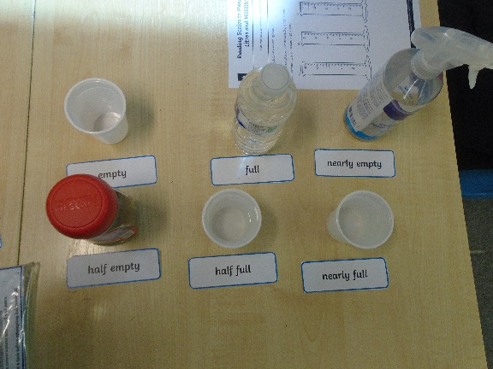

In English this term our topic was ‘The war of words’, the children really enjoyed this and it also linked to our topic theme for the term. The children have engaged beautifully in a range of tasks with the end tasks being to create a war themed poem. In topic we used the imagery created in the writing we explored in English to look at the experiences of a solider at war, paying particular attention to the trenches where they created their own amazing trench models.

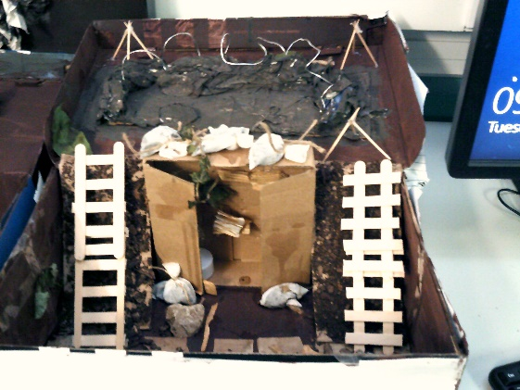
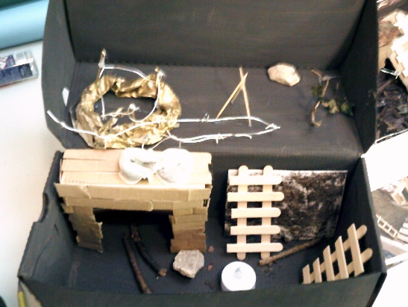

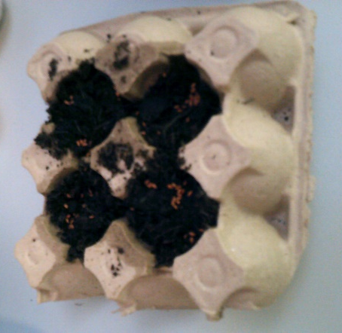
In topic the children also completed a sustainability topic where they looked at the six Rs of sustainability and we engaged in a large array of creative and practical tasks to consolidate our learning. The children enjoyed redesigning packing to become eco-friendly while also serving a purpose and they really enjoyed creating their own garden or decorative product from using old/reusable material. They did an amazing job as you can see from the images!
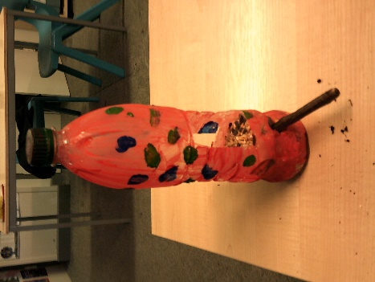
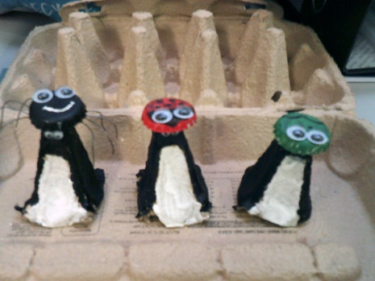

During the term we have explored a range of diversity events and key events happening in society and linked a range of sessions to this. The children really enjoyed looking at the Euros football and the Olympic Games. The children enjoyed linking our maths to the football players’ skills and we even had a class sweep stake which the children really enjoyed and kept them up to date with the scores. During the latter part of the term the children really enjoyed looking at the Olympic Games where they created their own Olympic torch and logo. To finish the term the children also took part in our mini class Olympic Games, where they worked amazingly within a team.
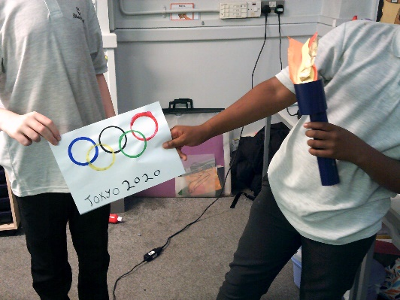
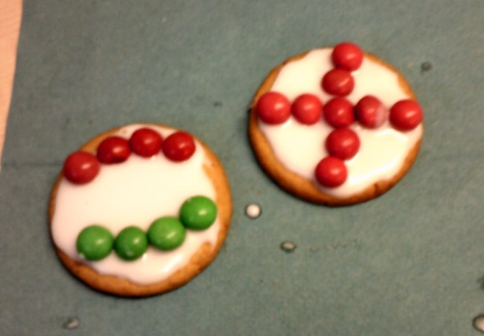

The children have been amazing this year and have really worked hard to meet their own goals and to create some amazing work. Staff are proud of the children attitudes, even during a difficult year with the ongoing COVID pandemic.
I would like to take this opportunity to thank you for your support during the school year and to wish you and the children the best summer holidays. I look forward to seeing the children in and around school in the new academic year!
Charlotte and staff in team Spode!
Middleton
In Maths, we have enjoyed learning about angles. We had great fun completing an angle hunt in our classroom and children were able to find lots of different angles. Children also enjoyed looking at patterns and were able to create some of their own repeated patterns. We had lots of fun looking at 2D and 3D shapes and creating pictures and models using different 2D and 3D shapes.
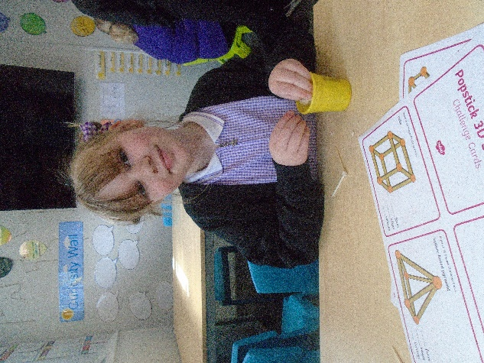
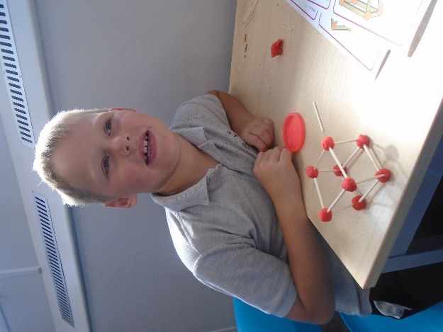

In Science children had so much fun experimenting with different forces. They had lots of fun carrying out an experiment to make a tennis ball bounce higher. We used the force of the basketball to help us with this.
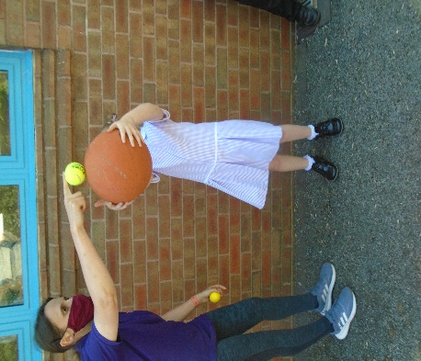
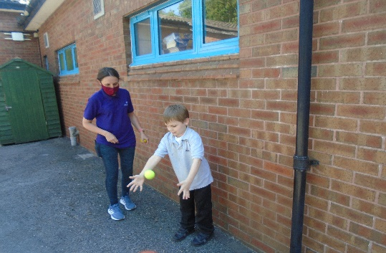
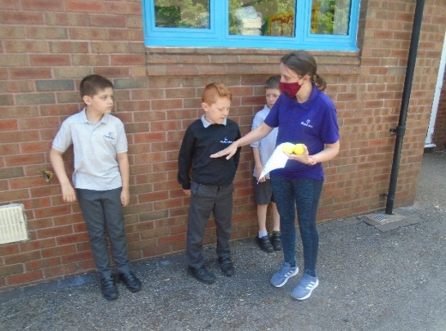
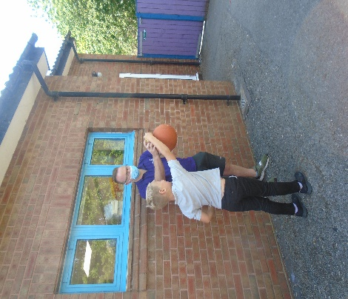

In Topic children have fully enjoyed learning about World War Two. We had some much fun creating our own Anderson Shelters and roll playing life in the War. We ended our topic taking part in our own VE celebrations. Children really enjoyed the VE party!
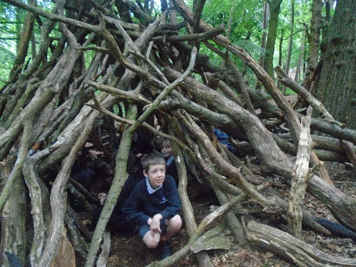
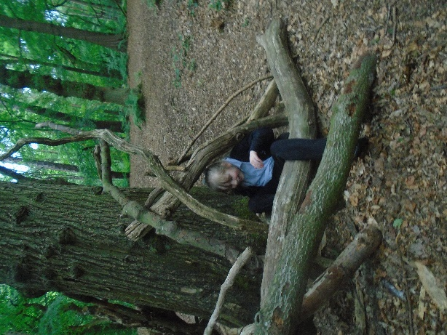
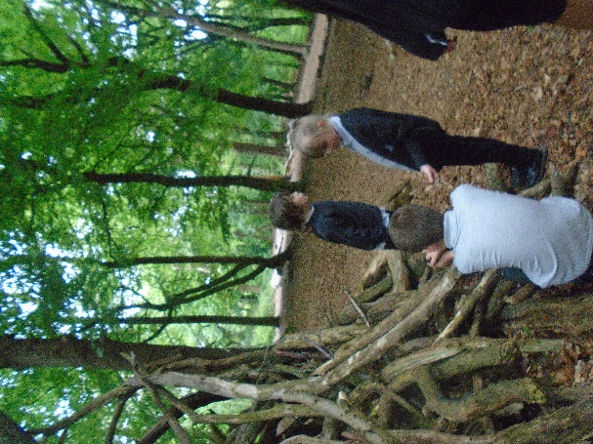

In ICT, children enjoyed using different computer programs to create some lovely patterns using different software.

In class Middleton we have also enjoyed helping our local community by completing a litter pick during one of our Social skill lessons. We picked up lots of litter, with the children having great fun in helping the local community!
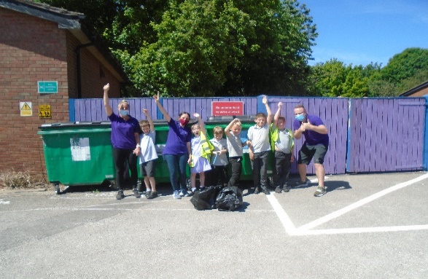
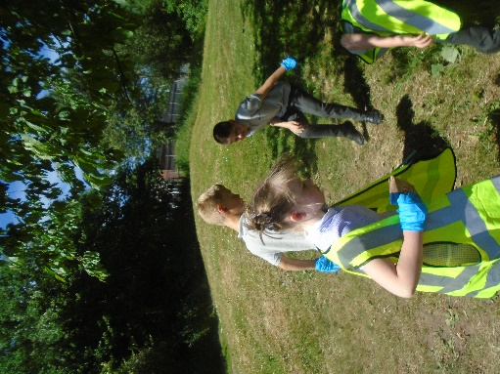
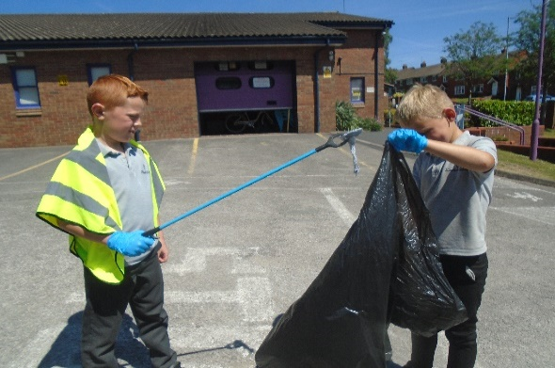

In English, children were able to look how to create a strong argument. We had our own class debate about whether or not fidget spinners should be allowed in schools. The children were very convincing as to why they should be allowed!

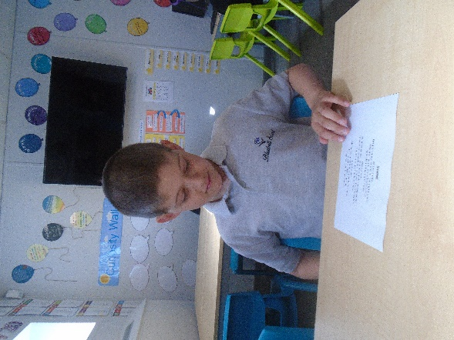
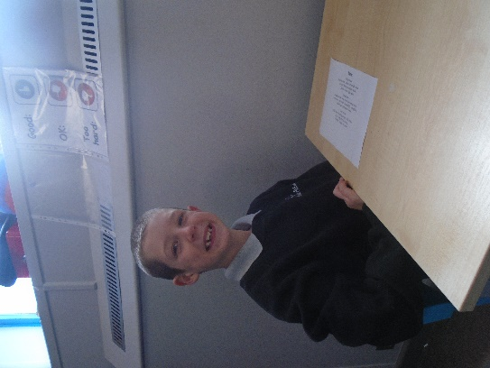

What an amazing year class Middleton have had. The class team would like to take this time to thank all children for their hard work this term! We hope that you have a great summer break!
Stay safe, we will see you all in September!

Wedgwood
Wedgwood class have had a brilliant end to the term! It has been great to welcome some new members to the class and have lots more fun together.
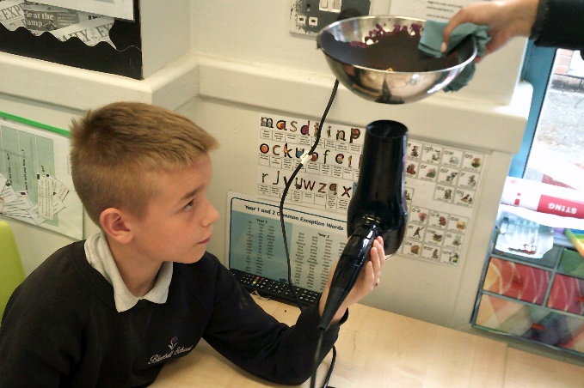
In Science, Wedgwood class continued to explore ‘light’ before revising the topics covered earlier in the year. Pupils have enjoyed completing lots of practical activities. We melted crayons and watched them solidify. It was interesting and helped us understand how igneous rocks are formed. We also investigated how glow in the dark paints work by creating our own t-shirts. This was great!
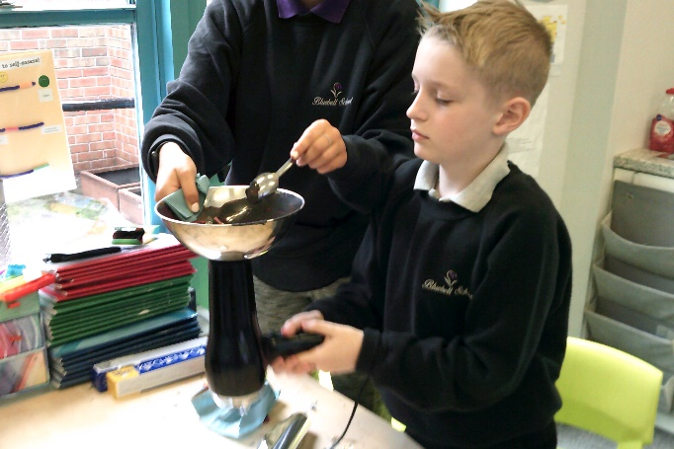
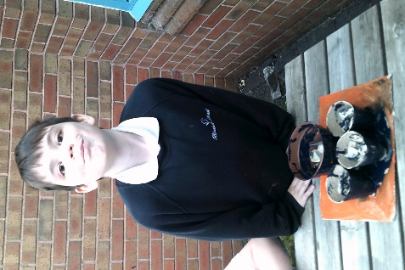
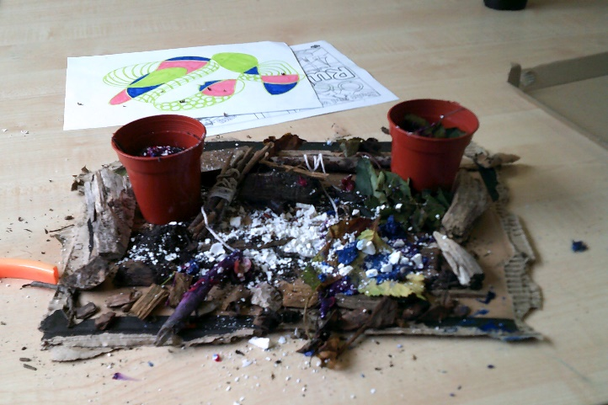
During our Topic sessions Wedgwood class have taken a journey back to World War 2. We explored some of the atrocities which occurred and ways which the Jews were discriminated against. Pupils looked at memorials from around the world which remember those who sadly lost their lives. They even created their own out of natural resources.
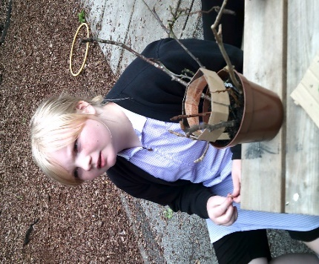
During our English sessions, we have got stuck into Slam Poetry. We have enjoyed watching, listening to and creating our own poems. Pupils got very creative and produced some descriptive pieces which they should be very proud of. We definitely have some budding poets!
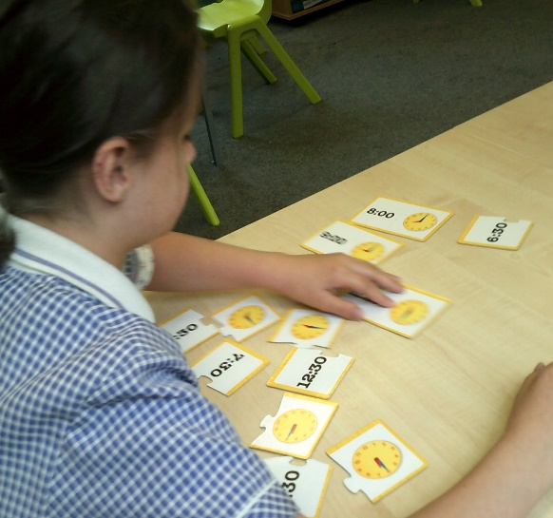
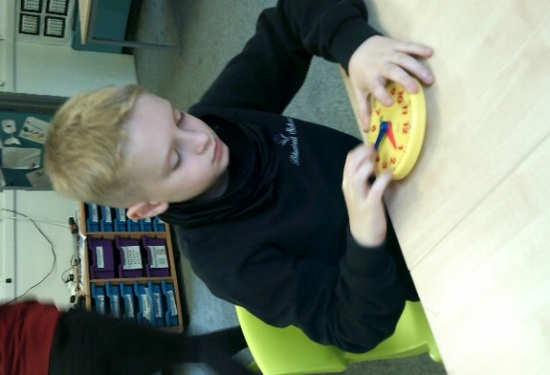
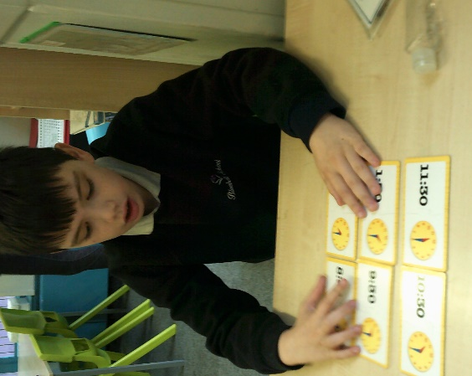
In Maths we have continued our work on addition, subtraction, multiplication and division. We have also been mastering time! We have made lots of progress.

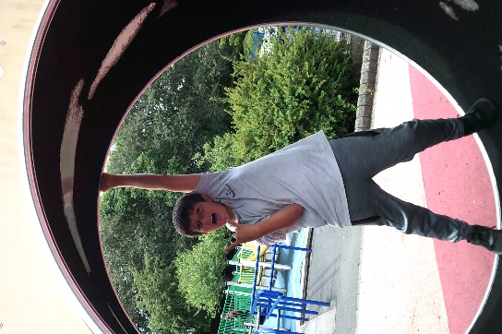
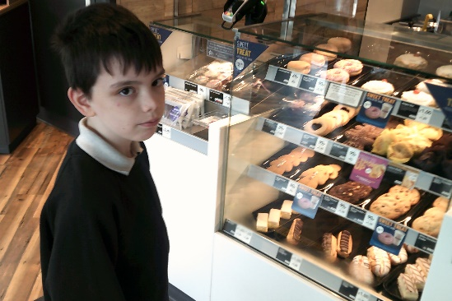
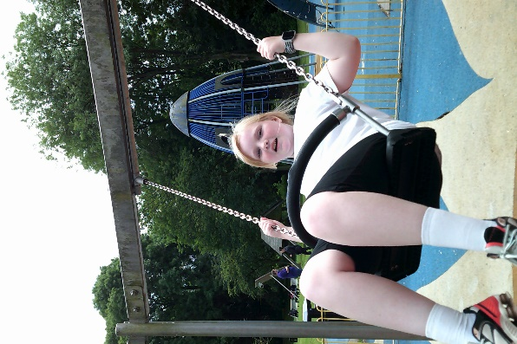
We have enjoyed developing our social skills over the term. We have been to park, the library, the local supermarket and to Greggs!

Well done for all your hard work this year Wedgwood. You have been a joy to teach and I hope you enjoy a well-deserved summer break. We look forward to welcoming you back in September.

Lauren and the Wedgwood team
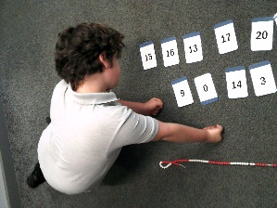
Steelite
Maths
in maths, we have been working on multiplication and division, finding halves and quarters and reading 2 and 3 digit numbers. We used beaded lines with adding and subtraction strategies to help with our work!

Over the last few weeks, we have been learning all about WW2. We have learnt about the countries involved, Churchill’s life and even created our own air raid shelter!

The children have especially enjoyed creating their own air raid shelter. The Children understood how different life was for a family living amongst the conflict of WW2.
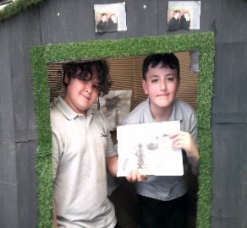
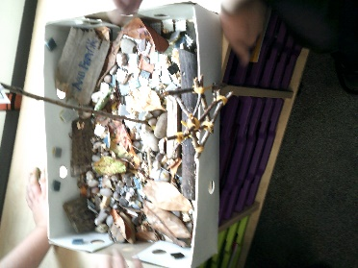
Steelite displaying their amazing work! They loved listening for the siren and walking to the air-raid shelter. They learnt all about the atrocities and about Anne Frank. They then went on to create a memorial.

Topic

In Science, we have been exploring light, shadows and reflections.
The children have enjoyed creating and manipulating their own shadows!
SCIENCE
English
Steelite have been learning about SLAM poetry, we have lISTENED TO DIFFERENT SLAM POEMS AND DISCUSSED THEIR FEATURES.
the children have ALSO ENJOYED LEARNING ABOUT APOSTROPHIES AND CONTRACTIONS!
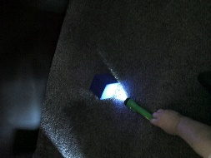
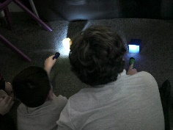
Steelite have had a brilliant term. The children have all produced some excellent work, and have especially enjoyed the practical side of their learning. Have a fantastic half term class Steelite and we look forward to another great term with you all in September. Enjoy a well-earned break.

Doulton
Class Doulton have settled into this final term of the year very well. The children have all adapted positively to any changes that may have occurred. In English we have been looking at World War diary entries and propaganda which was used during the war. Within this topic students designed their own propaganda poster which could have been trying to convince the women to work in the factories and play their part within the war. Some students chose to design a poster trying to convince the men that the country needed to help them fight in the war and help their country. Students were also able to complete a number of diary entries imaging that it was them taking part in the war and the different things they might hear or see while fighting. In science we have looked at wavelength and frequency. Students were able to explore and understand how wavelengths and their frequency are calculated. Students also looked at pressure and were able to work out using the formula Pressure = force divided by area.

In Maths we have covered units of measure, we looked at converting measurements and for this we needed to remember for example how many Millimetres in a centimetre and how many centimetres in a metre. Once pupils had grasped this they found this topic quite fun and enjoyable to convert. The other topic during this half term was working out percentages, this was based on the theme of Euro 2020, students needed to work out what the pie chart was split into and then work out the percentage based on how many slices there were. Once students had done this, we were able to find how many goals, for example Harry Kane, had scored in previous tournaments etc.

In Topic this half term we have looked at World War 2. Within this topic students have created a model trench using shoe boxes along with different materials found around the playground and garden such as rocks, twigs and moss. Students have been able to write their own World War 2 diary entry which was also being studied during English lessons.

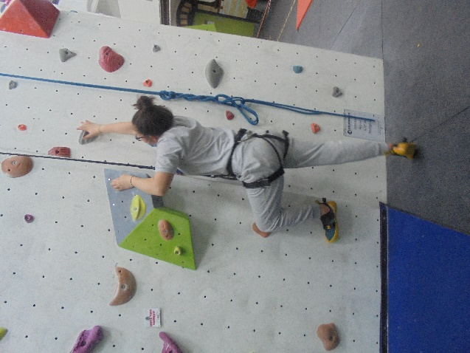
In PE we have been focusing on striking and fielding, learning different skills in both Cricket and Rounder’s. This has included learning some of the basic rules for rounders like the point scoring system E.G straight to second base is half a rounder and straight to fourth is a full rounder. In the Friday PE session with the roadmap out of lockdown easing we have been able to continue to take part in some climbing lessons, the students have loved these activities over the last half term and are looking forward to doing something similar when we return back in September.

I have thoroughly enjoyed teaching and getting to know each and every one of you in class Doulton and am proud of the way that you have been able to adapt so well to change. Myself and the staff team are wishing you a well needed break over the summer and we look forward to welcoming you back in September.

Nathan
Class Doulton Teacher

Twyford
Staff in class Twyford have been exceptionally pleased with the efforts of all pupils this half term and each individual has worked extremely hard with the activities completed across a range of lessons. Our year 10 pupils have continued their impressive work across all core subjects and have shown enthusiasm and endeavour with new challenges. For our year 11 pupils, for some this has been their last ever half term at Bluebell School and have conducted themselves maturely as they approach post 16 education.

In Maths, we have focussed on specific areas of the curriculum such as percentages, decimals and fractions. These have been tackled in a number of ways, including real life scenarios and practical activities and pupils have adapted well to further challenge to their learning.

With our English lessons, there have been a number of practice exam questions that pupils have completed in order to fine tune their preparation for GSCE qualifications. Pupils have needed to evaluate a wide variety of texts and establish the main points of each one, analysing their findings with longer pieces of writing. They have also worked hard in progressing with each of their IEP targets, re-enforcing existing knowledge in key areas.

During Science activities, the subjects have been based around waves and radiation. Pupils have established how to describe a wave and the movement it creates. They have also studied the electromagnetic spectrum and the uses of each type of wavelength, such as gamma rays, x rays and radio waves.

Towards the end of this term, pupils in Twyford were able to take part in ‘Independence Fortnight’. This was to assist with some of the skills needed in post 16 adulthood and prepare for real life situations. The pupils represented the school superbly when visiting Stoke on Trent train station and have particularly enjoyed creating their own choice of meal in the kitchen (the standard of cooking was very impressive!).

Like previous terms, class Twyford have shown commitment and effort when in school and for the year 10’s, we look forward to another successful year on their return in September. For some of our year 11’s, the staff want to wish pupils the very best in the future and hope their dreams and aspirations come true in the coming years!
Dan (class teacher)

Aynsley
It has been another busy half term here in Aynsley! Students have been extra busy finishing some of our qualifications and completing independent work.

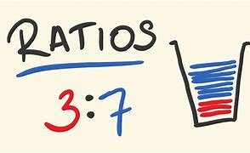
In Math’s we have been continuing to focus on our exciting project work to allow us to use Math’s skills in the outside world. Topics that we have focused on this half term have been fractions, percentages, decimals and ratio, which have linked into maximum visitor numbers and how businesses can run safely and effectively.

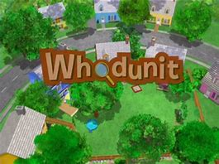
In English, we have been focusing on a ‘whodunit’ scenario, finding the suspects who have been involved in a crime. The students have been profiling potential suspects and identifying clues that could lead us to the culprit.

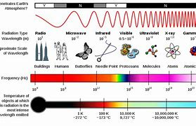
In Science we have all be studying the electromagnetic spectrum. We have been able to identify long and short wavelengths and how energy is transferred between different objects. We have learnt a fabulous song about the different parts of the electromagnetic spectrum which has stuck in our head for days!

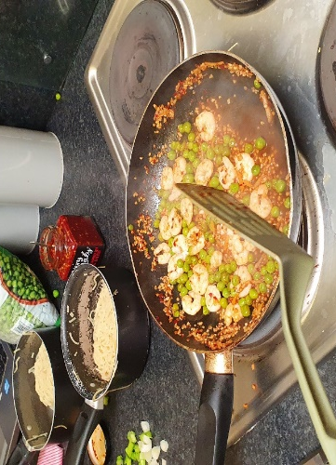
We have hosted our first ‘Independence Fortnight’. This has allowed our students to prepare for adulthood in a variety of ways. We have caught the train from Kidsgrove to Stoke-on-Trent in order to purchase our ingredients for our three course meal. Students made Bruschetta, Prawn Noodles and a selection of crumbles. I am so proud of all of their hard work! We have also spent time practicing how to complete key forms for our future such as passport and provisional license papers.

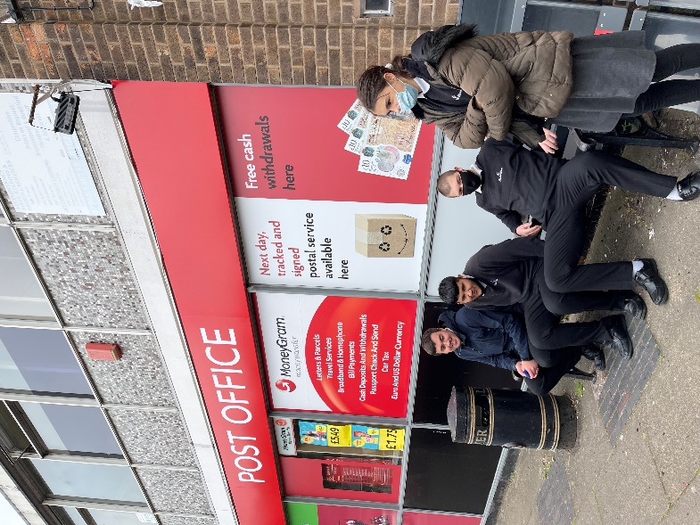
It has been a fantastic term and I am so proud of the way that all of our students have adapted to changes. We are extremely sad to see some of our year 11 students leave us for the next phase of their education but excited to see each of them flourish. We wish you all the very best for the future!

Coalport
Class Coalport have worked hard this term, engaging well with all tasks presented to them and doing so in a positive manner, finishing all BTEC units.

In Math’s we have been continuing to focus on our exciting project work to allow us to use Math’s skills in the outside world. During this half term, we have been recapping our knowledge on fractions, decimals and ratio, which we then related to real world business such as Alton towers and using our knowledge to explore the increase of visitors.

In English, we have been focusing on a ‘whodunit’ scenario. The children set up their own crime scene to visually see how police would find the body. We then created our own formal letter, explaining to the chief of police who should be arrested.
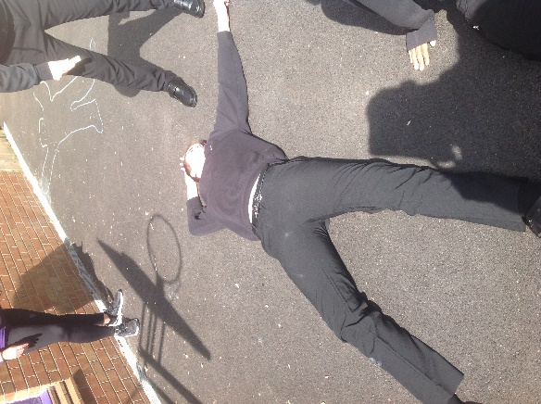

In Science we have all be studying the electromagnetic spectrum. We have been able to identify long and short wavelengths and how energy is transferred between different objects. We have created our own wave lengths, using a range of resources to display transverse and longitudinal waves.

In ICT BTEC we have been looking at different publications and creating our own flyers, logos and business cards for our chosen business. Everyone has worked hard and picked different companies to represent, taking their time to self-evaluate their work and their peers.
We have hosted our first ‘Independence Fortnight’. This has allowed our students to prepare for adulthood in a variety of ways. We have caught the train from Kidsgrove to Congleton in order to purchase our ingredients for our three course meal. For the starters the students made a prawn cocktail, the main course was a chicken burger made with Dorito bread crumbs, the dessert was jelly and angel delight

All of the students have worked hard this year and have all interacted well with each other. I hope you all have a well-deserved rest and will see you in September.

Jamie – Class teacher

